Object classification and distance sensor

Building a neural network from initial mathematical principles

Ronak De (U6SRA)

2024

Contents

Analysis 5

Problem identification 5

Why a computational solution is the most optimal solution. 5

Start of project introduction 6

Stakeholders 7

Problem decomposition 7

Iterative process 8

Interviewing stakeholders 9

Interview Questions 10

Interviews for people with some form of visual impairment 10

Research of existing solutions 13

Features of the proposed solution 17

Limitations of the proposed solution 19

Response to the proposed solution by stakeholders in the meeting 20

Requirements 21

Stakeholder requirements 22

Design 22

Success criteria 23

Design 24

Fundamental algorithms 24

Advanced User Interface 32

Security 33

Retraining 34

Instruction menu 35

Stakeholder input 35

Revised user interface 36

Data structures 37

Subroutine prototype 39

Subroutine linked structure and general structure. 41

Input methods 43

Validation 44

Key variables in data structures 44

Auditory outputs 45

Testing process 45

Testing checklist 46

Test tables 46

Development 48

Coding modular algorithms 48

Load functions 48

Sigmoid based functions 48

Cost function 49

Feedforward function 50

Logic-based simple prototype 50

Structure and design 50

Code solution and mathematical explanation 51

Backpropagation function 52

Learning rate 54

Logic-based simple prototype with hidden layers 55

Structure and design 55

Mathematical abstracted model 55

Coded framework: Feedforward 56

Backpropagation mathematical abstraction 58

Code solution and data structure explanation 64

Designing and building the final model 72

Image preprocessing 72

Requirements 72

Pillow library 72

NumPy array 73

CSV file 74

Image dataset and formatting 74

Neural network functions and prototypes 76

Requirements 76

Weights and biases initialisation 77

Loading and storing weights and biases 79

Loading images 82

Feedforward 83

Backpropagation 84

Feedforward network for image 89

Raspberry Pi image store 91

Auditory output 92

Activating change in voice speed feature 93

Testing changing voice speed 95

Activating time delay feature 101

Distance sensor 102

Testing of final product 105

Testing modular functions 105

Testing user experience 105

Evaluation 106

Testing checklist 106

Checking test tables 110

Input testing 112

Stakeholder testing and evaluation 112

Limitations 115

Requires pip installer to run 115

Only runs as expected on a Raspberry Pi camera. 115

Complex to set up. 115

Potential accuracy training 117

Slower than expected due to NumPy limitations. 117

Avoiding these limitations 118

User input evaluation 118

Maintenance 119

Final code 120

Neural network after training 120

Neural network training 124

Preprocessing 128

Change rate of speech input program 129

Initialise variables. 129

Prototype code 130

Simple network 130

XOR network feedforward 131

XOR network backpropagation 132

XOR network fail check 133

Bibliography 134

# Analysis

## Problem identification

Currently, individuals with visual impairments face challenges in recognizing common objects, often necessitating costly and specialized devices. If a program can automatically detect objects for a user, then this could allow them to understand their surroundings in a simpler way and reduce the risks of being visually impaired.

The features of this would have to be the speed of processing, not using expensive equipment and a computer to train the lightweight model for the user. The problem is most optimally solved through a computational solution because it would allow the user to not require reliance on a physical person to give the same information.

This solution would be in the form of a handheld device with a Raspberry Pi and a webcam that will automatically say the object that the camera is pointing at. This will then allow for a simple and multipurpose device to be used for the project and with open-source code, the speed of object identification at the cost of accuracy can be altered as well as the set of objects it has been trained on.

I will use a layer of abstraction to turn the images into a form that can be fed through a feed-forward neural network that I can then train. I will also abstract the way the images are taken by designing the model assuming that an image exists in a specific folder which I can check several times. I will also abstract the mathematical layers to simplify the concepts behind this.

## Why a computational solution is the most optimal solution.

Other solutions such as having an assistant would be impractical since you would not be able to always have a person with you and it would also mean the assistant would have to be with the person. This is an inconvenience so this solution would not be the most optimal if it can be automated with a cheap and simple device such as my device.

Creating artificial intelligence requires a computational solution because, without a computer, this would not be possible since it requires creating a set of weights that cannot be preset by people to give an optimal solution. This therefore requires a computational solution to function correctly since other solutions are not functional and software is required for this problem.

A computational solution is also ideal since it allows for the objects to be changed simply while another type of solution would not allow for this. Building a neural network purely mathematically is theoretically possible, running this in real-time is not possible since neural network relies on large matrix multiplications. This requires computational power since each multiplication requires several hundred multiplications which are then added together. There are a few optimised ways to do this however, this is not fast enough to be done by hand or any other way so the only way to produce a fully functional machine-learning network for this purpose is using quick matrix multiplication and this is only possible with a computer. Also, the speech technology requires either a person or a computer speaker.

The only other solution is using a physical person to identify the objects, and this is not practical and is expensive.

## Start of project introduction

To start this project, I chose a project title. I did this by finding a project that involved artificial intelligence. This interested me so I will attempt to produce my own network. I have decided to create a device that can complete object detection using a Raspberry Pi. I started with a list of project ideas and I decided to choose this one of the options. I believe I will have time to complete this project in time since I can iteratively solve each sub-part of the project and as long as each sub-part is simple enough with enough abstraction, I will be able to produce the software. I will use video evidence for testing using screen capture. I will also build milestones into my project so I can stay on track for the project.

I will be using Python and since this is the language used to build other neural network libraries, I believe this a suitable language to do this with. I am confident with the data structures which I may use in the neural network. I will separate my project into modules that I can complete in parallel which would improve the project since I can work on several parts at the same time, giving me more time to optimise each section at the end of the project since I would have more time at the end.

To start this project, I will also need to choose an IDE to code my program. I was going to use the Python default IDE however, I quickly realised that this would not be an optimal development environment. This is when I discovered Visual Studio Code. This has many built-in features that support my programming such as the built-in Python Intellisense which allows for the program to fill in variable names while typing them. It also detects variables that are used before assignment which makes detecting errors very simple and Visual Studio Code provides error messages that can be followed so I can detect where my errors are in a simpler way than with the built-in Python IDLE. It also allows me to open several Python files at the same time which makes programming across several different files significantly easier than having to open a new IDE for each program. It also has vertical integration with GitHub which allows me to commit the code to GitHub very easily so I can code on different devices without much difficulty. Visual Studio code also has support for other languages which I may use which will be very useful.

The greater customisation from Visual Studio Code is why I have chosen this over the Python built-in IDLE.

To create this document, I will be using Word since it allows for simple referencing and easy additions to headers and footers. It also has page and section breaks which are very useful. I also included a title page with the correct information. I also have used styles for the headings for each part of this document. I will be using a Harvard referencing system and a full reference in a bibliography at the end to document my research. I will create a backup on a USB drive and on the cloud, so I do not lose any documentation. I will also create several different versions so I can complete this project incrementally. Each version will be dated so I can go back to an old version and see the changes.

Since my project will contain great qualities of mathematical research, the majority of my research into my solution will have to be quantitative.

## Stakeholders

Stakeholders for this device would be people who are visually impaired and require a simple and cheap way to identify household objects. Due to the range of different demographics where this product will be the most optimal such as old people who have never used a computer before to people who understand how the code functions, this program must be incredibly simple to use by effectively just turning it on and it immediately identifying objects without requiring a setup process.

The main stakeholders are the visually impaired and could be used in an educational context to teach children what different objects are called. For example, a child could use this and point it at different, new objects and this would tell the child what the object is as well as a description of what it does.

This can also be used for those who cannot find their glasses and can be pointed in a general direction and give a description of what is in front of this as well as its distance using a distance sensor.

## Problem decomposition

This problem can be broken down into several different parts. An approximate example of what these steps will be are:

1. Developing and producing lightweight artificial intelligence
2. Implementing lightweight AI within Raspberry Pi quickly
3. Implementing distance sensor
4. Creating user interface and sound output
5. Combining parts into a package that can be used

One of the main objectives of this project is to produce a very fast neural network with almost no input lag so can be used in real time. This also has to be very simple to install so no specialised libraries should be used and the ones used should work on any device including old devices. Doing these in steps is essential in order to produce this properly. These are the explanations for my choices of the proposed computational solution.

The first step is building the software aspect of this from mathematical principles. This is essential in order for this to work on any device since specialised libraries may not be able to be run on all devices. It also makes this a very fast solution since it does not require any dependencies. This will also produce a software prototype which can be shown to the stakeholders and then be tested to see if the object identification is to the abilities that the stakeholders expect for this to be able to do. This also allows for the object choice to be changed relatively early on without having to redo later steps again from changes in the software in this stage. This requires a computational solution since it requires building a neural network software and this requires a computer to complete due to the need for matrix multiplication.

The second step is implementing this on the Raspberry Pi by integrating the code with a Raspberry Pi camera that actively takes photos. This allows for a functional prototype to be built and the abilities of this to be tested and therefore allows for changes to be made by the stakeholders after an interview before the process is completed. It also guarantees that the project will be able to implement one of the essential features of object identification. This also requires a computation solution since it involves a Raspberry Pi, this is a computer and therefore requires software to run.

Adding the distance sensor and implementing this within the software will allow for this feature to also be tested and let me choose how often to give this reading to the user. It also lets me interview the stakeholders again and see their opinions on the speed of the distance sensor and will let me adjust the range of the ultrasonic sensor. Since this is a prototype version, it will let me optimise the distance modes and I could find different solutions to measure the distance and see which one gives the most range of accuracy and range for distance. This can technically be done with a separate analogue sensor; it is done with the greatest level of integration with a digital ultrasonic sensor and can use the same speaker so this is why a computation solution is the most optimal since it allows for the greatest level of integration with the rest of the product.

The user interface will allow for a fully functional prototype and will allow the stakeholders to be able to use this device at this stage and give feedback on its functionality. It will also let me iteratively check my interface and see its compatibility with my stakeholders.

The final step is to build the actual device and doing this requires putting the parts together and combining this into a fully functional product. This will require different types of testing such as beta testing where I will give this to the stakeholders gain feedback about this and iteratively improve its design. This will allow for me to evaluate the final product and know how to improve this in the future. I can also see how to improve this device in the future using interviews with my stakeholders. I can also try different types of testing such as beta testing to see if the functions of each part are correct by looking through the source code as well as using black box testing where I test if the distance is accurate by comparing it to a known distance and I can test the speakers by using a set phrase and by listening to its ability to be understand what the program attempts to say using a voice library.

Since most of these steps require a computational method, this means that this requires a computational solution.

## Iterative process

I will have to choose between 3 different design methodologies.

My first choice is the waterfall methodology. This has some advantages such as fixed requirements and it allows for early identification of bugs and issues. However, this structure is linear and is not very flexible to the changing demands of my stakeholders.

Another design methodology that could be used is an Agile development methodology. This is where several short cycles are applied to the waterfall method. This has many advantages such as being more flexible and allowing me to adapt to changes more quickly however additional ideas could be difficult to implement within the project and there is a lower level of documentation however the documentation is essential for open-source code to be edited and understood. Documentation is also necessary for the user to know how to use the code. I will instead choose the final design methodology.

The design methodology that I will use contains prototyping and is the spiral methodology. This methodology is the best for my project because it allows the stakeholders to create defined requirements and will let them understand the direction towards the project and give ideas on how to improve this design. The spiral methodology is similar to the waterfall methodology but iterative where the process is completed several times. This also lets me develop the project quickly since I will be producing several prototypes that I can build upon which will be faster than the agile development where I produce prototypes that I cannot reuse. I also don’t need all of the details when building the prototypes and I can build these in for later prototypes. This has some drawbacks, however, such as it could take longer since many prototypes will be required. This could be a benefit because it will give me time to develop the solution at a greater depth. It may become difficult to time the prototypes so I will attempt to create simpler prototypes so I can build the program in incremental steps.

## Interviewing stakeholders

I will be able to contact the stakeholders after producing each prototype which will allow me to test its effectiveness at the end with each stakeholder.

The stakeholders that will be involved in my project are the following:

|  |  |  |  |
| --- | --- | --- | --- |
| Stakeholder | Role | Interaction requiring solution | Availability |
| Asha de Silva | Visually impaired | When waking up and can’t find glasses. | Weekly |
| Sarah Brown | Blind | Struggles with walking into objects  Walking in public spaces | Monthly |
| Shashank Vinoo | Visually impaired | Incapable of identifying basic objects | Daily |
| Dylan | Visually impaired | Difficulty seeing objects without glasses | Weekly |
| Mr Barlow | Visually impaired | Colourblind | Weekly |

These stakeholders are suitable since they all have problems that my device can solve in situations when interacting with the device.

If the user has difficulty seeing without glasses, then this device can help them identify objects around them. When it is difficult to navigate the room, the distance can be incredibly helpful in low-light environments where object detection could be less accurate. If a user struggles to walk in public, the constant distance information can give useful insight before walking into objects as well as their relative position to walls. If the user is colourblind, then it can be difficult to be able to tell the difference between certain types of objects such as between a can and a plastic glass while my object detection should be able to be trained to successfully be able to tell the difference against these. The effectiveness of my solution can be found by asking my stakeholders through interview questions.

## Interview Questions

### Interviews for people with some form of visual impairment

The questions for the stakeholders that require glasses are:

1. What objects do you struggle to identify without glasses?
2. What disadvantages do you struggle with when wearing glasses?
3. Do you require assistance with being able to tell the distance from objects?
4. How would you like to interact with a device that can identify objects?
5. What features would you like to have with an object-identifying device?

The first 2 questions will allow me to choose a dataset of objects to train with.

Question 3 will allow me to understand the importance of having a distance sensor with my solution and its value to those who do not wear glasses

Question 4 will give me information on how the final product should react to a user’s inputs as well as inform me of simple ways to interact with the device that is user-friendly.

The final question will let me find any additional features that can be added once the solution is created. These features must be simple to use.

I interviewed several of my stakeholders and these are their responses to each of these questions.

One of the stakeholders that requires glasses is Asha De Silva. This is their response to the 5 questions

1. What objects do you struggle to identify without glasses?

My glasses, light switch, edge of bed

1. What disadvantages do you struggle with when wearing glasses?

Can’t find glasses when I wake up, and can’t make out things over 2ft away

1. Do you require assistance with being able to tell the distance from objects?

Absolutely

1. How would you like to interact with a device that can identify objects?

Can type by holding the device close to my face, audio feedback would be good- want to read without glasses

1. What features would you like to have with an object-identifying device?

Distance measured and colour.

Some of the objects that my program will need to be able to identify are glasses which is demonstrated by the answers to the first 2 questions. The answer to the 3rd question demonstrates the necessity of this device to help the visually impaired to tell the distance from other objects. The answer to the 4th question suggests that audio information is essential so my device will have a speaker for the output. The 5th question answer gives information that distance measured is useful as talked about before and a new feature that could be added is saying the colour of the object. This can be implemented relatively easily by averaging the pixel values for different parts of the image and then relating ranges of RGB values with different colours.

I will attempt to implement the ideas given by Asha De Silva by adding colour detection as well as allowing for long-distance measurements for distance.

Another stakeholder whom I interviewed who requires glasses is Shashank Vinoo who struggles greatly with object identification.

1. What objects do you struggle to identify without glasses?

Without glasses, I find difficulty identifying objects such as my school bag or my books.

1. What disadvantages do you struggle with when wearing glasses?

Glasses can sometimes be uncomfortable and wearing them all the time is not an option such as when doing sport.

1. Do you require assistance with being able to tell the distance from objects?

Yes. Without my glasses, I am effectively blind and I cannot tell the difference between certain types of objects after around 5 meters.

1. How would you like to interact with a device that can identify objects?

I’d prefer a device that's easy to use, with options for voice activation and a simple interface. Quick and precise object identification would be essential. It would have to be intuitive.

1. What features would you like with an object identification device?

A description of the object would be nice and continuous distance information would be useful when walking.

This gives some of the same information such as being able to identify glasses is important. I also learnt that being able to identify objects should be possible from 5 meters away and the distance detection should have this range approximately. The 5th question gives an additional feature where you can give the distance continuously when an object is not strongly detected.

I will also interview people who have different forms of visual impairment such as blindness.

I asked Sarah Brown altered questions for a greater understanding of how to optimise my device. These are the questions and responses I have received.

1. What sort of objects do you struggle to identify?
2. Do you require assistance with being able to tell the distance from objects?
3. How would you like to identify objects?
4. Do you have any preferences on how to interact with the device?
5. What features would you like to have with an object-identifying device?
6. What sort of objects do you struggle to identify?

Identifying thin objects like wires or small obstacles on the ground can be challenging. Also objects with irregular shapes or varying heights are difficult to perceive accurately.

1. Do you require assistance with being able to tell the distance from objects?

Yes. Determining distance from objects is essential for me to navigate and avoid obstacles. Having a way to tell these distances is essential.

1. How would you like to identify objects?

I would prefer an auditory-based system that provides clear and descriptive information about the objects around me. Different tones, pitches, or verbal descriptions for various objects and their distances would be highly beneficial.

1. Do you have any preferences on how to interact with the device?

A device with a simple, ergonomic design and tactile buttons or a touch interface would make interaction easier. Voice activation for commands and feedback would also enhance usability. The option for customization and personalization based on my preferences would be great.

1. What features would you like to have with an object-identifying device?

I would appreciate features like automatic object detection, distance measurement, and the ability to identify common objects in various environments. Real-time updates as I move would be helpful, as well as a directional guide to navigate around obstacles.

Questions 1 and 2 confirm the purpose of this device and question 3 suggests that an auditory form is useful. A new possibly useful feature is using different tones for different objects which could be implemented as an extra feature. Voice activation could also be implemented to turn the device on and off however, it could be confusing and add extra complexity compared to a button that turns the device on and off.

## Research of existing solutions

Many of the products that are for blind people are for text-to-speech applications. One of the examples is this.

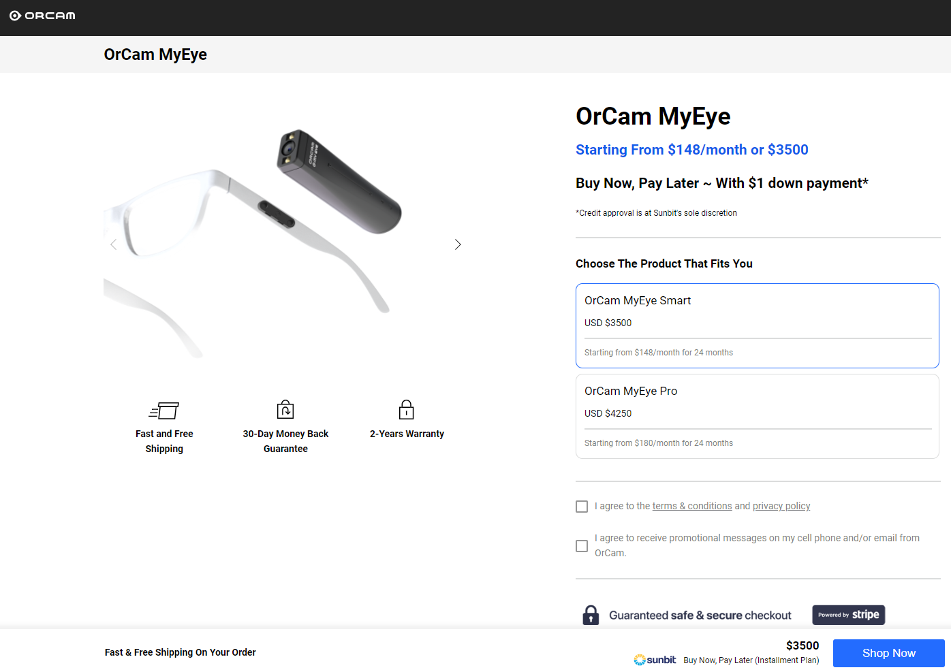

This enables the person to be able to easily view text however is much more expensive than the Raspberry Pi setup for my project and does not allow for any other types of object detection.

A device that does allow for object detection is the Envision Glasses professional edition. This has an integrated camera that does object detection using the glasses and has an internal speaker. However, this device costs £3,000 before tax which is significantly more than my product and does not have a handheld version. It also does not let the user choose which objects to identify as well as give a description of the objects once it detects a specific object. However, there are some interesting features of this product such as having lights on the device which would allow for the device to work in low light conditions such as in the morning and could also give visibility to the user in these conditions.



This device, however, does provide some features that could be integrated into my product. An example of a feature that this provides that my product does not is the ability to detect the light level and detect different people within the device. I will attempt to code these as extra functionality however the network will have to be retrained for each new person since a new architecture will be required so this may not be possible.

A form of software that can be used for a similar purpose is Google Lens.

 

Google Lens can be used to detect different objects and allow for objects to be identified. However, I think a problem with this software is that it requires the user to reach the app from a device and then be able to read the information. This would not be a functional solution because if someone is visually impaired, their ability to read from a device information would not be possible and if they had the capability to read the information, they would also be able to identify the objects.

However, this solution does have some interesting features such as giving specific information about the objects being identified so my device could give a small summary of each object it detects once this is done so the person is aware of what it is exactly.

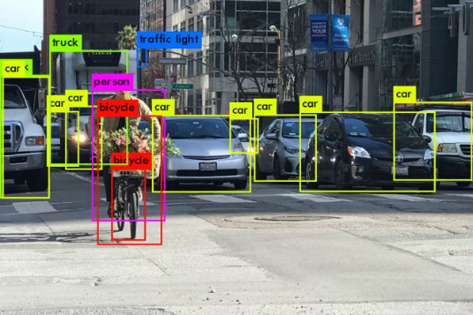 

A software approach towards object identification is OpenCV which is a pretrained Python library for object detection. However, this does have some problems with using. For example, OpenCV runs incredibly slowly on a Raspberry Pi with the time between detections being over 5 seconds. It also has disadvantages such as causing the Raspberry Pi to become very hot since it stresses the IC to 100% as soon as it is run. It also has many dependencies that many Python installations do not come with so the user will have to know how to install these dependencies which is difficult for the users to understand how to complete. This also is a trained library, so it does not allow for the user to train for their specific objects.

This is problematic due to its high resolution and very high processing time. This can be run very fast on a normal computer however since Raspberry Pi’s do not have a dedicated graphics unit, this is quite slow compared to computers that do have this. This is why OpenCV is not a viable solution for my project since it requires a more powerful processor and does not allow the user to choose which objects to be able to identify. This however does have some interesting features that could be implemented within my solution such as being able to identify multiple objects at the same time. Due to the architecture of my network currently, this is not possible however this could be implemented in later iterations for the network.

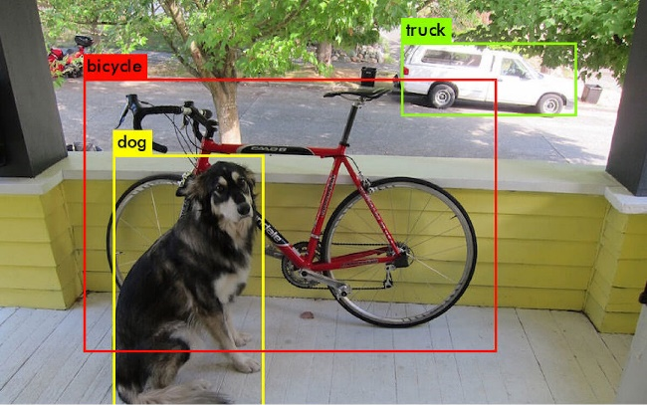

YOLO or You Only Look Once is another unique type of object detection which, unlike traditional methods such as those in OpenCV that perform multiple region proposals and evaluations, YOLO divides the image into squares and predicts the bounding boxes based on this. This decreases processing time greatly and since my program will not be using this feature at all, the bounding boxes are not necessary. This different approach reduces redundant calculations and results in faster detection. The speed of this is advantageous for this purpose since quick responses are necessary for effective object detection for this purpose and are greatly more suited for this purpose compared to OpenCV.

However, despite its improved speed, running this on a Raspberry Pi with its hardware-constrained performance could potentially be a challenge even when running on the modern Raspberry Pi 4b. The computational power required for YOLO will train the limited resources of the Pi and therefore will not allow for real-time object detection with this device. To address this to gain real-time object detection on the Pi, a custom neural network will be necessary and can therefore allow me to tailor this for the specific purpose of identifying objects since the program does not need to have to be able to tell where an object is in the image, just that it is there, dramatically reducing the processing time required. This increased efficiency through the architecture will allow me to match the hardware constraints and can enable real-time object detection possible even on this. creating an application specialised for this purpose will guarantee that this will run properly without the requirement of complex download procedures for other libraries.

One feature of YOLO that I could implement is that it can complete a single-pass prediction. This is where the image is processed through the frame once through the network to predict the bounding boxes of the objects. This can give an approximate position of the objects and will benefit the user since it gives an approximate place. This could be a potentially useful feature for my solution.

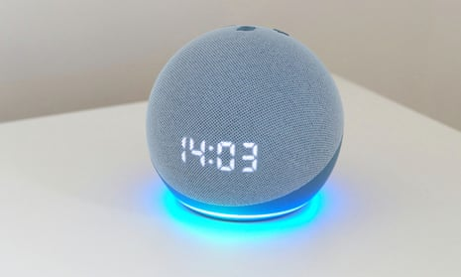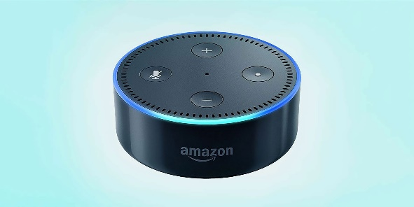

The use of the voice sensor requires a voice library and a device that speaks in a human voice is Alexa. This uses a technology called Text-to-Speech (TTS) to generate a voice output. This is a process where written text is converted into words by a computer. The one used by Alexa is a proprietary system developed by Amazon which involves complex algorithms that produce natural speech from text. When interacting with Alexa and a command is given, the text is sent to a processor which completes natural language processing and gives an answer. This response is then turned back into a speech response using TTS and sent through the speakers. I will attempt to complete this final stage of my project. This will mean that for each object to be identified, I will have to write my very own descriptions for each object. I could also produce a way such that the library can easily access the object descriptions and then edit them.

One of the features from Alexa that I can introduce into my project is that it integrates with TTS into my system, allowing for the text input to enter another part of the program through the voice activation code to give a correct voice output. The voice activation library must be found that is natural, similar to an Alexa.

## Features of the proposed solution

Using the research from the other devices and interviewing the stakeholders, I have developed my solution to this problem to have several new features. These new features are:

* Real-time distance information
* Object description once identified.
* Different pitches are used for each object type.
* Colour information about the surroundings
* Logs of objects identified and distance.

The original features included:

* Object identification and audio response
* Distance sensor for object distance once identified.

This research and interviewing have increased the feature set of my device.

To produce this device, I will use a Raspberry Pi, an ultrasonic distance sensor, a camera and a speaker which will be combined into one device that can then be used by simply turning this on. A battery may be used to power the entire device. The device will also have an advanced mode where it is plugged into a device and another person can use the software to train more images. The software will then adjust the weights and biases based on the new architecture and will rebuild again based on the original weights to implement the new values. This should allow any user to be able to detect objects without requiring other people.

The essential feature of this will be successful object identification since this will allow the stakeholders with visual difficulty to successfully identify objects when required. It also is required in order to successfully keep a log of the information.

The audio response is the only way someone with visual difficulty will be able to easily understand what is detected since the text will not be any easier to read than detecting the object. This is essential to function properly and can be understood when an object is detected. This must be coded such that it is never cut off while saying one object. The distance sensor is also essential because it allows us to gain even more information about the object being identified. This is essential because people with visual difficulty will also have difficulty gaining distance information about their surroundings.

The extra features such as constant distance information improve this to have a greater utility. Describing the object could potentially have some use cases however this feature is optional since gaining information about the type of object is the most important part. This is also the case for colour types and using different pitches. The logs will be very useful and can be used to see the accuracy as well as train it towards the objects that are identified more commonly.

In conclusion, the features of object detection, audio response and distance sensor are essential while the other features can be added once the primary features have been implemented since these allow for the device to function as expected. This product will not be using a GUI for normal use cases since it is a mainly auditory device and when a GUI is used, the text must be large and high contrast. Colours could potentially be used however this would mean that this product will not be suitable for those with colour blindness so any colours used must not give otherwise unknowable information to the user. For example, a red square cannot represent closing the settings since a colourblind user will not be able to distinguish from the rest of the GUI. The data structure that will be used is going to be an SQL database to log the objects in a secure table and the distances will also be stored in another table. These tables will dynamically link to file locations and will allow an advanced user to train the network on these new objects with correct values if the network gives a lower accuracy than expected. This is an example of the data structures that will be used.

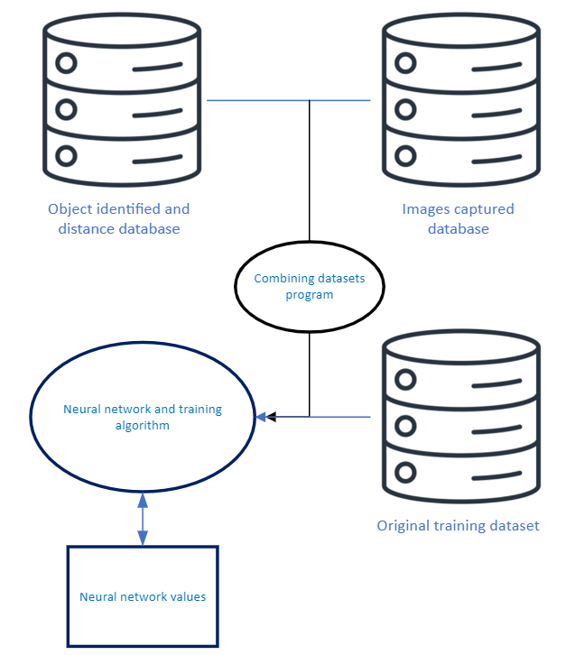

As can be seen, 3 databases will be used, and the weights will be stored in a file structure with the algorithm. The images being captured will link to the objects identified through a foreign key where each record of the objects identified will link to the image for which it believes that the image is. If the user believes that it is not accurate for a specific image, then the user can edit the records and the images such that they are accurate. This can then be combined with the original training dataset to produce a new set of network values.

## Limitations of the proposed solution

One of the major limitations of my device is that the user will have to hold this device instead of being able to wear this like glasses. It will also have a limited number of potential objects that it can detect, and the range of the ultrasonic sensor could affect how far the device can see. In the advanced mode, the user will have to know how to navigate a file structure and how to download images so simplifying this process will reduce the technical skill to use this software.

Another limitation would be the resolution of the camera. In order for this to be a lightweight neural network, the resolution of the incoming image must be reduced significantly, and this could affect accuracy in detecting the objects. The network may also not be able to deal with different lighting conditions so the lighting may have to be normalised in order for this to function as intended.

Another potential limitation of this project is the battery life of this device. Since this device will run on a portable charger, the time for which this device is active could be an issue and will most likely not last all day. This could also be difficult to charge for someone with visual difficulty since the charging cable is quite small and therefore an assistant is required to recharge the device. If the battery device is low, then this could cause issues with its usage.

One limitation of the distance sensor is the effective distance that an ultrasonic sensor can detect. If this is low, then this could cause problems with its usage and could give misleading values if it is beyond its effective range. This could potentially mean multiple different sensors would be required which would have to work in parallel.

The Raspberry Pi also has limited computational power since it does not have a dedicated graphics unit. This means that the matrix multiplication is optimised by graphical units. This would mean that this would run significantly faster on a general-purpose computer compared to the integrated processor within a Raspberry Pi. This could also reduce the speed of distance sensors. The sound quality could also be affected by using a Raspberry Pi over a device with an integrated DAC converter since producing audio from a digital signal is generally of a lower quality than using an integrated DAC from a device.

The final limitation of this solution is that this will require setting up a speaker, camera and ultrasonic sensor by the user once a Raspberry Pi is found. This could be difficult to do since it requires creating a circuit using a breadboard which can be very difficult for those without good vision.

## Response to the proposed solution by stakeholders in the meeting

I have now informed some of the stakeholders of this initial phase of analysing the problem and this is their response to my decisions about the device. I have informed the stakeholders of the following:

* Functionality of the product and its ability to complete different functions
* Implementation of ideas such as changing pitch for different object types
* How to train with different images in advanced mode
* Potential distance and resolution limitations affecting accuracy

This is the response by some of the stakeholders such as Sarah Brown

“After thoroughly examining the functionality of this product and its capabilities to perform a variety of functions, I believe that this product is suitable for this purpose. I like the idea of incorporating pitch adjustments for different object types and I think it will be a valuable addition that can make it more adaptable. Being able to train with different images would be very useful because I can use it for my purposes specifically and adds flexibility. The limitations could affect the usability and effectiveness of this device but if you can work out how to increase the range, that would be good.”

This gives a detailed answer to my initial brief and shows that one of my stakeholders is happy with the design of the product currently. I will need to work out another solution to increase the range somehow such as by using 2 sensors instead of one.

I also gave the solution to Shashank Vinoo and this is his response

“Seems good. If you can get the pitch changing working, then it would be cool but I don’t need it. Training with different images seems difficult but if you can make it simple, then that would be good. If the distance is like 5 meters it’s fine.”

This gives some information such as a range that the stakeholders would like to detect. It also suggests that the user should be able to disable the pitch-changing mode as desired since many users may not require or want this.

For each prototype, I will show my stakeholders and see their opinions on the device as well as the direction the device is going towards. This will allow me to iteratively adjust the program towards the final solution.

## Requirements

In order to use this device, several other devices are required. An example is a Raspberry Pi. This has to be fast enough to be able to quickly identify objects so a Raspberry Pi 3b or above should be functional. This will also require a battery pack such as a portable charger. However, this is not necessary since most Raspberry Pi’s come with a cable so it can plug directly into the wall. A Raspberry Pi-compatible camera is also needed. This can be a USB webcam or a specialised Raspberry Pi camera such as the Raspberry Pi camera module. To add the images to the device, another computer can be used to SSH into the Raspberry Pi and can be imported into the Raspberry Pi after being flashed with a headless operating boot mode. However, if the user does not have the technical capability to use this, they could use a computer on the local network and use a program such as VNC viewer to connect to the Pi after the local IP address is found. However, this does require peripherals to set up for the first time and to get the code for object detection. The peripherals required include a mouse, keyboard, and monitor. A wired keyboard is required for setup in the beginning. A wired mouse can be used if the user can reach the wireless network using a keyboard only.

Hardware devices required.

* Raspberry Pi 3b or above
* Camera (USB camera or Raspberry Pi camera module)
* Power supply or portable charger with a compatible cable.
* Peripherals for set up:
  + Keyboard (USB)
  + Monitor (HDMI or VGA)
  + Connecting cable (micro-HDMI to HDMI/ micro-HDMI to VGA)
  + Mouse (USB or wireless)
* Raspberry Pi setup:
  + microSD card slot/ SD card slot with microSD to SD card converter
  + Raspberry Pi imager software
  + SD card (min 32Gb)
* Additional components:
  + Breadboard with wires
  + 1kΩ Resistor
  + Ultrasonic sensor

The Raspberry Pi must be running Raspberry Pi OS or another form of Debian GNU that is compatible with a Raspberry Pi. A Python interpreter is also required. Since the libraries I will be using are automatically within Python, no extra installation is required. The code is then cloned from GitHub and once run, it will automatically detect objects. This means that an internet is required to set up the device or it can be preinstalled on the device so the user only needs to turn this device on, and it works. These instructions must be able to be found easily because otherwise, it is not possible for the user to be able to set this up.

The camera is required for the object detection. Without this, this would not be possible. The Raspberry Pi will connect the components together and run the calculations. A power supply or portable charger will be required for the Raspberry Pi to function. The peripherals are only required for the setup since they are only used for installing the software. These parts are used together to use the Raspberry Pi as a PC and therefore can be used to build the neural network and confirm the components attached function as expected. The components for the Raspberry Pi setup are to just download the operating system and the microSD card slot with the converter is generally included. This can be preinstalled by the developer if the user does not have access to an SD card slot. The additional components are required to get a functional distance sensor working.

Software required.

* Raspberry Pi compatible operating system such as Debian GNU or Raspberry Pi OS
* Python interpreter (included with Raspberry Pi OS)
* Web browser (included with Raspberry Pi OS)

This has a very lightweight software requirement as it is designed to be as fast as possible and to be compatible with as many devices as possible. The operating system can be downloaded onto a microSD card slot relatively easily by just using a Raspberry Pi imager and the Python interpreter is automatic on most Raspberry Pi-compatible operating systems. If not, it can simply be downloaded from the Python website. This will allow users without a high level of technical ability to get this product working with minimum setup from the software side. The minimum functionality with the web browser is that it can allow for files to be downloaded from them and that modern URLs can be accessed so almost all web browsers that a user can access should be functional. Almost any Python3 interpreter should allow the user to run this code since it does not use any specialised libraries. All Raspberry Pi operating systems come with a Python interpretation so there are no limitations from having a legacy Raspberry Pi operating system.

This solution is appropriate to the needs of the stakeholders because it will allow for those with a visual impairment to successfully navigate their surroundings and give information about where they are as well as their distance from objects which the stakeholders have agreed to be an optimal way to approach this problem. It solves the problem of difficulty of object identification as well as being able to tell the distance between objects without requiring a physical personal assistant so is appropriate to my stakeholder’s needs.

## Stakeholder requirements

### Design

|  |  |
| --- | --- |
| **Requirement** | **Explanation** |
| Simple to use in default mode | The user would like to be able to use this simply by turning the device on with minimal setup required |
| Lightweight design | The network must be lightweight, so it is fast enough for quick object detection. |
| Simple to change image set | The users must be able to simply change the image dataset with minimal computer knowledge. This means that there has to be an instruction set included so the user can easily follow once a dataset is found. |
| Simple training process | The user should only have to press start and it automatically trains |
| Way to turn off and on easily | There should be a simple button which turns the device on and off by simply pressing this button. When turned on, it should also start object detection. |

## Success criteria

|  |  |
| --- | --- |
| **Criteria** | **How to evidence** |
| Object identification | The software can identify objects from a USB camera |
| Object description | Allow the user to set a description for when an object is identified and automatically say this after an object is detected. |
| Using a Raspberry Pi for object identification | Only using a Raspberry Pi to run code without using VNC viewer with a PC (direct monitor connection) |
| Simple, lightweight design | Fast detection |
| Simple user interface | When in the advanced mode to change the image dataset, a simple-to-use user interface is necessary. |
| Simple to set up | Giving to stakeholders and timing how long it takes to set up |
| Simple to use by default | When turned on, automatically does what is expected using the settings stored from the previous time it was used. Automatically turns on once Raspberry Pi turns on. |
| Can be turned on and off easily | Testing with stakeholder’s ability to do this |
| Ability to activate and deactivate features through a settings menu | Give stakeholders instructions and see how they interact with the interface |
| Ability to retrain with different image sets | Give to stakeholders and see how easily they can change their values |
| Low refresh rate mode | Include in options where the number of images taken is lower. Evidence by showing decreased Raspberry Pi temperature. |
| Simple and followable instructions | Picture of instructions in an easy-to-access place |
| Detects multiple different objects dynamically | Video of the device detecting different objects |
| Change pitch for different objects | When 2 different objects are identified, each one will be said in a different tone to be able to easily differentiate between these. |
| Colour information about the surroundings | Ability to change a setting where the average colour is taken and output for a specific image shot. |
| Image logging | The objects detected and their distance will be stored as well as a screenshot of what is taken. This will allow for improving the model in the advanced mode where the user can say whether what is done is correct or not. |
| Data protection | The images that are logged must be stored correctly in accordance with the Data Protection Act so the drive will be encrypted and will require a strong password to access the stored images. This password will not be required to use the software normally |

# Design

## Fundamental algorithms

Building the algorithms is an essential part of this project and the way they interact with each other will allow for the neural network to build itself and train without requiring external development. Here is how the algorithms will work together to build the network.

Each of these algorithms is fundamental to the production of the neural network and I will therefore explain each of these functions below. Each of these functions breaks this problem down into smaller solutions and this allows for each of these to be coded and then combined to produce the network.

1. Class constructor function.

This will create the class containing the different variables required and the functions for feedforwarding and backtracking functions. Building the class allows for the classes to be run and the variables to be locally stored. Here is an example of the simplified function.

Objectdetection(weights,biases,generalvariables)

Function __init__:

Global weights= self.weights

Global bias = self.bias

This will help me complete my project by allowing me to construct the functions for my neural network.

1. Library load function.

This function will load all of the libraries required. These libraries will be from Python and will not need to be installed from Git. This function will be modular so it can be used by multiple functions. The libraries loaded will be NumPy to simplify mathematical operations, CSV to load the images after being processed, and pyttsx3 text-to-speech functionality. Here is an example of the coded solution.

Function load_libraries():

Import NumPy

Import CSV

Import pyttxs3

This will improve the functionality of my program by using optimised multiplication functions which will improve the speed of moving through the neural network. It will also allow for an auditory output as described within the success criteria.

1. Sigmoid activation function.

This will turn the input between 0 and 1 by using a mathematical function. If the input is negative, then it approaches 0 while if the input is positive, it approaches 1. It is continuous between these values.

Function sigmoid(x):

Return 1/(1+e^(-x))

This activation function is essential for a neural network to function since this allows for the outputs for each layer to be applied to a layer that normalises the outputs to a known input space. This stops any cases where the outputs become incredibly large, therefore making the network have a very low performance. Activation functions are required to build this type of neural network.

1. Differential of sigmoid activation function.

This function takes the mathematical derivative of the sigmoid function. This differential is at a maximum in the middle and lower on each side. This will be important for training the network since during the backpropagation function, this will be used within a partial differential. This is similar to the sigmoid function

Function diff_sigmoid(x):

Return sigmoidfunction(x) * (1-sigmoidfunction(x))

This is used for building the neural network and is an essential function since it allows for the network to be able to calculate adjustments for the weights and biases accurately. This is required to build this type of neural network.

1. Inverse sigmoid activation function.

This function is used after the feedforward function to get the original values for the function. Since sigmoid is a one-to-one function, this can be done to reverse the sigmoid function. And gain the values before the sigmoid function is applied. This will be important for training the network.

Although, the original values can be stored before the sigmoid function is applied. This increases the memory space significantly and it would be simpler to just inverse the function when necessary. It is similar to the other functions.

Function inv_sigmoid(x):

Return ln(x/(1-x))

1. Cost function

The cost function represents the values to be optimised by the network. The point of training the network is to reduce this value in order to improve the values of the network. For each of the outputs, this is calculated and therefore gives the network a general sense of how far off each output is from where it should be.

Function cost(output, expected_output):

Return(1/2 (output-expected_output)2)

This allows for the performance of the neural network over time, therefore linking to the success criteria of building a functional network.

1. Combined average cost function.

This allows the user to understand how well the network is improving off of a normalised scale. This is not used directly by the program since the averaging nature is combined with the constants used within the program and can be generated based on the number of outputs, therefore making the need for an average, an arbitrary calculation during the training process however will be used to track its performance over time and can be graphed after the optimisation to see the rate of improvement of the network.

Function average_cost_function(x):

Return loss(x)/numoutputs

This also links back to the success criteria of building a neural network. This function specifically allows for neural networks with different architectures to be compared against each other and will therefore inform me how to improve each prototype.

1. Loss function.

This represents the difference between the true values and expected values. This is important since it is used in the backpropagation function and allows for the network to understand how to adjust the values. This lays the groundwork for the backpropagation function to understand how the network is performing relative to the values it should be.

Function error(output, expected_output):

Return (output-expected_output):

After the network has produced an output, a secondary function can then be run to find the adjustments for each weight and bias. This first requires, however, moving through the network using a feedforward function.

1. Feedforward function.

This brings the network one layer through the network. This allows for the network to function since it moves through the network one layer at a time until the output layer is reached. However, this function only brings the network forward by one layer and the network is generally multiple layers. This function will require several of the functions used previously. This links with the success criteria of building the network since this function is used to move through the network by one layer at a time.

1. Feedforward all functions.

This applies the feedforward function many times to move from the input layer to the output layer entirely. This allows for the entire network to be run through with a locally stored state of weights and biases. This allows for the outputs to be generated and therefore to use the error function. Splitting the feedforward function into 2 produces more modular code and therefore will allow for simpler error detection as well as making the changing of the architecture much easier. This links with the success criteria of building a neural network since this moves through the entire network.

Function feedforward(input,weights,bias)

X=multiply(input,weights)

Y=add(x,bias)

Z=sigmoid(y)

Return(z)

Function feedforward_all(input)

Layer1=feedforward(input)

Layer2=feedforward(layer1)

Layer3=feedforward(layer2)

Output=feedforward(layer3)

Return output

1. Backpropagation function.

This uses the error function to move backwards through the network and produces the adjustments for the weights and biases. These represent the gradient of the cost function and is applied during the backpropagation function. This will use several of the functions above. In order to code this, several mathematical frameworks will be required which I will discuss within development before designing this function can be completed. Once this function has been built, this will allow me to train the neural network, therefore completing the success criteria of allowing for the network to train with image datasets and be able to detect these different datasets.

1. Load main function.

This loads the main classes to allow for the network to be produced. This function allows for the program to run on startup as well as to function as expected. This will run several other functions such as the class constructor and the other load functions.

Class load_main()

Function __init_:

Load network

Load images

This links to the success criteria since this links all the features from the success criteria together.

1. Load feature’s function.

This loads all of the complimentary functions such as the output controller which will be mentioned below. Here is an example of pseudocode for the first 2 examples

Class load_features()

Load general variables

If line4(general variables)==”yes”

Load change_pitch

If line5(general variables)==”yes”

Load colour information.

1. Load all function.

This combines the main and features functions as well as loading the other important variables that will be used. This also loads the libraries from the load libraries function. This loads both the accessory functions and the main functions

1. Store main function.

This stores the new weights and biases produced after the training process and stores these values. This is parsed through the file structure-function to avoid any unwanted overwriting of previous weights and biases unless wanted since the previous set is untrained. An example of this is:

Function(values):

store(values) using filestructurecontroller()

1. Store other function.

This will store the user’s input values as well as small variable values from the network such as which training level is used. If a second network is trained, the original network will be stored. However, which network level is being trained or used must be stored in a general variables file.

Function(generalvariables)

Store(generalvariables) using filestructurecontroller()

1. Distance function.

This distance function will be used to generate the distance values using the sensor. This will be used in the distance program and will be combined at the output layer.

Function distance()

Time1=Take time()

Time2=Take time()

Return (time2-time1)

This links to the success criteria of distance detection since this program will complete this part successfully.

1. Save function.

This saves the weights temporarily. This is important if an interrupt happens during the training process and allows for the network to continue training at the correct epoch number.

Function save ():

Store(values) using filestructurecontroller()

1. Reset function.

This resets the weights to rerandomize for the new network values and stores these values as a new set of weights and biases, and will communicate with the file structure controller to update the general variables accordingly.

Function reset()

Make random weights

Make random biases

Store(weights,biases) using filestructurecontroller()

1. File structure controller.

This finds the file structure of the different images and stores this within the general variables file. This then allows for the training program to understand the locations of different images as well as their names for each output layer. This will also sort through the different sets of weights and biases and update the general variables to inform main which set to use as well as informing the training program which set of weights to use for a new training process.

Function filestructurecontroller()

Find files in images

For image types: set in general variables

If location in general variables == “trained”

Return not trained

Else:

Return already trained

1. Image processing function.

This preprocesses the images into a set of numerical pixel values that can be fed into the network. This will also communicate with the file structure controller to inform the types of images which will then be able to change the general variables.

Function image_preprocessor(image)

For pixels in the image:

Return pixel_values

This links to the success criteria of allowing for the user to set their own image datasets since this function will turn the images into a readable format for the network, allowing for this dataset to be trained on.

1. Variable list debug function.

This allows me to find any errors by storing any local variables in a debug file in case an error occurs during the program. Since the program uses a modular structure, this can be used for different variables. This will be useful if debugging is required after each function is tested modularly.

Function variabledebug(variables)

Store(variables) in debug_folder

1. Audio output function.

This combines the distance function and the main function outputs to create a text output that is then turned into an audio output using the speaker and a library. It will also communicate with the peripheral check function to confirm that the speakers do exist. I have explained this function below. I have used a specific text-to-speech library called pyttsx3

Function audiooutput(distance,object)

Text=Combine(distance,object)

Load_libraries()

Use pyttsx3 to turn text into audio

1. Peripheral check function.

This checks if all of the outputs such as the speaker and the webcam required are present. This is done by checking for an error when these devices are attempted to be accessed. If an error occurs, other functions will be informed by this.

Function check()

If speaker = “on”

Return “speaker on”

Else:

Return “speaker off”

If camera = “on”

Return “camera on”

Else:

Return “camera off”

This links to the success criteria to be able to start itself once the device is turned on since this allows it to check if all its features are working properly before attempting to function, reducing the risk of error while running the program.

1. User interface function.

This produces a function that allows the user to change the values in the general function. This is used to protect the general variables file from the user from potentially making incorrect values. Here is an example of pseudocode for one of the input options

Function user_interface()

If user_input “yes”:

Change(generalvariablesline11) to “yes”

Elif “y” in user_input or if “Y” in user_input:

Return “Did you mean “yes”?”

Else:

Return “Invalid input please try again”

1. Feature reset function.

The rest of the values back to default. This would protect the values from potentially being damaged by the user accidentally and would remove any potential errors.

Function reset()

Change(generalvariables) to Generalvariablesoriginal

I have broken the problem down into functions. This allows for a computational solution since functions can be coded modularly and therefore is suited towards a computational solution since the code is modular and is made of discrete functions that will be combined within a class structure.

## Advanced User Interface

When the user changes the training dataset, they will be introduced to a user interface to add new images to be trained for as well as to change the feature set such as how often to give a distance measurement or colour detection.

To reach this interface, the device must be unlocked to access the encrypted drive. The program can be run without unlocking the device.

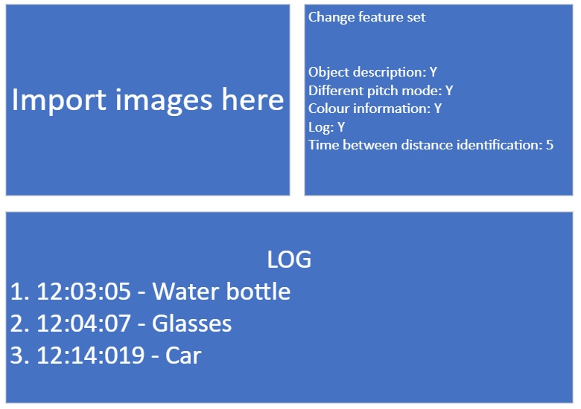

A minimal design is important since this could potentially be set up by someone who is visually impaired however, normally, this is set up in the beginning by another person. Once set up, changing the feature set can only be done by connecting the device to a computer monitor and with peripherals which could potentially be difficult for someone who is visually impaired. Once the device is in use, the need for a GUI is not required since this only requires an auditory mode.

This will complete several of the success criteria such as:

* Simple user interface
  + Only 2 boxes for input
* Simple to set up
  + Device will function when turned on. Set up is not required
* Ability to activate and deactivate features through a settings menu
  + Menu can be changed by simply updating the text values for each variable
* Ability to retrain with different image sets
  + New images can be imported and new files can be run
* Change the pitch for different objects
  + Can be activated or deactivated from the menu by changing the text value for each variable.
* Colour information about the surroundings
  + Can be activated or deactivated from the menu by changing the text value for each variable.
* Image logging
  + Can be activated or deactivated from the menu by changing the text value for each variable.
* Data protection
  + To be able to access the user data, this can only be done using a password. The drive cannot be imaged using forensic tools easily since encryption is used (such as BitLocker) so the only way to access logs is through the password.
  + This is not required to use the device.
  + Data is stored locally and not on the cloud so no risk of external hacking since not connected the to network.

Once in the advanced user interface, the user can then select a box to change the values which are stored in a data structure and the images can be pasted into the import box by dragging through a browser on the device and this will be used in the device. The user can then run the file from the file structure and will retrain the neural network with an updated network structure (where the number of output neurons is different).

The images can be imported by using the box. This will then be stored in a data structure where the images will be labelled as a new folder and the user will import what type of image this is by labelling the images in a specific format. This is done automatically by the program after the 1st image is labelled correctly and the rest will be reformatted such as getting the correct file type.

### Security

The interface allows the user to not only introduce new images into the training dataset but also fine-tune the features depending on how the user may use the device on a day-to-day basis. However, in order to access this, a critical layer of security is important. The Raspberry Pi hosting the object detection can be run without being unlocked so the functionality of the device is not impacted by the additional security. The device being unlocked serves as the initial access to the features as well as the logs. This ensures that only authorised users can manipulate the device’s features and protects the user’s control over the device as well as their data from optional logs of images being detected to improve the accuracy of the program. This also reduces the risk of malware since only the user can access the code which prevents tampering such as having the device upload a video feed. To reduce this risk further, the device’s networking ability will be able to be turned off or on by the user. Uploading through a local source could potentially be simpler by the user however could potentially have a risk of using interface devices which could be turned off to improve security. The integrity of the device can be kept by simply allowing the interface devices to be able to interact with other files on the system after the device has been unlocked and after the storage device is scanned for any potential viruses. If the device could potentially be expanded with an external camera such as a phone camera, keeping the security of the video stream is paramount and since an external camera is used, a secure handshake is required where only the video is sent from the camera to the Raspberry Pi to reduce any risk of the phone’s potential security breaches from reaching the Raspberry Pi and extracting the user’s data through an escalation of privilege attack

To ensure the security of the training dataset and the network, several measures should be taken such as encryption of the training images which could potentially include parts of the user’s surroundings. This would improve the accuracy of the network dramatically however poses a great security risk if this would potentially be hacked. Encryption of the drive protects this even if the device was physically stolen since the drive cannot be accessed without the password.

Before potentially making any changes to the original training dataset, the original program will validate the procedures before attempting to potentially run any malicious files and will prevent the model’s performance from being adversely affected. This maintains the integrity of the machine learning model and ensures performance is not affected. Another way to protect the original machine learning model is by building a second network and keeping the original model in a secure file structure. This will not prevent any other users from being able to tamper with the device.

Documentation of the security features will be essential to allow for a trained user to be able to effectively interact with the network and to be able to give a greater change in the network’s structure.

In conclusion, the user will be protected from potential attacks by keeping the device off of local networks and encrypting the drive that the user’s training images are stored on as well as the logs which will also encrypted.

## Retraining

The retraining process requires the retraining program to be run by accessing the file directory. By selecting the program, it will be run and after being trained, the network will be able to detect this type of image as well.

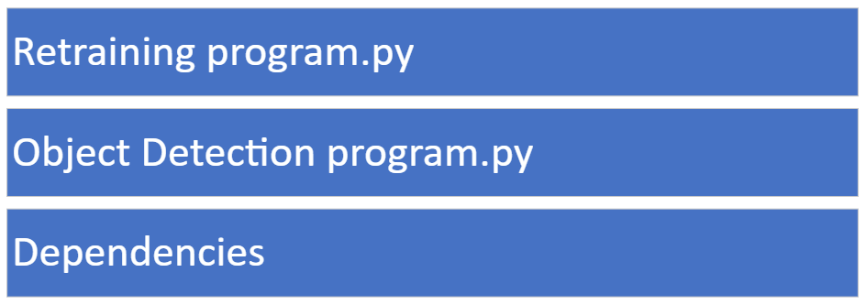

The retraining program is run by the user after the images are imported. These images are stored in the dependencies as well as the original architecture of the program. This will then update the dependencies and produce a new structure. Once run, the device will be able to detect this type of image as well.

This links to the success criteria of being able to retrain the network.

## Instruction menu

To reduce the complexity of accessing the feature set of the program, I will include an instruction set which will explain how to access each part of the program. This will include instructions on how to find datasets, how to collate images together, how to import images from different sources, how to label the first image, how to check for minimum resolution, how to convert to the correct file type using the command line (with both Linux and Windows CLI to ensure compatibility) as well as how to import these by pasting into the user interface. I will also give instructions on how to change the feature set by what to type for each potential box. I will also give the user instructions on how to retrain the network as well as how to do this on their machine using GitHub if the training process is too slow. This would be done by creating a branch on the Raspberry Pi with the new image dataset and then syncing to the GitHub page. This can then be pulled from any device and the network can be trained using this. The user must be careful not to change the page after the branch is synced since this could cause a merge error. I will also include instructions on how to fix merge errors and how to use a command line interface to push to Git (as well as how to install and set up a Git CLI)

I will also give instructions on how to remove the Raspberry Pi using SSH or VNC viewer and how to find the local IP address in a simple form such that the user will be able to follow these instructions if they choose to change the network. This will give the user a much easier and simpler way to interact with the device from using their computer instead of requiring external peripherals.

## Stakeholder input

I will now show my stakeholders the simplistic user interface as well as the functionality of the program through a meeting and will receive their feedback. This is an essential part of the iterative development process of this since it allows the user to give feedback and will allow me to make any changes to the user’s request to make this process simpler.

After showing my stakeholders my original design process, these are the replies that I have received:

Shashank Vinoo

This seems like a relatively simple and friendly design which would allow for users with vision impairment to be able to easily access this. This seems to allow for easy and simple ways for me to import my own images into the program however there seems to be no simple way for me to remove any images from the dataset. It would be useful to have a way to remove image datasets and would give me greater control over the network’s training process. I agree with the security protocols of keeping the device offline unless strictly necessary such as importing images from online datasets. I would however, recommend using an antivirus which would give a greater level of protection since if any viruses entered the device while connected to the internet, it could upload the images after being connected to the internet again. To avoid this, I would recommend using an antivirus. Also, a firewall should be used and I would like to be able to configure this firewall such that only authorised websites or ports can be opened. When I am not wearing my glasses, I am not sure if this will be as usable so could the different parts of the user interface to potentially be different colours?

This gives valuable feedback such as tightening up security through using a user-configurable firewall as well as an antivirus which constantly scans the drive for any potential malicious files while connected to a network. It also gives valuable choices for the user interface such as using different colours for each part of the interface. This would be beneficial to those with poor vision since they would be able to understand what each part of the interface does without needing to be able to read each box in detail. What each box does could potentially be stored in the instructions so the user can complete these.

I will also ask Sarah Brown after showing my current design process.

I like the simple design however there are some parts that I feel are a bit too complicated such as reaching the interface requires a password and connecting the Raspberry Pi could potentially be difficult using other accessories so having other ways of accessing this would be useful. I believe that the security features are good to keep, however, I am not sure if I would be able to reconfigure this device after being set up since it is difficult to find another dataset. I think using large labels is useful. I think I would be able to complete these with clear instructions.

This gives essential information about the need for clear instructions as well as having large labels since this allows users to be able to interact with the device with greater ease. The instructions should be clear on how to access each part as well as give different methods to reach the interface such as using SSH or using peripherals and this would allow the user to choose the simpler way for their choices.

This feedback allows me to change the user interface to use both different colours and will inform me on how to change the instruction set to form a simpler way which means that inexperienced users with visual impairments could potentially set up the device.

## Revised user interface

I have included these updates in accordance with the feedback from my stakeholders. I have included different colours as well as options to remove datasets where you can click to remove each dataset. I have also made this with different colours which allows for the user to be able to simply tell the difference between the meaning of each box using the instructions. Using the feedback I will also ensure that the instructions are detailed and allow for the user to easily move through the interface.

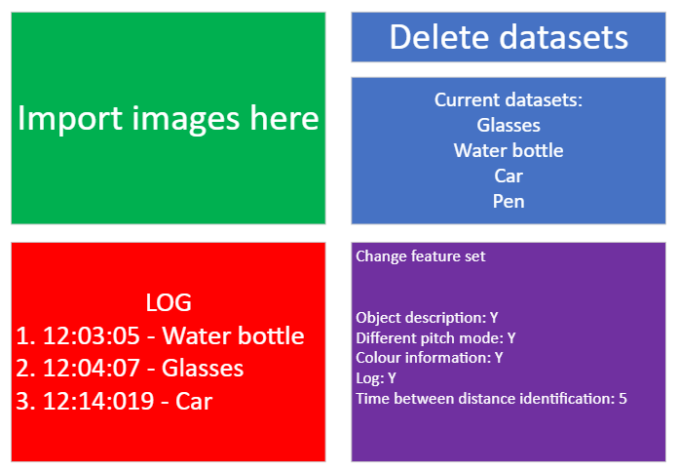

The user can delete different parts of the dataset by simply clicking on the name of each dataset and this will bring the user to the file structure behind this dataset. The user can then simply press delete and this will delete the dataset.

## Data structures

Given the number of different variables within and outside the main programs as well as the accessory programs, it is essential to have a clear data structure so the network can effectively be used and this can be done by using a layer of abstraction.

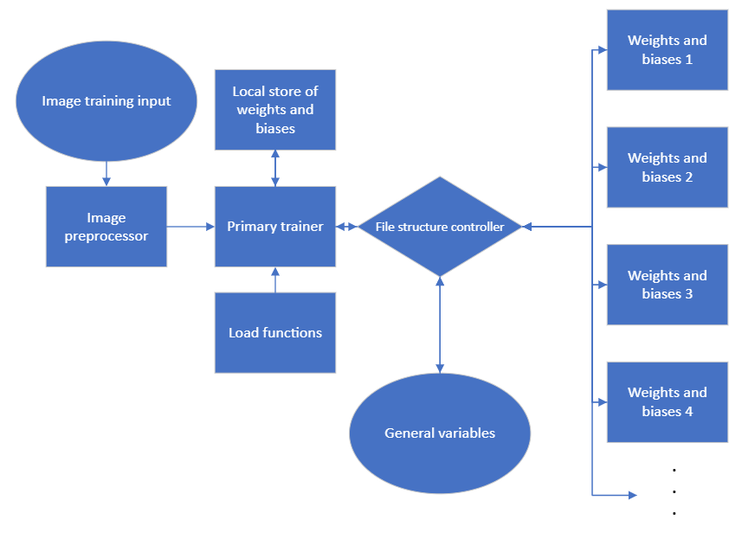

As can be seen, the weights and biases will be linked to the main training program and a local copy is stored. This will then update this unless a new program is called where a new set of weights and biases are stored and the pointers from the general variable location. This will protect the original trained program from being rewritten when retrained. The accessory programs will make sure the general variables are updated correctly. The dependencies of the libraries will also be stored here through a virtual environment. This will keep that version of the library locally without requiring a pointer to the main location within Python. This protects the program in a way such that it can be run on any device. The images are processed through an accessory program in the correct format. It is important to keep this in a read-only state when the program is being trained and if a dataset is marked for deletion, then this dataset is not accessed by the program. Any new datasets will be processed by the image preprocessor accessory function and will update the general variable location accordingly. The main function will have a debug function to make sure that all of the expected values are there using a form of validation.

## Subroutine prototype

There are several different functions that will be designed together. These will be in different subroutines. The subroutines are:

* Input routine
* Image preprocessing
* Object identifier
* Network trainer
* Output controller

I will now break each of these subroutines down into their functions using pseudocode algorithms

For image preprocessing, I will need to run several functions such as loading the images and then storing them in the correct data structure as well as adjusting the general variables accordingly.

The first function is to take the inputs and change these into a format that can be placed into the general variables file. This can be done using a pseudocode routine such as this one.

IMPORT GeneralVariables

options=inputs

FOR choice in options

format choice into GeneralVariables

ENDFOR

STORE GeneralVariables

This imports the variables into the file and stores the changes back into the file depending on the inputs from the user interface. The inputs from the images are automatically stored in the correct places since the user places these images into the file structure and the labels are stored in the inputs

The second function that must be completed is loading the images. This requires knowing which datasets are available. This is done by importing the general variable set and using the names of the files in the data structure between specified lines from the general variable set. Once this is done, the images are turned into pixel values using an image-to-pixel function. These pixel values are stored in accordance with protocols from the general variable set which allows for the trainer to be able to access these. I will now write pseudocode for this subroutine.

IMPORT GeneralVariables

names=line10 of GeneralVariables

FOR objects IN names:

IMPORT images from location(image/objects)

function (images -> pixel values)

ENDFOR

STORE pixelvalues in location(pixels/objects)

This allows for me to use the information from GeneralVariables to build the pixel values. Using this information allows for the neural network to be updated.

The next subroutine completes the object detection.

This first takes an image and parses the images through the image preprocessor. This is then fed into the network and the output is then fed into the output controller which then turns the output into speech and will have a description of each object. Here is a simplified pseudocode representation of this subroutine.

TAKE image

IMPORT image FROM location(image/ImageName)

processedImage= imagePreprocessor(image)

networkOutput=neuralNetwork(processedImage)

distance=distancemeasurement

RUN OutputProcedure(networkOutput,distancemeasurement)

The final sub-procedure is the output controller.

This takes the input of the networkOutput and will then use the largest output from the networkOutput and will use this to give a speech output using the 2 inputs.

Here is the pseudocode example for the code.

IMPORT GeneralVariables

Object_descrition=Choose max(networkOutput)[GeneralVariables:line10]

OUTPUT Object_description,distance

## Subroutine linked structure and general structure.

To build this network, I will design a general structure for the subroutines. This will allow for me to know how to interconnect the values together. There will be 3 different types of input used. There will be the user input which will influence the general variables. This includes the features set and the different images being detected as well as locations for where different data structures should be kept.

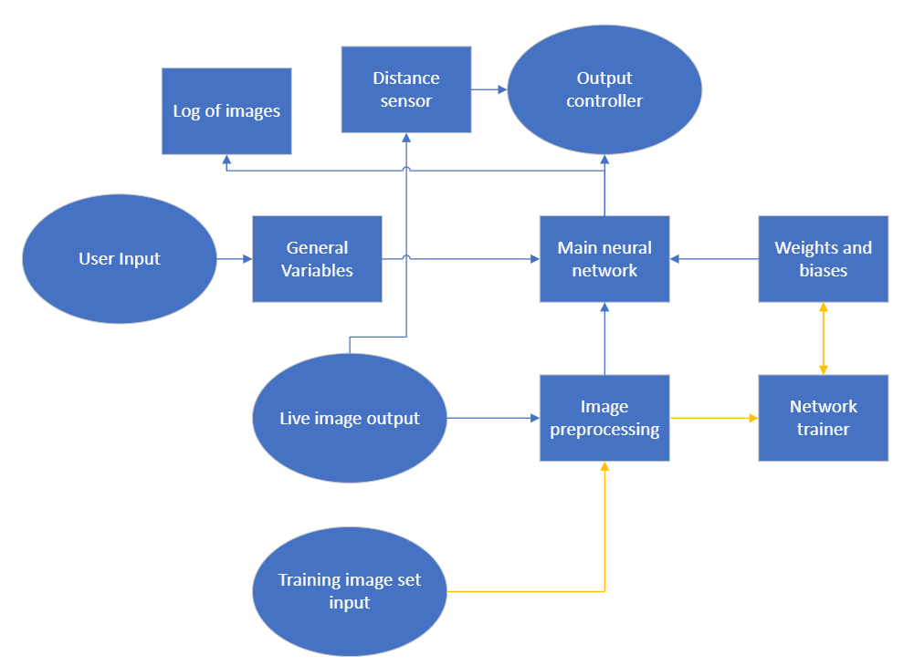

The live image output will take an image of the surroundings, and this is fed into the image preprocessor. This is then parsed through the main neural network and into the output controller. While this happens, a distance measurement is taken, and these are fed into the output controller which will then give a voice output.

The training image will also use the image preprocessor but will then be fed into the network trainer to adjust the weights and biases accordingly. The main network will know which set of weights and biases to use using the information from the General Variables. The orange arrows represent the training process, and the blue arrows represent the process when it is run. The arrow from weights and biases is only in one direction. This is essential to protect the integrity of the weights and biases. If the network could potentially alter the original weights and biases while detecting images, this could cause significant problems such as causing the network to refuse to give a valid output. This is why the weights and biases will be kept safe from changing.

Now I will also include the subroutines and functions for each part of the program through using a flowchart structure. This design will then allow for me to develop the architecture of the neural network accordingly as well as how the different parts of the program connect to other parts of the program.

For the main program, to complete the full feedforward process, these are the functions applied.

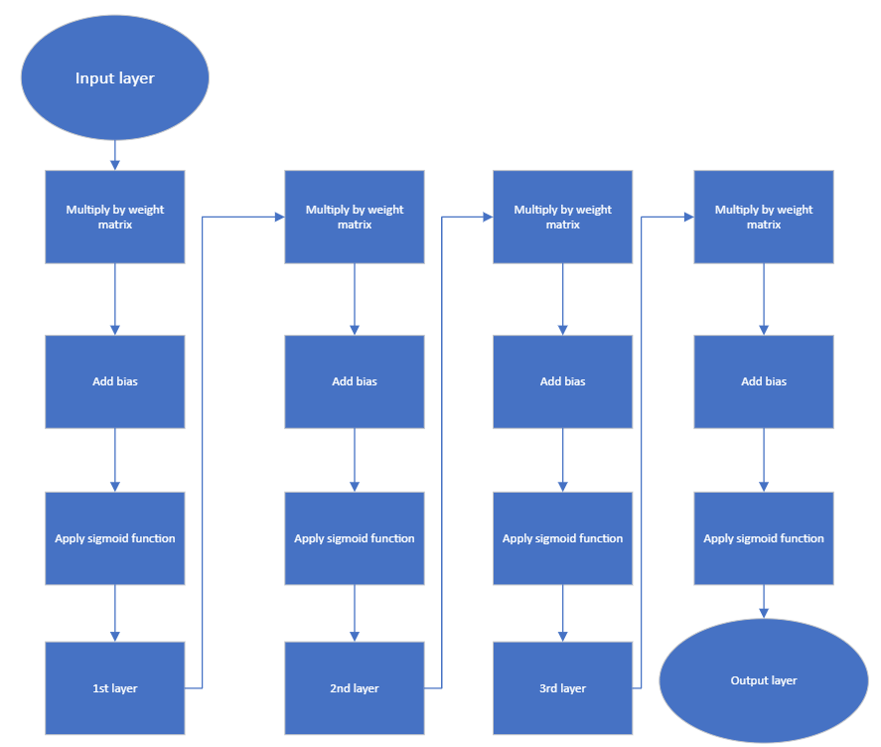

This is my list of functions to complete the feedforward part of the function. I will now be able to produce the main network structure. This is represented as feedforward as the program above. I can now represent main using this.

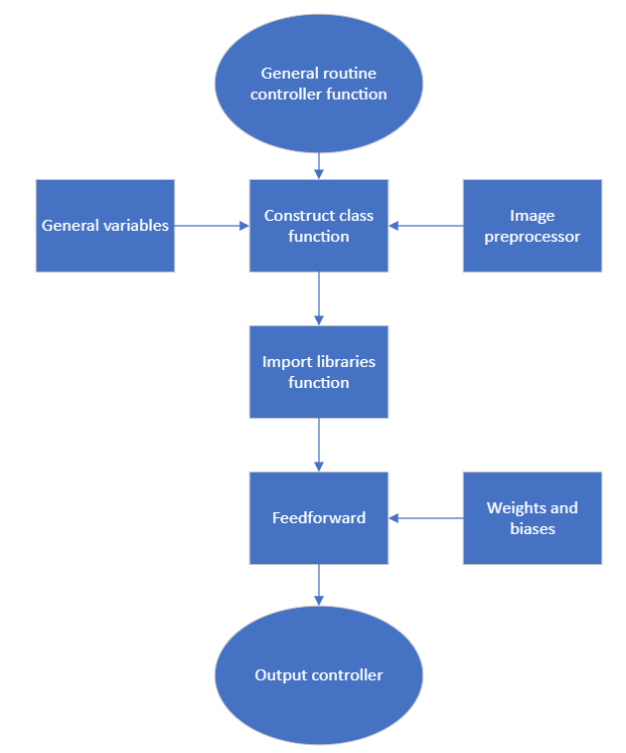

This is a visual representation of the basic functions to be run during the main neural network. The general variables.

I will use these to build the network of the main structure of the network by producing each function individually and then putting these together to build the network. I can now produce the main network design and then I will connect this to the output program.

This gives a good representation of which parts of the program can be put in parallel as well as which processes must be completed in series.

## Input methods

There are several input methods that are used. One of these inputs is through using a keyboard and mouse to edit a general variables file. This is processed by the main file which will use these to initialise or build the network ready for usage. The output is using a different auditory output.

Another input method that is used is turning the device on. The output is the auditory output.

The final input method is entering images to retrain the network. This can be done by the user by adding these to the file location using the user interface. This will be processed by preprocessing the image and then putting the image through the main neural network. The output is a different detection by the neural network.

## Validation

To ensure the program is safe from errors, a layer of validation will be used on the input methods. One example of a layer of validation to be used is on the general variables file. This will not be edited directly by the user since it will be stored as a private attribute by a class. This would only allow for the class itself to change these values. The user will interact with this class by giving inputs on how to change each value and the class will then validate each of these values by checking against a set of possible values that could be used for each value. The class will then use this to properly change the values in the general variables local variable structure. This layer of validation protects the program from being affected by the user from interfering with the values since these are private attributes. This also brings a layer of security since it cannot be tampered with because it can only be accessed by a class that loads these values and then stores them once the changes have been made. This layer of protection between the true values and what the user has access to prevents any mistakes from a user who is not entirely sure how to properly change the values. The program will attempt to approximate any desired changes and then ask the user if they would like to make these changes. For example, in the general variable files, there will be a specific line representing if they would like to change the pitch of the voice output. If the user accidentally changes this from “Y” to “n”, then this would not allow for the voice output class to be able to interpret this correctly so the class between the user input and the true values will be able to correct this to the correct formatting.

The retraining of the network can be done relatively safely since it will save the new model every pass through the program. This memory allocation could potentially increase wear on the disk however, since the writes only happen after a full pass-through, this should not be a significant problem. The user only needs to start the program and then it will automatically change the values accordingly and change the model set.

The validation of the webcam to function properly is done through the program by confirming that the webcam is there and its resolution to ensure compatibility with the program. This will prevent any critical errors that would prevent the device from working if a webcam is unplugged during operation and then plugged in.

## Key variables in data structures

|  |  |  |
| --- | --- | --- |
| **Name** | **Data type** | **How it’s used** |
| Weights | A 2-dimensional matrix of floats | Contains the matrix of values between layers. When the feedforward function is used, the weight matrices are used to move to the next layer. |
| Bias | 1-dimensional set of floats | The value added at each node. When the feedforward function reaches this layer, this is added to this value which allows for the output value to be calculated. |
| Input node | A 1-dimensional values of floats | The input values for the network. |
| Error | A list of floats | Different between the expected output and the true output. This allows for the network to be able to know which outputs to change. |
| Cost | A list of floats | The sum of the difference between the outputs squared. This gives the network a general idea of how well it is performing and therefore how to adjust its values to improve. |
| Learning rate | Floats | Adjusts the size of weights and bias adjustments |
| Adjustment weight | A 2-dimensional matrix of floats | Adjusts the weight by this certain amount |
| Adjustment bias | 1-dimensional set of floats | Adjusts the bias by this certain amount |
| ML functions | Class | Combined class of functions containing these key variables. |

## Auditory outputs

An auditory output will be used with the program. The process used for the auditory output is through using a class that takes in the distance information and the object type. It will then interact with the speaker through a driver by sending commands on what to output by using a voice library. The output will be a voice giving information about its surroundings.

## Testing process

There are several different forms of testing. These are White box testing, Black box testing, Alpha testing and Beta testing.

I will use all of these methods to test my program to ensure its stability and effectiveness in the different cases.

I have broken the problem down into simpler functions that can be independently tested using the Agile method. The agile method is a form of development methodology where the function is developed in cycles. The program can be tested by using different values for the inputs of the function and testing to see if the predetermined outputs are as expected. This will allow for me to test if it works properly. I will use modular code so after testing each part, it can be independently tested for its functionality. This will make sure that the code’s problems can be isolated. This simplifies the testing process since each part of the program is modular and therefore errors are less likely to appear since all the functions will be correct.

I will also be able to check the input from the general variables using a form of black box testing as well as a form of white box testing through both myself and my stakeholders to try this and see if the program works as intended. When the program is complete, white box testing will be used to ensure that all of the potential permutations of the user’s choices function as expected. If the result is not as expected, then the functions can be tested using the modular design and which part the error occurs. A final test will be used over the entire program after each module is produced and then the entire program will be tested with all 4 testing methods to ensure stability. Any repairs in the final stages will not require a full redesign since a spiral methodology is used to develop the project so after the final prototype is built, any errors can be repaired so the program is functional again. The iterative development process is essential for the program since it allows for constant prototyping which allows for any errors to be spotted quickly. The program can also be copied and error tested to confirm that the program has good error detection. This is where incorrect data is input and tested to see if the program can react to these. The program will also have random interrupts to see if the program can still function even if random interrupts occur such as during the training process and whether the program can continue training even if turned off during the training process. I will record the results in a test table.

The use of an iterative development process is essential since it allows for this modular design and prototyping to ensure that the program works without having to redesign and reprogram the device when errors are found such as with a waterfall methodology. I will show the testing methods to ensure that the program will perform as expected. The code can be repaired if any errors occur through using these testing methods. Any maintenance of the code can be performed at the end as well to ensure that the program is optimised so updates may be released on the program to ensure performance is stable.

## Testing checklist

|  |  |
| --- | --- |
| Actions to test | Functionality/10 |
| Main network class |  |
| Training Class |  |
| Auditory output class |  |
| Change frequency output |  |
| Change object set output |  |
| Change colour information |  |
| Change input training files |  |
| Change the time between identification |  |

These are the generalised parts of the program that I will test for functionality if all parts are fully functional, then the program will be complete. I will update this for a different score from a scale of 1 to 10 for the completeness of this.

## Test tables

Some parts of the program can be tested using test tables.

The first part I will test will be the default object identification using the different objects.

|  |  |  |  |  |  |
| --- | --- | --- | --- | --- | --- |
| Object type | Attempt 1 | Attempt 2 | Attempt 3 | Attempt 4 | Accuracy |
| Object 1 |  |  |  |  |  |
| Object 2 |  |  |  |  |  |
| Object 3 |  |  |  |  |  |
| Object 4 |  |  |  |  |  |
| Object 5 |  |  |  |  |  |

These objects could be, for example, glasses or a water bottle. I will show the network 4 new images for each and see if it can accurately tell if the images are that type. I will record the confidence of the network from 1 to 10 if the network is incorrect. If it has a high confidence in a wrong image, then this would suggest the network is underperforming. I can then calculate the accuracy for all of the images and create a generalised value on the accuracy of the entire network. I will calculate the accuracy from an incorrect reading by subtracting 10 from its confidence and averaging these confidence values for the incorrect values where correct values give an automatic confidence of 10 since it is correct. For example, if the network is certain a pair of glasses is a car, for example, then this will affect its accuracy more than if it is unsure since if it can classify this object wrong once with confidence, it is likely it will classify this object wrong multiple times.

I will also test the input types such as different ways to interact with the options to choose for the network for both valid and invalid inputs. This table is for perfect outputs.

|  |  |  |
| --- | --- | --- |
| Action | Expected output | Output |
| Object description | During object detection, object description is given |  |
| Different pitch mode | During object detection, each object has a different pitch |  |
| Colour information | During running the program, colour information about the surroundings is given |  |
| Log | The log either runs or does not run |  |
| Time between identification | Changes the time between object identifications |  |

This table is for similar actions that are incorrect, and the problems should be able to correctly identify these and replace the user’s answers with the correct answer

|  |  |  |
| --- | --- | --- |
| Action | Expected output | Output |
| Object description | Did you mean “yes”? |  |
| Different pitch mode | Did you mean “yes”? |  |
| Colour information | Did you mean “yes”? |  |
| Log | Did you mean “yes”? |  |

This table is for inputs that should not be considered and prompt the user to try again.

|  |  |  |
| --- | --- | --- |
| Action | Expected output | Output |
| Object description | Invalid input please try again |  |
| Different pitch mode | Invalid input please try again |  |
| Colour information | Invalid input please try again |  |
| Log | Invalid input please try again |  |
| Time between identification | Invalid input please try again |  |

# Development

## Coding modular algorithms

Using the modular structure of the program, I will code some of the modular functions within this program as well as explain the meaning of the code. This will allow me to produce prototypes for the neural network. Here are the first few modular functions.

### Load functions

I will now code the modular functions to load the libraries and the different files. The first program I will modularly code will import the libraries.

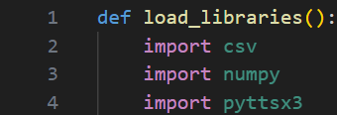

### Sigmoid based functions

One function to be coded into a neural network is the sigmoid function. The sigmoid function is defined as: $\frac{1}{1+e^{-x}}$ . This is an example of an activation function which is applied to the output for each neuron except the input neuron. Another activation function I may implement later during the development process due to its performance is the ReLU or rectified linear unit. This is defined as x for all values greater than 0 and 0 for all values less than 0. Below is an example of ReLU and sigmoid within a class structure.

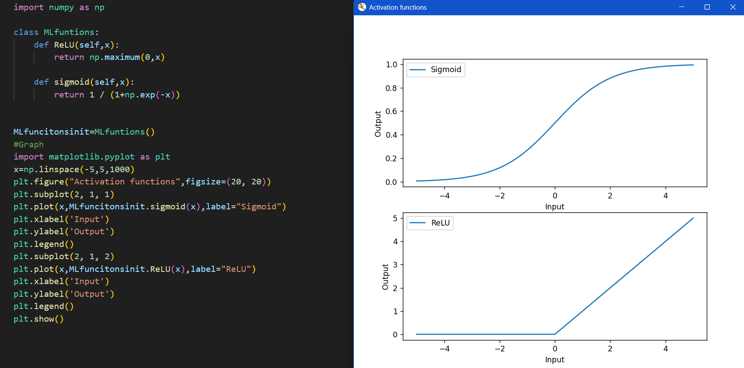

These functions are used for the feedforward aspect of the network. However, in order to backpropagate through the network, the differential of the functions is required.

Here are the differential of these functions coded within the class structure. I have also graphed these on the main graph. This is how I ***tested*** these functions to ensure they look as should be expected.

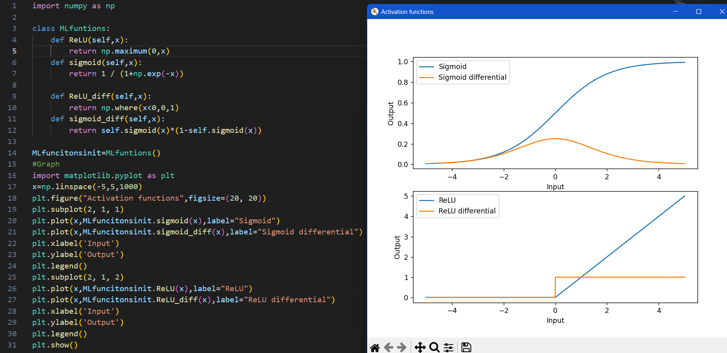

### Cost function

The cost function will give the performance of the neural network depending on how close the activations are to what they should be. I found this by subtracting each activation from their expected activation and squaring this. this is then summed for all the values and divided by the total number of activations being measured. The cost can be coded as below for a specific example with 2 outputs.

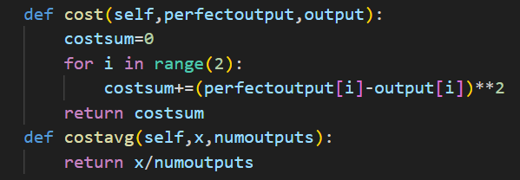

The model aims to reduce this cost. For this example, the theoretical highest cost is 5 where all the activations are on except the value that should be on (which is impossible) and the theoretical lowest cost is 0 which is a perfect activation (which is also impossible in most cases). To find the average cost function which can be tracked by the user, this is divided by the number of outputs. This normalises the cost function to be comparable for all networks.

### Feedforward function

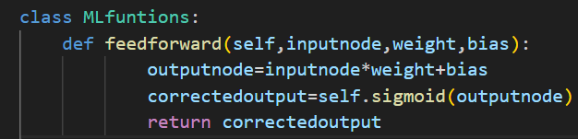

This function multiplies by the weight and adds the bias. The sigmoid function is then applied to this.

## Logic-based simple prototype

### Structure and design

Using the functions and framework above, I will build a prototype version of this with 1 input neuron and 1 output neuron and then expand this to the entire network. Such a small “network” cannot do any real logic so I would like the input of a 0 to go to 1 and an input of 1 to go to an output of 0. This is arbitrarily easy to do with a normal algorithm and creating a simpler prototype of a neural network will help to build the final, much larger network.

I will start with 1 weight and 1 bias. This will be set randomly. A dataset is then made with all ones having a perfect output value of 0 and all zeroes having a perfect output value of 1. I will also put all of the functions from the previous function and edit them for this simple, artificial dataset. I will feedforward through this and then backpropagate to train it. This will be done in 8000 epochs with 2 values each time (one for the 0 to 1, one for the 1 to zero). An epoch represents running through all training data however, since the size of this data is 2, I can set the epoch number to such a large number. In real training situations, having 8000 epochs is rare. This is a visual of this simple model. The $σ$ represents applying the sigmoid function, which was previously defined as $\frac{1}{1+e^{-x}}$.

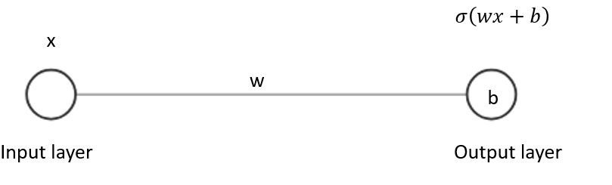

Each node can be thought to have a bias (except the input node) and each line represents a weight. To feedforward, each input activation is multiplied by its weight from the line it comes from and then a bias is added to this result. This is done for each line connecting to that specific node and then the activation is applied. After this, the result is compared to what the result should be, and the cost function is applied. This is then averaged over all of the datasets. The network will try to reduce this value by finding the cost gradient. With 1 weight and 1 bias, it will not be very difficult to plot this on a graph and show the minimum that gives the lowest cost but in all other networks, there are usually many more variables, so it is not possible to do this. Even this example cannot be represented on a simple graph for all different weights and graphs because normally graphs only change 1 variable and this requires changing 2 variables, therefore requiring a 3-dimensional representation.

### Code solution and mathematical explanation

Here is the basic code without the backpropagation algorithm containing the dataset and the random weight and bias. The dataset includes the values that give the wanted output. I have set the weights in a way that gives a relatively low cost however, when training this, I will randomly set the weight and bias like how it will be for my larger network.

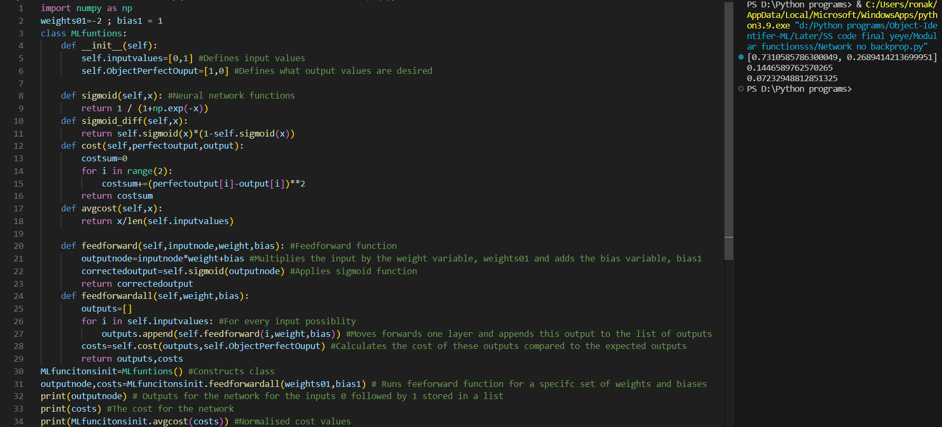

To initialise the dataset, since there are only 2 inputs that will be used and 2 outputs, the total dataset is of 2 values. The input values are stored in input values and the wanted output values are stored in ObjectPerfectOutput.

This creates the framework of the model and allows you to test the untrained model for a given weight and bias.

An instance of the class is created and the functions are run using a class because this makes it simpler to change the weight and bias without having to call them as global variables at the start of every function or require to return these values and then storing the outputs as the variable names which is unnecessarily complicated.

After creating the framework, I then needed to train this model using backpropagation. To do this, an error is created which is the difference between the original output and the perfect output. This value represents the gradient of the cost function which is defined as ½(original output - perfect output)2. The training process is designed to decrease the cost value. To do this, if you can find the gradient of the function, you will know which direction to change that variable to decrease the cost. To decrease the cost in the most optimal way for a given variable, the adjustment should be proportional to the gradient. If, for example, the change in cost for changing a specific variable is only 0.0001, then for that example, this specific variable is already optimised or is not important. If it was larger such as changing that variable changed the cost by 0.01 for example, then this is significantly more impactful so should be changed in proportion to this. The quantity of the change of the cost for a given change of a variable is the gradient. Therefore, if this gradient of the cost function can be found, then calculating the correct way to change the weights and biases can be found to minimise this cost function.

If the gradient is positive, this means decreasing the variable will cause the cost function to decrease. This gives a relationship where the change of the variable should be proportional to the negative gradient to decrease the cost most efficiently. You then multiply by the differential of the sigmoid function after inversing it to give the effect of the value. Logically, this is because if the output before the sigmoid function is close to 0, then the gradient is significant so changing the weight will change the output more than if the output is already -5 or 5.

Multiplying these produces a set of adjustments that depend upon the output. However, the adjustments should also be dependent on the input. For example, if the input was 0 then changing its weight will make no difference for a specific data example so you multiply this adjustment by the input of the previous function to get an adjustment that is proportional to the most optimal change. You then multiply by the learning rate.

## Backpropagation function

The backpropagation function is the function to train the neural network. To produce this, I will first have to take an input from the output of the network. From this output, I can then compare this to the expected output using the loss function of subtracting one from the other. After this error has been produced, I will then inverse the sigmoid function from the output, reducing the output by 1 step. I will then apply the sigmoid differential since if this output is very positive or very negative, then any adjustments will not cause a significant reduction of the costs. For example, if I have an output of 5 before the sigmoid function is applied, will give a final output of $\frac{1}{1+e^{-5}}$ which is 0.9933. If I choose to change this output by 0.1, the new output will be 0.9926. This causes a very insignificant change in output and therefore if this output is very large or small, then any changes will be less significant. This is adjusted using the sigmoid differential.

I then multiply the differential of the output after inversing the sigmoid function by the error since the error represents how far the output is from the expected output, therefore allowing the network to understand how to adjust these weights. This produces the general adjustment which will be multiplied by several values before being applied to the weights and biases.

When calculating how to change the weight, the general adjustment is multiplied by the input values since, for example, if the input was 0, then changing the weight will make no difference for that specific example. This produces a partial differential of the cost function, representing how a small change in the weight will affect the cost. However, since the differential is an approximation of how to change the cost (since the differential only approximately looks like the true cost function for small values), this is multiplied by the learning rate. This ensures that the cost differential accurately represents the changes to the weights that cause a cost reduction.

To calculate the change in bias, the input values are not relevant since it is additive. A +1 will have the same effect on the output of 0 as for the output of 1. The effect of applying the sigmoid function is compensated for by applying the differential of the cost function.

In conclusion, 2 algorithms are produced to understand how to change the weights and biases correctly to optimize the network. Firstly, a general adjustment is produced using the output with a function applied to this and the error. An adjustment for a specific weight is then produced by multiplying the input value followed by the learning rate. An adjustment for a specific bias is produced by multiplying the learning rate only since the effect addition is not affected by the input.

Addition is not affected by the input in the same way as multiplication is which I will describe simply using an example below.

0*1=0

2*0.1=0.2

0+1=1

2+1=3

For multiplication, if the input is 0, then changing the second value is pointless since it is dependent on the first value while for addition, the final effect of adding 1 is the same for both examples and is therefore independent of the first value, not requiring to be multiplied by the input value.

I have now coded this algorithm into the simple neural network, and I have applied this many times using 8000 epochs, meaning that the training algorithm has run through the input values 8000 times, therefore producing 8000 different adjustments.

I ***tested*** the algorithm by programming this and then running this. Since the cost is reduced, the algorithm works as expected.

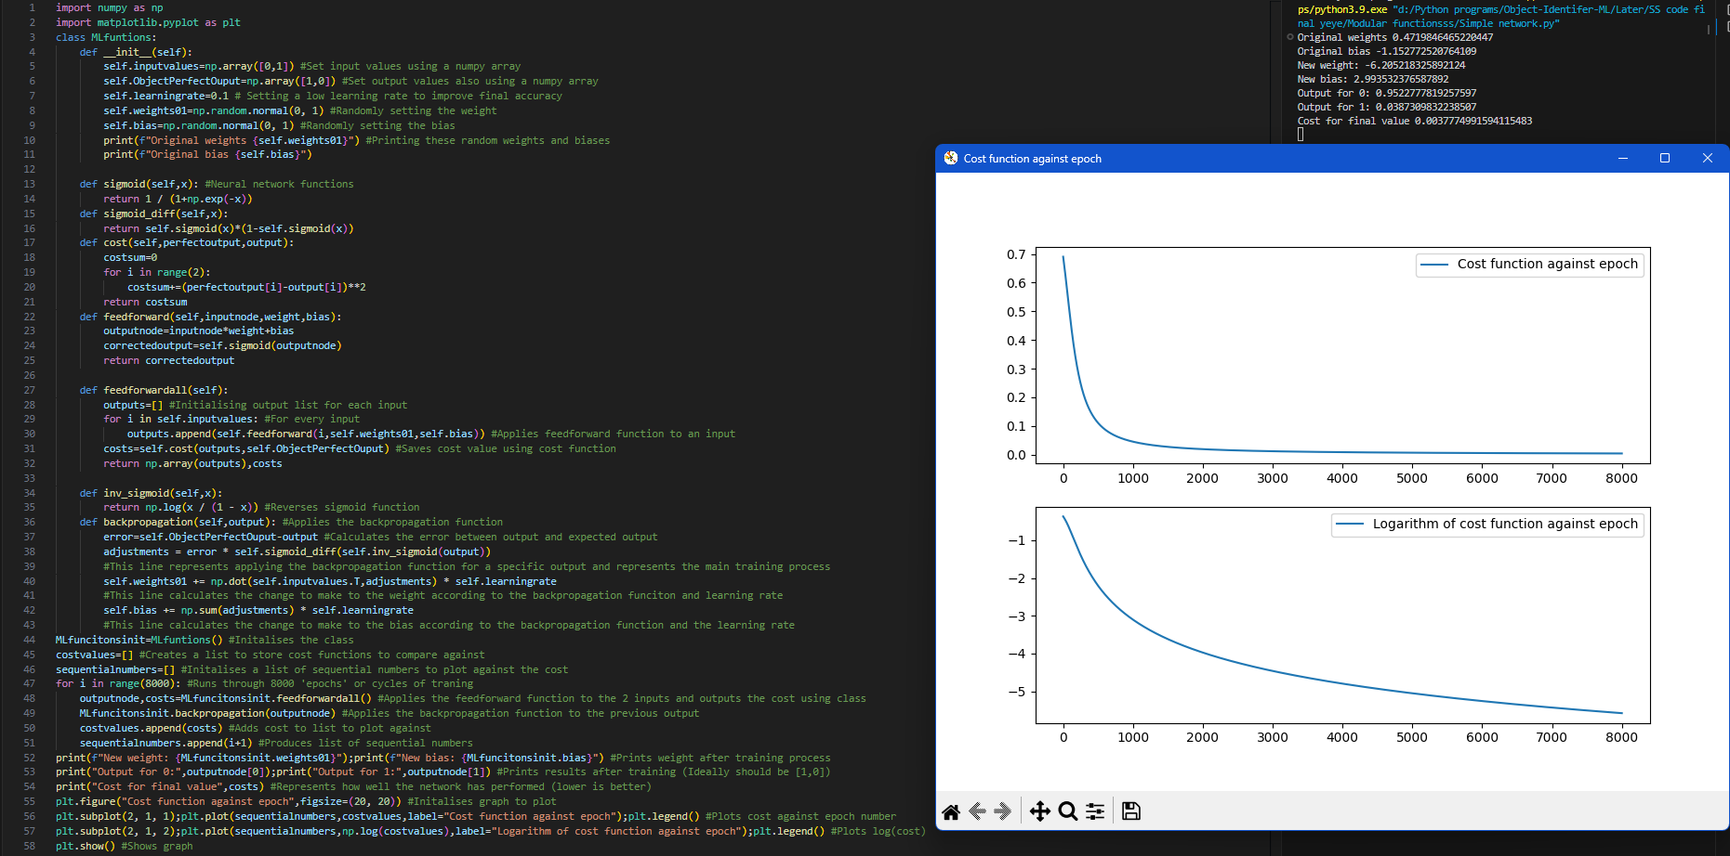

The most important new part of this algorithm is that the weights and biases are originally randomly and at the end of the training process, the correct outputs are produced. I wanted this algorithm to turn a 0 to 1 and a 1 to 0 and as can be seen for the output for 0 of 0.952 and an output of 1 of 0.0387, the network has successfully learnt this. The first program produced the architecture of the neural network, and this program successfully trained this program. The most important, new part of the program is the backpropagation function which I have highlighted below.

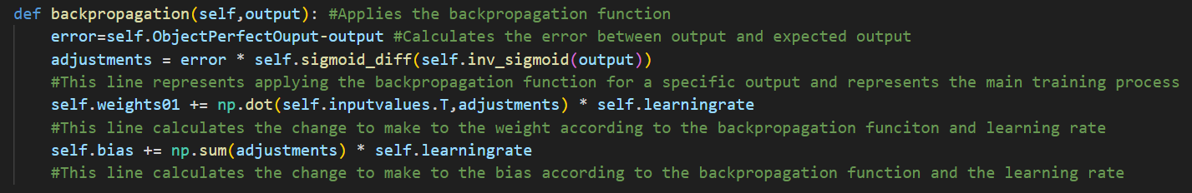

For this algorithm, I have applied the algorithm as I have talked about above. I first calculated the error and then multiplied this by the differential of the output after inversing the sigmoid function on this. I then adjusted the weight by multiplying the input values by the adjustments. I have used a NumPy array to improve the modular design of the code to allow me to use this type of structure for the later prototypes of the program.

I have also plotted the cost against the epoch cycle. This shows how the cost reduces over time. In the beginning, there is a significant cost reduction followed by smaller and smaller reductions in cost. This is due to multiplying by the error. A lower loss will cause a lower adjustment, therefore causing less impact on the cost. As can be seen from the logarithmic graph, the cost continues to decrease even when this decrease is beyond being visible from the cost against the epoch cycle graph.

### Learning rate

The learning function is to give a value for the proportionality constant between the gradient and the change to make to a specific variable. Making this bigger will mean that a larger “step” is taken towards the minimum however, since the gradient only locally represents which way to move to decrease a function since curves can be represented to be “locally flat”, when increasing this learning rate, the approximation of the cost decrease will be less accurate because the gradient will be a worse representation of which way to move.

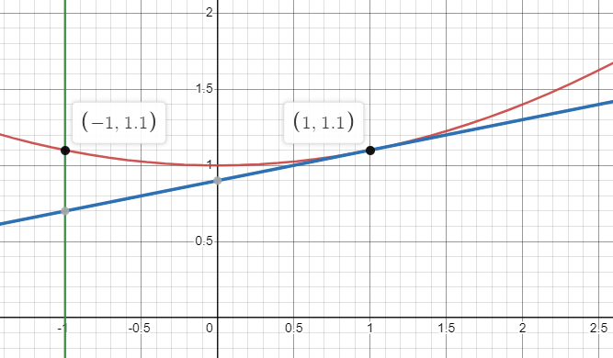This can be seen in the graph on the left here. If the learning rate for this example was 20, for example, then the graph misses the minimum and goes to the other side of the graph (The red line represents the cost function, the blue line represents the gradient of the cost function at x=1, the green line intersecting the red line represents the point to where the cost would move to if a learning rate of 20 is taken). This represents how the learning rate has to be small to reach the minimum and this will be very important for the final model. Increasing the learning rate will improve the speed of learning but after enough epochs, this increased learning rate will cause a greater final cost.

On the left of the code, the rate of improvement can be seen. The program quickly improves the cost value for the first 2000 epochs and then improves much slower (but still improving as seen in the log graph). The reason why the improvement slows down dramatically is because it is effectively impossible for the value to be fully reached since the steps are proportional to the gradient and this reaches 0 at the minimum.

The weight was -6.02 and the bias was 2.99 at the end of the learning which causes a very low cost. Of course, a weight of -1000 and a bias of 500 will give a lower cost and this will be reached in enough time. Unfortunately for this specific example, there is no local minimum and decreasing the weight like this will make this more accurate. This means that for this example, the larger the learning rate, the better since it moves closer to a large negative number for the weight and a large positive number for the bias. This means finding a suitable learning rate from this model for the final model is not possible.

## Logic-based simple prototype with hidden layers

### Structure and design

This code gives a good proof of concept of the model and gives me information that the structure works however moving to the final model will not be a good idea because if it doesn’t work, then figuring out the mistakes will be next to impossible. This is why I believe doing another secondary prototype with a trivial problem will be useful.

This simple, NOT gate network does not include any hidden layers and only 1 weight. For this second example, I will include a hidden layer with 2 nodes and 2 outputs (although only 1 is needed for this).

For this second example, I will be coding an XOR for the first output neuron and an XNOR for the second output. This is the logic I would like to use for this example. This second neuron does not provide any new information but will help me understand how to build a network with 2 output neurons and how to implement hidden neurons.

|  |  |
| --- | --- |
| Input | Output |
| 0,0 | 1,0 |
| 1,1 | 1,0 |
| 0,1 | 0,1 |
| 1,0 | 0,1 |

The structure of this network will be slightly more complex however if I can complete this successfully, increasing this to the full model will only require changing the number of neurons and the number of layers which will not be significantly difficult for building the architecture.

Each letter represents a variable however to build this, I will need to change this into representing vectors and matrices for this abstract model. When actually coding this, I will be using lists and NumPy arrays however understanding this in an abstract model and having a framework from the previous model will help me build this.

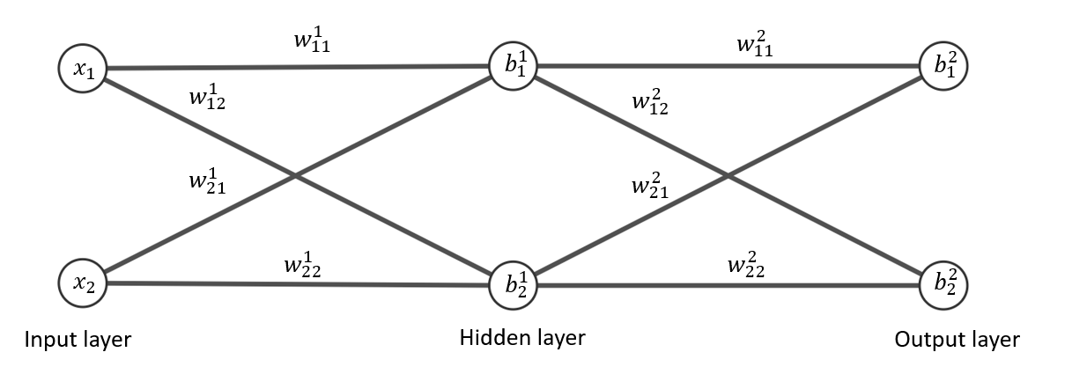

### Mathematical abstracted model

I will start with the input layer of x1 and x2. You then move through to the next layer by multiplying by the weights for each line. For example, the weight $w_{12}^{1}$ starts from the first neuron in the first layer and to the second neuron in the second layer.

For the feedforward step, will need to be able to from the inputs x1 and x2 to the values of y1 and y2. To do this, I need to be able to multiply by the weights correctly and then add the biases. A way to achieve this is by using a weight matrix and a bias vector. The inputs are multiplied by the weight matrix and the resulting vector is added to the bias vector. The sigmoid is then applied to this vector by applying it to each value individually.

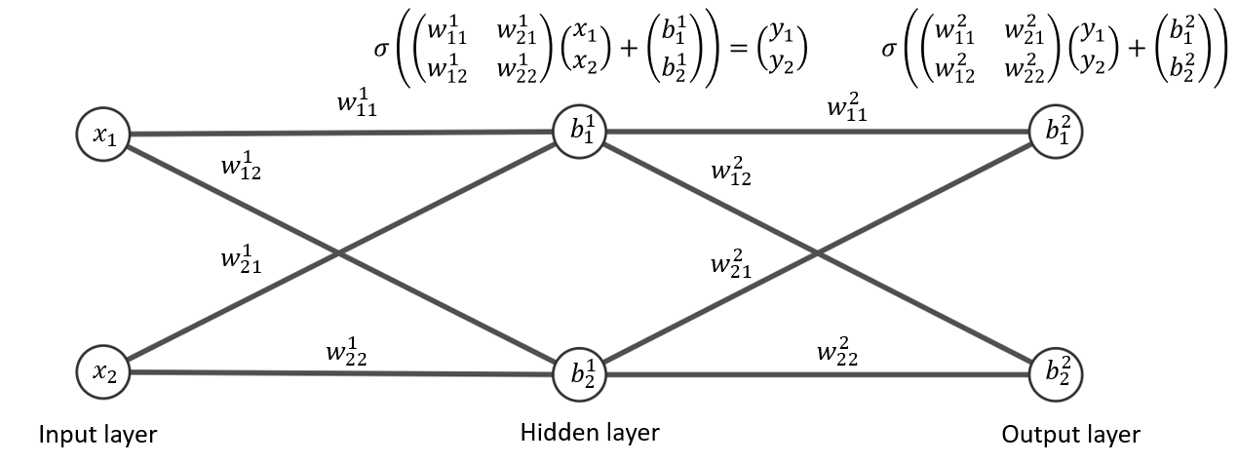

When expanding these terms for each output neuron, the correct values are found so by applying a weight matrix to the input layer, adding the biases and applying the sigmoid function, the correct values are found for the next layer. This is then repeated for the next layer. 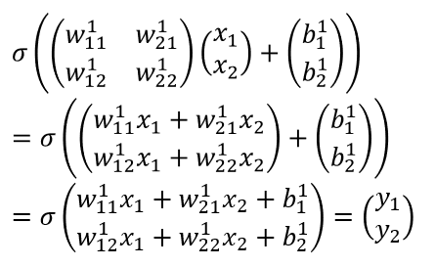

### Coded framework: Feedforward

Using these mathematical concepts using matrices, I can now represent this in a more codable form. The inputs are taken as a list. The weights are then stored as a NumPy 2-dimensional array. The biases are also stored as a NumPy 1-dimensional array. I then multiply the NumPy array by the input using a NumPy matrix multiplication function due to its low-level optimisation for this type of operation and then I will add the bias to the resulting vector. I then apply my sigmoid function to this output. Using the original framework, I can keep the original functions and the general class structure.

Here is the basic code without the backpropagation algorithm containing the dataset and the random weight and bias. I have randomly set the weights and biases. I will then code the backpropagation again after building the network’s architecture.

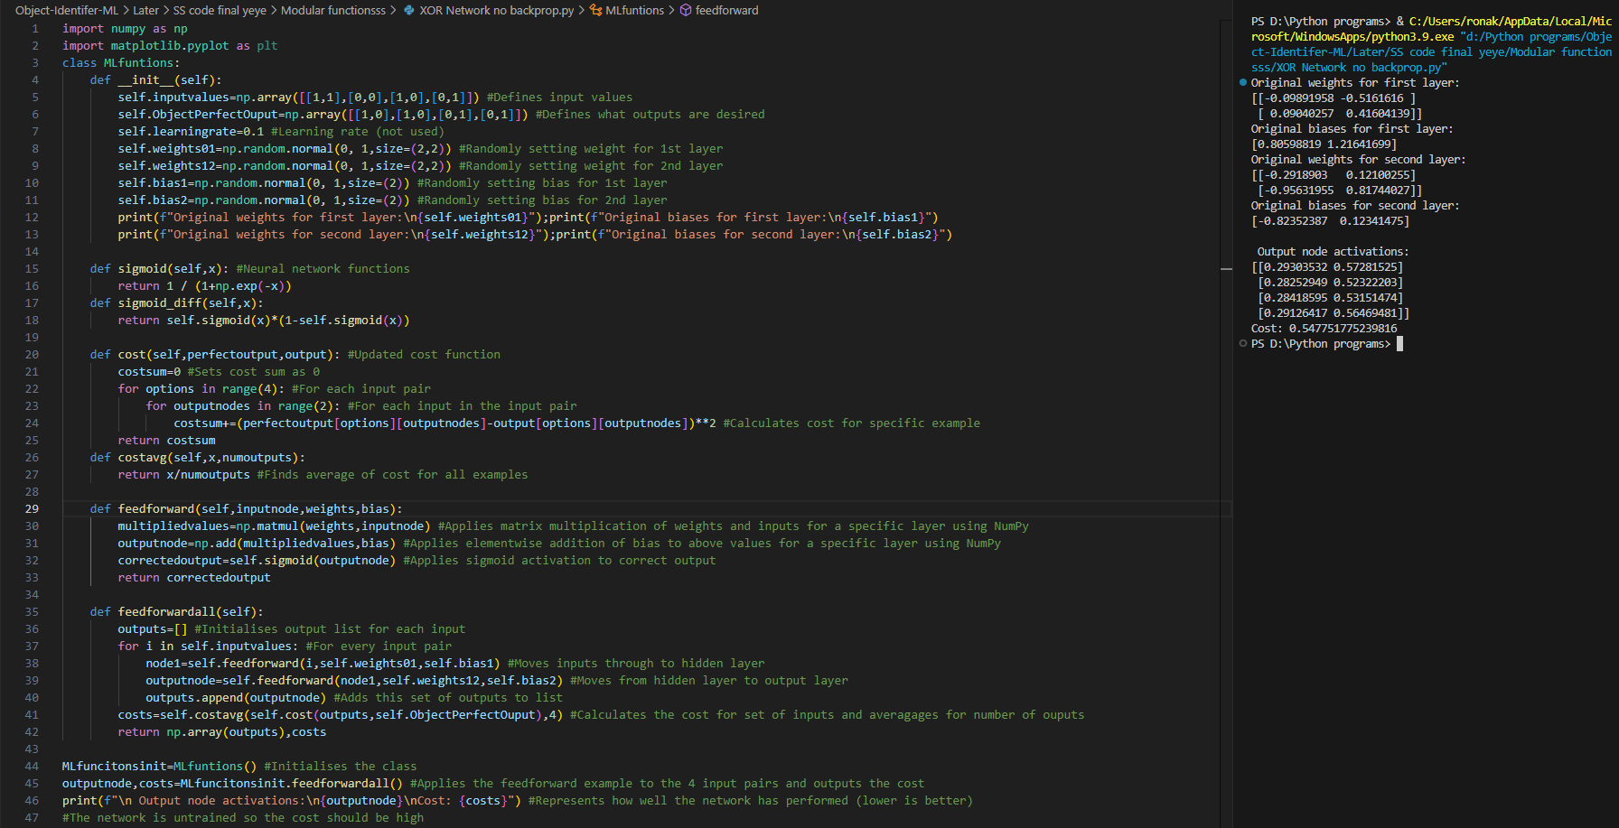

The main change between this and the original simpler model is that there are 2 nodes for input and output, so the input values and the perfect outputs use a 2-dimensional list. The weights are also now identified as 2 by 2 matrices. To get to the next layer, I used a NumPy function for matrix multiplication to get to the next layer.

I then tested this by running the set of input values and seeing the result for each input set.

Due to this increased complexity, I had to modify some of the network’s functions to allow for this. The first function I modified was the cost function. This now uses a nested for loop to calculate the cost for each example separately and then sum these together by using a counter called cost sum. I also included a cost average function to normalise these cost values so I could compare against other networks.

I also changed the feedforward function to include matrix multiplication as described with the mathematically abstract model. I achieved this using NumPy which efficiently completes matrix multiplication using the fast matrix multiplication algorithm. I then used NumPy to complete the elementwise addition of the bias to the result from the multiplication of the input with the weight matrix. This effectively allowed me to add 2 vectors together using the NumPy array data structure. I then applied the sigmoid function to this as used within the simple network. For my sigmoid function, I used NumPy to complete the natural exponential function since this allows for several inputs to be calculated in parallel. This means an output from the network with multiple values can be taken as an input and calculated together without requiring to unpack this into singular values to apply this function. This improves speed since these operations can take place in parallel.

The final function that I changed was the feedforward all function since this network has 3 layers (input-hidden-output) instead of 2 from the simple network (input-output). To achieve this, I took the input and after applying the feedforward function, I stored this as a variable called node1. This was then taken into a second feedforward function where this node1 was taken as a variable. The cost was also found within this function however, the cost was also averaged using the modular function, cost average.

### Backpropagation mathematical abstraction

#### Adjustments in output layer for simplified model

The next step is to code the backpropagation algorithm. This will require a greater level of complexity and the mathematical framework from before will be used. The algorithm will attempt to reduce the cost function by backpropagation and in order to do this, you will need to find its derivative as discussed in the original prototype. To do this, the output of the network is compared to the perfect output and the weights are adjusted to the following variables.

* Error of output

The changes in the weights should be proportional to how incorrect the weights are for that example. If, for example, a specific output neuron’s activation is the same as it should be, the change to the weights connected to that neuron should not change.

* Previous activation

If the previous activation for a specific weight is close to 0 for example, then changing its weight will not change much since a near 0 activation will mean multiplying by a weight will not affect the output neuron significantly.

* The differential of the sigmoid function applied to the output before the sigmoid function is applied.

This is to tell how much difference changing the weights gives. As explained in the previous prototype, if the output before the sigmoid function is applied is already very large and positive (100) or very large and negative (-100), then once the sigmoid function is applied, these values will be very close to 0 or 1. Even if the weights change, the effects on the value before the sigmoid function will not affect the output after the sigmoid function in any noticeable way so changing them is effectively pointless. This can be seen within the derivative of the sigmoid function where it is close to 0 for large and negative and large and positive values, which suggests that changing the weights is effectively pointless.

This is why the weight changes should be proportional to the derivative of the output before the sigmoid function is applied: it gives a value on how much effect changing it will give to the output.

* Learning rate

This is to keep the approximation of the gradient as the function accurate. This will matter significantly for more complex models

The changes for a weight are indirectly affected by the bias of the neuron and the effect it has on the neuron through finding the error and the differential of the output before the sigmoid before it is applied.

Most of these values are known or can be known relatively easily. The previous output is stored as a variable in the program so this is known. The previous activation is also known and stored in the program so this is not a problem either. The learning rate is also set in the program and finding the error for the output layer is simple. However, when backpropagating, this error needs to be found for the n-1th layer from the nth layer. This requires some computation to find. This can be abstracted into a very simple model again with a model with 1 input neuron, 1 hidden neuron and 1 output neuron. This model is quite simple and does not contain all of the concepts of backpropagation but adds more information that will help for the next abstract model. Here is a diagram of the simple 1 hidden neuron model below with backpropagation of the weight and bias between the hidden layer and the output layer.

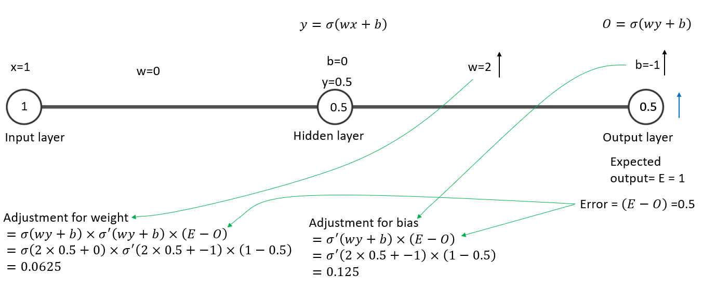

This contains arbitrary weights and biases with an input of 1. Let’s say, for example, we want the output to be 1 for an input of 1. This means that we want the output to be larger. This is represented by the error being positive. Combining this with the previous activation, a learning rate of 1 and the differential of the sigmoid function of 0.25, you get an adjustment for the second weight of 0.5*0.5*1*0.25= 0.0625. This is how much the network “wants” to increase the second weight by 0.0625 for these values. To change the bias to a value that is wanted, you the same calculation except without the previous activation (because the bias is not dependent on the previous activation). However, the network will also want to change the value of the first weight and to find this, an error is required. To find this error, you move backwards through the network.

#### Error in the hidden layer for a simplified model

We also want the hidden layer value to be larger. So to do this, we make the error proportional to

* The error from the top error

This is because we want the error to be propagated backwards through the network and therefore it should be proportional to the error from the top layer

* It should also be proportional to the weight

This is because the weight of the previous layer is how much influence the neuron has on the network and therefore the error added from this connection should be proportional.

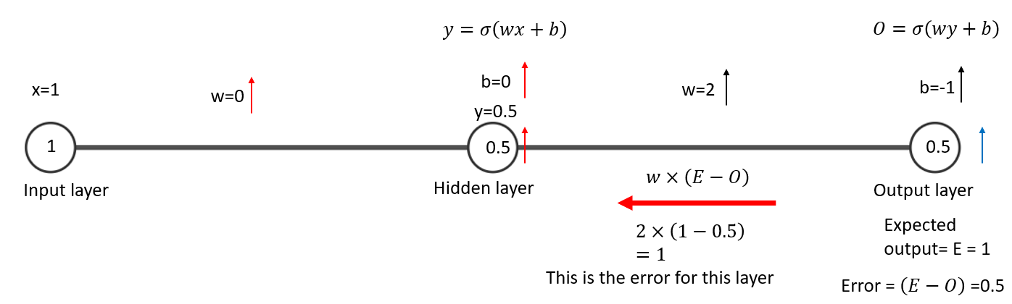

This allows you to find the error for the layer down and then the adjustments can be found using the same variables as for the first layer. Now the errors can be found for this network, the error can be attempted to be found for the XOR XNOR network. To calculate the error for the XOR XNOR model, I will not use numbers, just algebraic concepts.

#### Error in the hidden layer for XOR XNOR model

The error for the next layer down will also be proportional to the same value as for the previous model however finding the error for the next layer down is slightly more difficult.

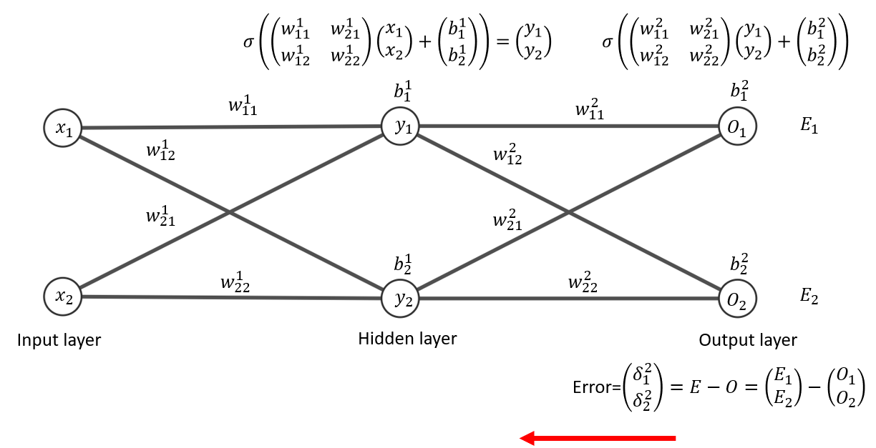

The error squared is defined by E – O where E and O are both vector quantities and the 2 represents this being in the second layer. Now, I will use the mathematics from the previous model to find the error for the next layer down.

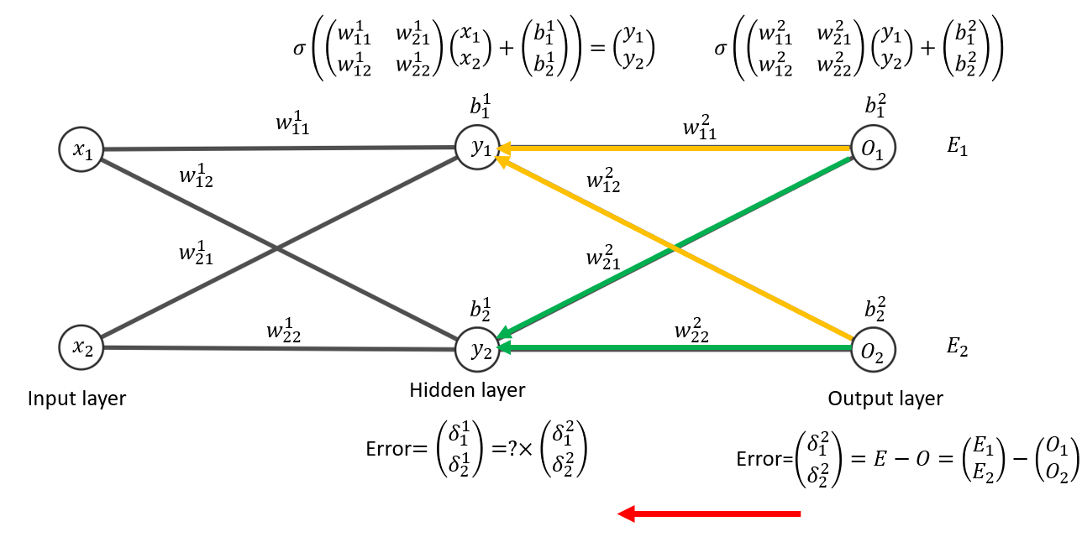

To find the error, you multiply by the error in the layer above and the weights connecting the 2 layers to each other which is represented as the question mark above.

The green and orange arrows represent how the error “travels” to the next layer down where green represents the bottom neuron on the hidden layer and orange represents the top neuron in this layer.

Let’s consider finding a value that is proportional to the error for $y_{1}$ by finding how the error of the previous function affects this one.

We start with the error coming from the top neuron from the output layer. This gives us $δ_{1}^{2}×w_{11}^{2}$. Then, consider the error coming from the bottom neuron from the output layer. This gives us $δ_{2}^{2}×w_{12}^{2}$. Adding these together, you get $δ_{1}^{2}w_{11}^{2}+δ_{2}^{2}w_{12}^{2}$.

Doing the same logic to find the error for $y_{2}$ is proportional to $δ_{1}^{2}w_{21}^{2}+δ_{2}^{2}w_{22}^{2}$.

This means that the error in the hidden layer is equal to these values. These outputs are very similar to a matrix output so finding the matrix to multiply by to find the error value in this layer allows for this to be coded.

Error = $\left(\begin{aligned}δ_{1}^{1} \\ δ_{2}^{1}\end{aligned}\right)= ? ×\left(\begin{aligned}δ_{1}^{2} \\ δ_{2}^{2}\end{aligned}\right)=\left(\begin{aligned}δ_{1}^{2}w_{11}^{2}+δ_{2}^{2}w_{12}^{2} \\ δ_{1}^{2}w_{21}^{2}+δ_{2}^{2}w_{22}^{2}\end{aligned}\right)$

Error = $\left(\begin{aligned}δ_{1}^{1} \\ δ_{2}^{1}\end{aligned}\right)=\left(\begin{matrix}w_{11}^{2} & w_{12}^{2} \\ w_{21}^{2} & w_{22}^{2}\end{matrix}\right)×\left(\begin{aligned}δ_{1}^{2} \\ δ_{2}^{2}\end{aligned}\right)$

This matrix in red is what to multiply the error in the layer above to find the error for the next layer down as described as a question mark in the diagram above. This matrix is the original weight matrix transposed. This means that the rows become columns and the columns become rows. This insight is essential for coding the backpropagation algorithm because it now allows me to find the error for the next layer down. Now the errors can be found, I calculate the adjustments for each of these weight values.

#### Adjustments in output layer for XOR XNOR model

As for the simplified, model, the adjustments are affected by

* Error of specific layer

This can be found using the logic above

* Previous activation

This is known

* The differential of the sigmoid function applied to the output before sigmoid function is applied.

This can be found relatively easily

* Learning rate

This is set by the program

To simplify notation, I will define a z value as the activation of a neuron before the activation is completed.

$σ\left(\left(\begin{matrix}w_{11}^{1} & w_{21}^{1} \\ w_{12}^{1} & w_{22}^{1}\end{matrix}\right)\left(\begin{aligned}x_{1} \\ x_{2}\end{aligned}\right)+\left(\begin{aligned}b_{1}^{1} \\ b_{2}^{1}\end{aligned}\right)\right)$ = $σ\left(z^{1}\right)$

$σ\left(\left(\begin{matrix}w_{11}^{2} & w_{21}^{2} \\ w_{12}^{2} & w_{22}^{2}\end{matrix}\right)\left(\begin{aligned}y_{1} \\ y_{2}\end{aligned}\right)+\left(\begin{aligned}b_{1}^{2} \\ b_{2}^{2}\end{aligned}\right)\right)$ = $σ\left(z^{2}\right)$

This z represents the values at the neurons in their respective layer before the sigmoid function is applied. This 2 represents the second layer. This is an image with all of the simplified notation which allows for the adjustments for the values between the hidden layer and the output layer to be written in a simpler form.

The adjustments for the output layer for the weights are $μ×σ\left(z^{1}\right)×δ^{2}×σ^{'}\left(z^{2}\right)$.

However, this is quite abstract and poses some issues such as dimensional consistency. $z^{1},δ^{2} and σ^{'}\left(z^{2}\right)$ all have a dimension of 2 by 1 and the learning factor is a constant however, the problem is that my implementation requires a weight matrix so the output has to correctly give the adjustments from this. Also, multiplying two 2 by 1 matrices together is not possible so a different function is required.

In order to multiply the two 2 by 1 matrices together, something called the Hadamard product. This is a form of element-wise product where each element in the matrix is multiplied by the same position of another element. This allows for 2 vectors to be multiplied together. This is shown by a dot with a circle for this example: $⊙$ However, this still produces a 2 by 1 matrix while the weight matrix is 2 by 2. This can be done by transposing the output of the hidden layer. This is then multiplied by the learning product.

$μ×\left(\begin{aligned}δ_{1}^{2} \\ δ_{2}^{2}\end{aligned}\right)⊙σ^{'}\left(\begin{aligned}z_{1}^{2} \\ z_{2}^{2}\end{aligned}\right)×σ\left({z_{1}^{1} z}_{2}^{1}\right)$

$μ$ represents the learning rate.

$\left(\begin{aligned}δ_{1}^{2} \\ δ_{2}^{2}\end{aligned}\right)$ Represents the error on the output layer.

$σ^{'}\left(\begin{aligned}z_{1}^{2} \\ z_{2}^{2}\end{aligned}\right)$ Represents the differential of the output layer before the sigmoid function is applied for the reasons given from the simpler model.

$σ\left({z_{1}^{1} z}_{2}^{1}\right)$ This represents the output from the hidden layer. This has been transposed to correctly find the adjustments from the 2 by 1 matrix from the other values multiplied together and allows for the correct weight adjustments to be found.

However, this notation is very abstract with several layers of simplification on top of each other so I will need to be careful when coding this to guarantee that all of the values go to the correct places.

To find the adjustments, many different and unique notations are used so an expanded form of all of these gives the values below. This is a representation of the expression for the adjustments to be made.

$μ×\left(\begin{aligned}δ_{1}^{2} \\ δ_{2}^{2}\end{aligned}\right)⊙σ^{'}\left(\begin{aligned}z_{1}^{2} \\ z_{2}^{2}\end{aligned}\right)×σ\left(\begin{matrix}z_{1}^{1} & z_{2}^{1}\end{matrix}\right)=μ\left(\begin{matrix}σ\left(z_{1}^{1}\right)×δ_{1}^{2}×σ'\left(z_{1}^{2}\right) & σ\left(z_{2}^{1}\right)×δ_{1}^{2}×σ'\left(z_{1}^{2}\right) \\ σ\left(z_{1}^{1}\right)×δ_{2}^{2}×σ'\left(z_{2}^{2}\right) & σ\left(z_{2}^{1}\right)×δ_{2}^{2}×σ'\left(z_{2}^{2}\right)\end{matrix}\right)$

This is then added to the weight matrix as this is (a part of) the negative gradient of the cost function

$\left(\begin{matrix}w_{11}^{2} & w_{21}^{2} \\ w_{12}^{2} & w_{22}^{2}\end{matrix}\right)+=μ\left(\begin{matrix}σ\left(z_{1}^{1}\right)×δ_{1}^{2}×σ'\left(z_{1}^{2}\right) & σ\left(z_{2}^{1}\right)×δ_{1}^{2}×σ'\left(z_{1}^{2}\right) \\ σ\left(z_{1}^{1}\right)×δ_{2}^{2}×σ'\left(z_{2}^{2}\right) & σ\left(z_{2}^{1}\right)×δ_{2}^{2}×σ'\left(z_{2}^{2}\right)\end{matrix}\right)$

The adjustments for the biases depend on the error, the differential of the inverse output and the learning rate. This does not depend on the output of the hidden layer because the bias has the same effect on the neuron’s value (before the sigmoid is applied). +0.5 will be +0.5 if the hidden layer output is 0 or 1. This is not the case with the weights because it is multiplicative. The adjustments of the bias gives the expression.

$μ×\left(\begin{aligned}δ_{1}^{2} \\ δ_{2}^{2}\end{aligned}\right)⊙σ^{'}\left(\begin{aligned}z_{1}^{2} \\ z_{2}^{2}\end{aligned}\right)=μ\left(\begin{aligned}δ_{1}^{2}×σ'\left(z_{1}^{2}\right) \\ δ_{2}^{2}×σ'\left(z_{2}^{2}\right)\end{aligned}\right)$

This is then added to the bias vector as this is (a part of) the negative gradient of the cost function.

$\left(\begin{aligned}b_{1}^{2} \\ b_{2}^{2}\end{aligned}\right)+=μ\left(\begin{aligned}δ_{1}^{2}×σ'\left(z_{1}^{2}\right) \\ δ_{2}^{2}×σ'\left(z_{2}^{2}\right)\end{aligned}\right)$

This is the same structure as the weight adjustment except without the output of the previous layer.

To recap the several layers of abstraction

* $σ\left(z^{1}\right)$ represents the hidden layer which is equal to $σ\left(\left(\begin{matrix}w_{11}^{1} & w_{21}^{1} \\ w_{12}^{1} & w_{22}^{1}\end{matrix}\right)\left(\begin{aligned}x_{1} \\ x_{2}\end{aligned}\right)+\left(\begin{aligned}b_{1}^{1} \\ b_{2}^{1}\end{aligned}\right)\right)$
* $σ^{'}\left(z^{2}\right)$ represents the differential of the output layer before the sigmoid function is applied which is equal to $σ^{'}\left(\left(\begin{matrix}w_{11}^{2} & w_{21}^{2} \\ w_{12}^{2} & w_{22}^{2}\end{matrix}\right)\left(\begin{aligned}y_{1} \\ y_{2}\end{aligned}\right)+\left(\begin{aligned}b_{1}^{2} \\ b_{2}^{2}\end{aligned}\right)\right)$
* $δ^{2}$ represents the error between the output and the output it is supposed to give. This is given by E-O where E is the expected output (the output it is training to give) and O which is the output. This output is $σ\left(\left(\begin{matrix}w_{11}^{2} & w_{21}^{2} \\ w_{12}^{2} & w_{22}^{2}\end{matrix}\right)\left(\begin{aligned}y_{1} \\ y_{2}\end{aligned}\right)+\left(\begin{aligned}b_{1}^{2} \\ b_{2}^{2}\end{aligned}\right)\right)$
* A subscript of 1 means the bottom values of these quantities and a subscript 2 represents the top values of these quantities.

For example, $z_{1}^{1}$ represents $σ\left(\left(\begin{matrix}w_{11}^{1} & w_{21}^{1}\end{matrix}\right)\left(x_{1}\right)+b_{1}^{1}\right)$. This can be seen by how the second value of the weights is a 1; and the x and the bias have a subscript 1. The superscript 1 represents the first layer to the hidden layer.

#### Adjustments in the hidden layer for XOR XNOR model

The adjustments in the hidden layer use the same structure as the adjustments in the output layer. The superscript values all decrease by 1. This means that the input values are now taken which can be seen by using $\left(\begin{matrix}x_{1} & x_{2}\end{matrix}\right)$ instead of $σ\left(\begin{matrix}z_{1}^{1} & z_{2}^{1}\end{matrix}\right)$. As defined above, the error for this layer is the transposed weight matrix multiplied by the error in the layer above.

Weight adjustments for input to hidden layer $w^{1}+=μ×\left(\begin{aligned}δ_{1}^{1} \\ δ_{2}^{1}\end{aligned}\right)⊙σ^{'}\left(\begin{aligned}z_{1}^{1} \\ z_{2}^{1}\end{aligned}\right)×\left(\begin{matrix}x_{1} & x_{2}\end{matrix}\right)$

Bias adjustment for input to hidden layer $b^{1}+=μ×\left(\begin{aligned}δ_{1}^{1} \\ δ_{2}^{1}\end{aligned}\right)⊙σ^{'}\left(\begin{aligned}z_{1}^{1} \\ z_{2}^{1}\end{aligned}\right)$

The expansions are the same.

This is the mathematical structure that will be implemented however, due to its complexity, having clear data structures is essential.

The values that I need to have in clear data structures are:

* Input
* Weights and biases
* Output for each node
* Expected output

This will be repeated for all examples and then an average of the adjustments is found. This is then applied to the weights. It is important to average them because then no single example can influence the cost in such a way that it increases the total cost (even if it decreases the cost for that specific example). Finding this for all examples and then averaging is the gradient descent algorithm. For this algorithm, I will iterate through each example separately.

I will now code this algorithm.

### Code solution and data structure explanation

I will now code a solution and test this by running the program and seeing if the program correctly trained as well as the training progression through the cost function against the epoch cycle.

I ***tested*** the program by coding this and then checking that the cost reduced towards a local minimum which confirms that the algorithm works as expected.

The input data is [0,0], [1,0], [0,1], [1,1]

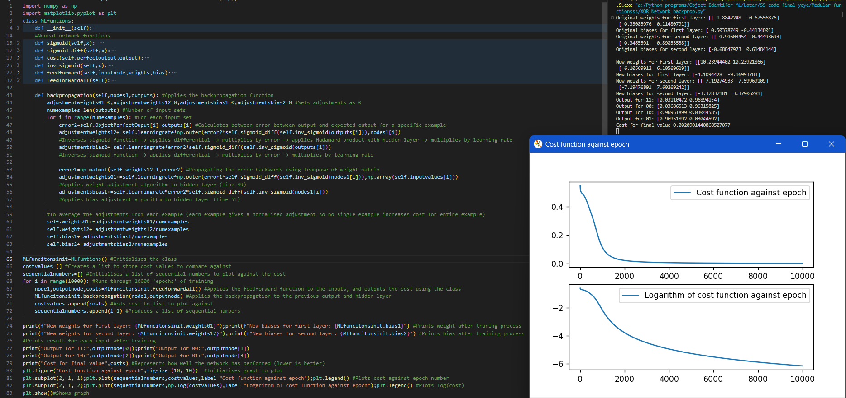

This links to the success criteria of building a lightweight neural network since this program successfully trains a multi-layer neural network.

The additional code from this example is from the backpropagation algorithm where each line represents one of the formula from above. Looking through the code, the first formula that is used is the E-O to calculate the error for the output layer on line 47. The adjustments are then found. Line 46 is the coded form of the following formula:

$μ×\left(\begin{aligned}δ_{1}^{2} \\ δ_{2}^{2}\end{aligned}\right)⊙σ^{'}\left(\begin{aligned}z_{1}^{2} \\ z_{2}^{2}\end{aligned}\right)×σ\left({z_{1}^{1} z}_{2}^{1}\right)$

* Self.learning rate represents the learning rate, $μ$
* error2 represents the error, $\left(\begin{aligned}δ_{1}^{2} \\ δ_{2}^{2}\end{aligned}\right)$
* self.sigmoid_diff(self.inv_sigmoid(outputs[i]) represents the differential of the output before the sigmoid is applied which is $σ^{'}\left(\begin{aligned}z_{1}^{2} \\ z_{2}^{2}\end{aligned}\right)$

instead of storing both the output before the sigmoid is applied and after it is applied, it is easier to simply inverse the sigmoid function since this can be done for this specific activation function

* nodes1[i] represents the output of the hidden layer

Here is the backpropagation algorithm.

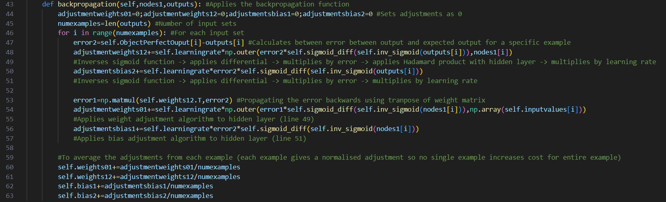

In order to do the Hadamard product within the weight adjustment algorithm, since I am using a NumPy array, I can simply just use a Python multiplication which is *. This means I do not have to code this function myself.

To multiply by the output of the second function and produce a 2-dimensional array, I will need to transpose the hidden layer output. However, this is not a function that is within NumPy so I had to use a different function to multiply these 2 values together to get a 2 by 2 matrix. This is done by using np.outer()

I then multiplied the entire matrix by the learning rate which is applied to every value in the matrix.

This allows for me to find the adjustments for the weights.

I then found the adjustments for the weights this code is almost the same as for weights except without the use of the np.outer() function with the hidden layer outputs and the other values. I then needed to find the error for the hidden layer. To do this, I multiply the error, (error2) by the transpose of the weight matrix. I transposed the weight matrix by using .T which is an inbuilt function within NumPy. This backpropagation is seen on line 49.



The adjustments for the weights in the next layer down is very similar to the previous adjustments. The main change is that all the values are now the equivalent except one layer down.

* Instead of using error2, error1 is used.
* Instead of finding the differential of the output before the sigmoid function is applied to the output layer, it is found for the hidden layer.
* Instead of multiplying by the hidden layer outputs, I multiplied by the input layer

For the bias, the same changes were made.

After doing this for every example this is then averaged. It is averaged so each example has the same effect on the gradient descent step. This allows for the most (locally) optimal step to be taken every single time from a starting position. This averaging is seen from lines 53 to lines 56.

This completes the coded solution of the backpropagation algorithm. The same graphing algorithm is used as for the simpler model and I output the final weights and biases

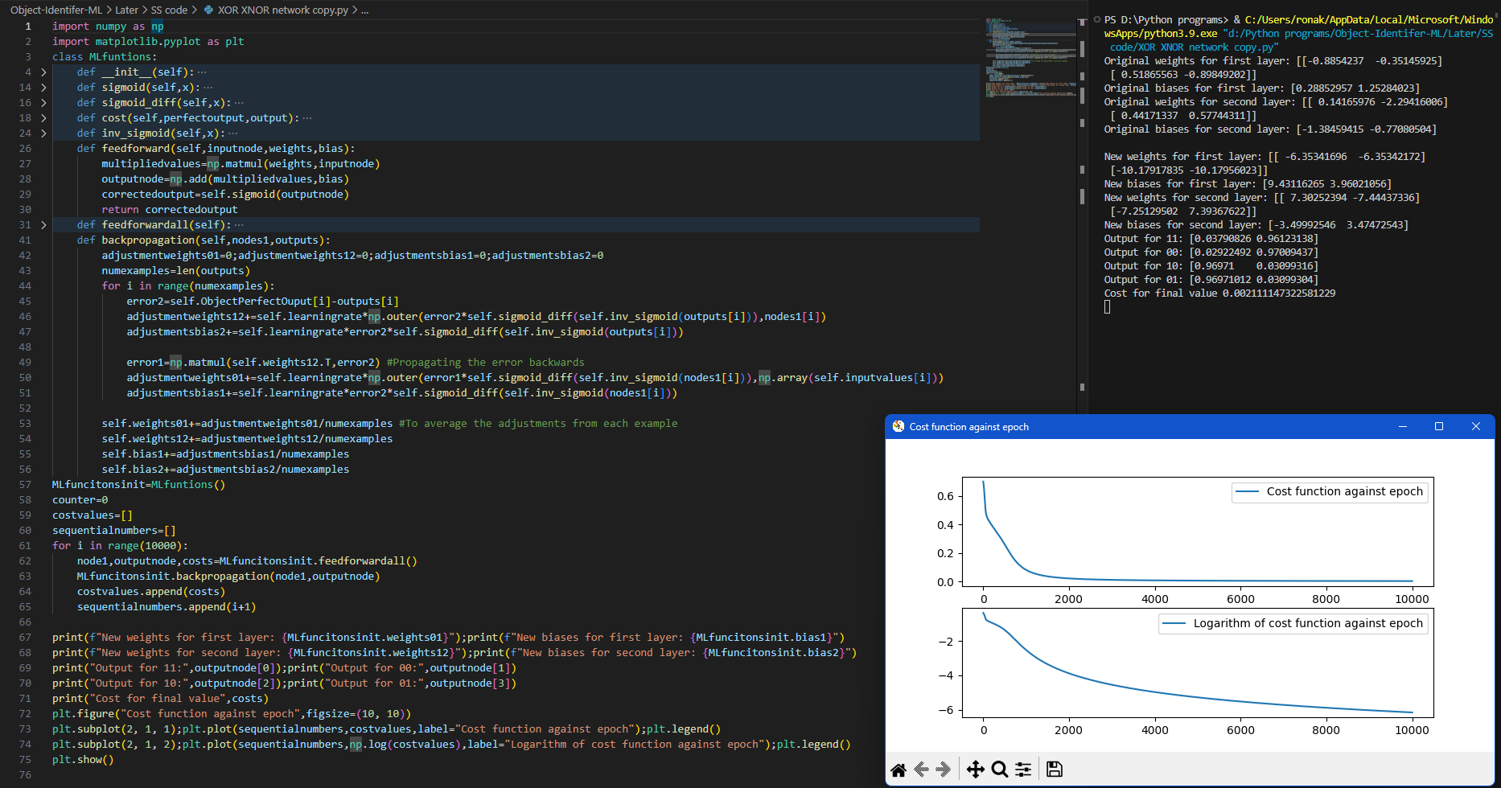

As seen above, the weights and biases for the final values are not very predictable and setting these manually without knowing them beforehand would be almost impossible. Some patterns can be seen within the weights and biases which is interesting. As can be seen, the outputs for each example is very close to what is expected. The input of 11 gives the output of 01. The 0 of the output represents XOR 1 1 and the 1 represents XNOR 1 1 which is correctly 0. Unfortunately, due to the simplicity of the model, it would not work if I would not work if I didn’t give all possible examples. If I only gave it 3 of the values to train on and then gave it a 4th combination, it would not work because the sample size is too small so it would be able to correctly identify this so this network cannot do one of the main advantages of neural networks which is being able to process information that is new and unique.

Testing

After ***testing*** this program several times, some unusual behaviours were noticed.

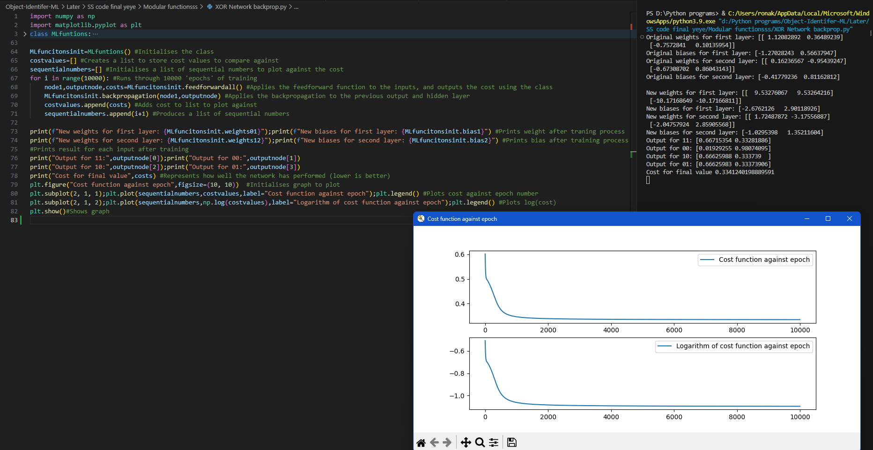When I ran the code this time, the final cost was 0.334. This would not be a problem if the cost kept on decreasing however after 2000 epochs, the cost stopped decreasing as seen on the log graph. This is concerning because this cost is quite high and this can be seen by the incorrect outputs for all of the values except 1 0. Although the correct output is larger than the incorrect output (for 00, the output is 0.33 0.66 when it should be 0 1). This suggests that there is a mistake in either the coded solution or with the mathematical model. I will now review both below to see where the mistake lies.

If this error happens within the final model, it will be much harder to detect where and since training that model will not be quick (with an expected training time of days) running it several times will not be a way to debug while running this one and training it takes several seconds.

#### Testing modular code

Adjustment for weight = $μ×\left(\begin{aligned}δ_{1}^{2} \\ δ_{2}^{2}\end{aligned}\right)⊙σ^{'}\left(\begin{aligned}z_{1}^{2} \\ z_{2}^{2}\end{aligned}\right)×σ\left({z_{1}^{1} z}_{2}^{1}\right)$

Assuming that the mathematical model above is correct, the adjustments should follow the formula stated above. Every function can be tested independently to confirm that the outputs are expected.

First, I will ***test*** if multiplying a NumPy array by a constant multiplies all the values by this.

The test data is $\left(\begin{matrix}1 & 2 \\ 3 & 4\end{matrix}\right)$ and the output expected should be $\left(\begin{matrix}4 & 8 \\ 12 & 16\end{matrix}\right)$ when the learning value is set as 4 and when the learning value is set as 0.5, the output is $\left(\begin{matrix}0.5 & 1 \\ 1.5 & 2\end{matrix}\right)$ in float form.

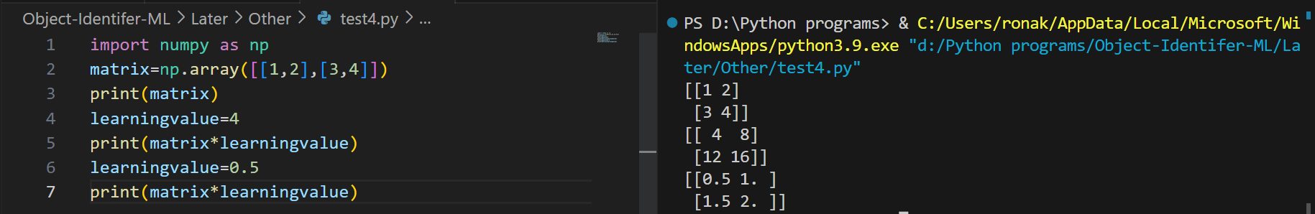

This functions as expected, completing the constant multiplication successfully.

I will now test if the Hadamard product works for 2 NumPy vectors

The test data is $\left(1 2\right)$ and $\left(3 4\right)$ and the output expected would be the element-wise multiplication of these vectors which should be $\left(3 8\right)$

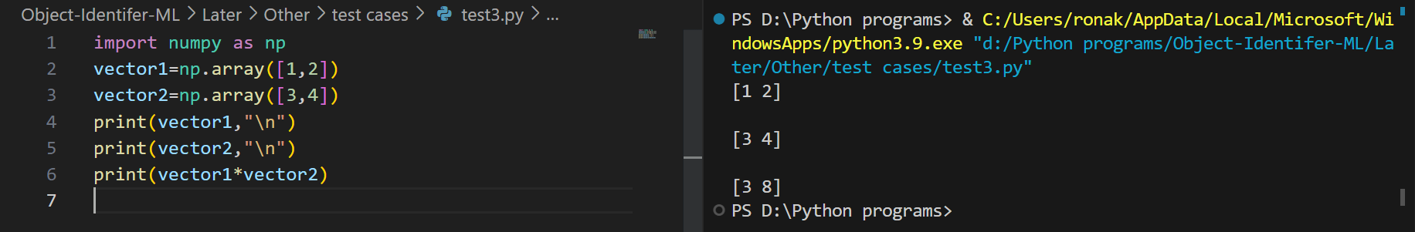

As can be seen, the elementwise multiplication works as expected.

I will now test to see if the outer function produces the correct matrix.

The test data is $\left(1 2\right)$ and $\left(3 4\right)$ and the expected output is the outer multiplication followed by the transpose function which is $\left(\begin{matrix}3 & 6 \\ 4 & 8\end{matrix}\right)$

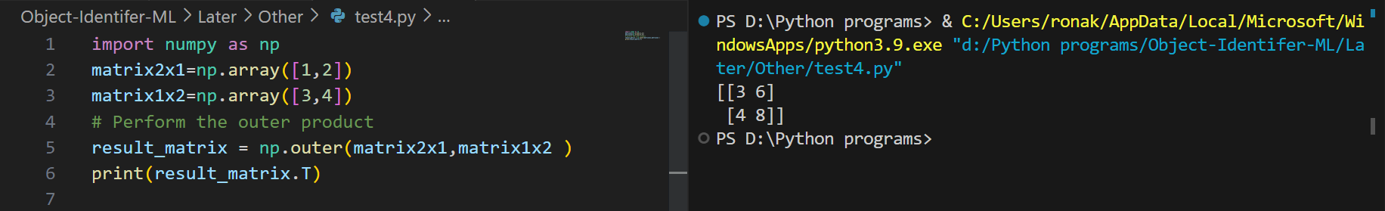

This is the matrix that is wanted where the columns represent a multiple of the 2x1 matrix and each column is multiplied by their respective value in the 1x2 matrix. If this does not make sense, then this is the algebraic form of this.

$\left(\begin{aligned}a \\ b\end{aligned}\right)×\left(\begin{matrix}c & d\end{matrix}\right)=\left(\begin{matrix}a×c & a×d \\ b×c & b×d\end{matrix}\right)$

All the code used within the backtracking functions as expected so the implementation is correct. This unfortunately suggests that some part of the mathematical model sometimes functions as expected while other times does not work.

#### Mathematical model review

The basic concept is that each of these adjustments represents the negative cost gradient multiplied by some constant. This constant is the learning rate.

The partial differential of the cost with respect to the weights can be found using the chain rule. This is not the full derivative because you are only taking some of the weights. This is the partial derivative with respect to the weights.

$\frac{δC}{δw^{L}}=\frac{δz^{L}}{δw^{L}}\frac{δa^{L}}{δz^{L}}\frac{δC^{L}}{δa^{L}}=a^{L-1}σ^{'}\left(z^{L}\right)\left(a^{L}-E\right)$

$z^{L}=w^{L}a^{L-1}+b^{L}$

$a^{L}=σ\left(z^{L}\right)$

$C=\frac{1}{2}{\left(a^{L}-E\right)}^{2}$

Differentiating each of these with respect to the specific letters gives the term above. For example, when differentiating $z^{L}$ with respect to $w^{L}$ which is $\frac{δz^{L}}{δw^{L}}$, you would get $a^{L-1}$ because the $b^{L}$ is a constant and the $w^{L}$ is removed during the differentiation process.

For the bias, it is very similar except without the activation of the previous layer. This is because $w^{L}a^{L-1}+b^{L}$ differentiated with respect to b is equal to 1. This is the partial derivative with respect to the bias.

$\frac{δC}{δb^{L}}=\frac{δz^{L}}{δb^{L}}\frac{δa^{L}}{δz^{L}}\frac{δC^{L}}{δa^{L}}=σ^{'}\left(z^{L}\right)\left(a^{L}-E\right)$

For the activation of the previous layer (which is the error), it is almost the same as for the weights giving this. This is the partial derivative with respect to the previous activation.

$\frac{δC}{δa^{L}}=\frac{δz^{L}}{δa^{L}}\frac{δa^{L}}{δz^{L}}\frac{δC^{L}}{δa^{L}}=w^{L}σ^{'}\left(z^{L}\right)\left(a^{L}-E\right)$

The calculations have all been correctly done so this suggests an error in the underlying mathematical concepts behind gradient descent.

After researching this further, this is due to the fact that gradient descent will only find a local minimum and not a global minimum of a function. This explains the inconsistency of the program to reach a proper minimum. This can be understood by looking at a function with 1 input (instead of 12 like this program). This is an example function. As can be seen, there are 3 different minimums. With one variable, it is trivially easy to know where the minimum is and then find it to a high degree of accuracy by using an algorithm such as gradient descent, but this demonstrates the problems being faced with my current program.

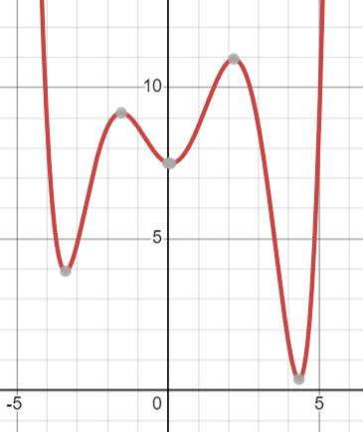This graph could potentially represent how the change of a specific variable affects the change in cost. If, for example, the cost was close to 1, then the gradient would be positive.

Since the adjustments represent the negative gradient, this would cause the variable to move towards 0. Although this does decrease the cost, this moves the variable towards the local minimum close to 0. This is not as desired since the true minimum is located near 5 and I need to find a way to prevent from this happening.

This explains why this error is intermittent because, for this example, there are some values where it goes towards a true minimum while there are other values where this is not the case.

This applies to the XOR function as well so sometimes it reaches a local minimum.

This is useful to know and allows me to improve my code for both this model and the final prototype. There are several ways to attempt to do this. The simplest way to do this is to train it and then if the error does not go below a certain threshold, train it again. I then repeat this again to confirm that it is in a local minimum and then I reset all the weights and biases. This is an example of this code with the entire program.

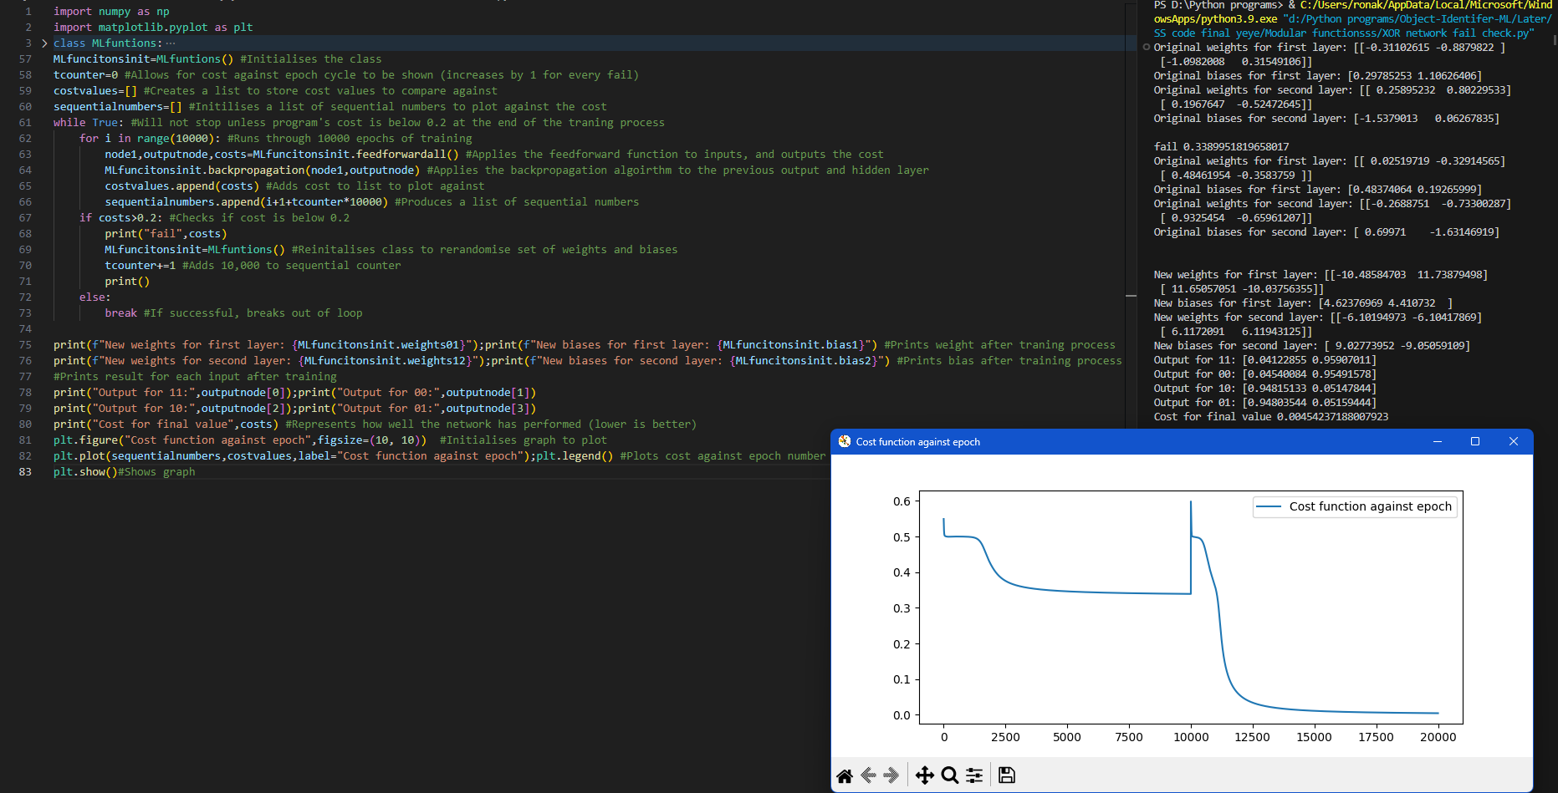

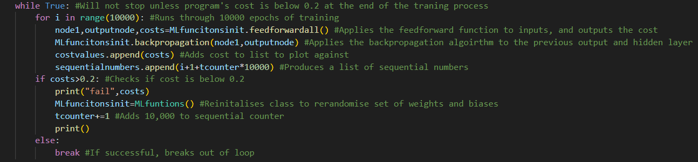

As can be seen from above, this will not stop the training process until the network has a sufficiently low cost. Before checking if the cost is low, this will first train the program through 10000 epochs. If the cost does not reach close to 0 at the end of the training cycle, such as for the example above, the program will rerandomize the weights and biases and then run through the program again. For the example above, for the first set of weights and biases, a local minimum for a cost of 0.33 was reached. This is not close to 0 so the program resets the weights and biases to retrain the program. After this was done, the program successfully found a close to global minimum, with a final cost close to 0.

The only way to escape a local minimum is to run through the entire program and at the end of the training process. For the finalised model, if the cost is not sufficiently low enough, then this model is reset and reinitialised with rerandomized weights. I will store these high-cost models in a place where I can access them later to test their accuracy for the finalised model.

After producing a simplified prototype of a neural network with all the fundamental algorithms required to produce this, I will now build the final model.

# Designing and building the final model

## Image preprocessing

The first step in producing the final model is to produce a way to input the images into the network.

To feed the image into a neural network, it must be in the form of numbers which can be entered into the input layer. To do this, the pixel values of the image must be extracted and stored as part of the preprocessing of the images. The correct output of the neural network must also be stored as part of the image information.

There are several important parts that image preprocessing completes such as standardization. This involves normalising the pixel values and the resolution of the image. This guarantees that the data is consistent across the different images and allows for new images to be taken in relatively easily. The images must be standardized by bringing them all to the same format in a data structure. To do this, each RGB pixel value is averaged to give a greyscale image to allow for standardization and then stored in a list.

Preprocessing the image increases the speed of training because the model does not need to process the images while being trained, increasing its efficiency. Without preprocessing the images, the images would have to go through several computationally intensive steps before being able to even input the data into the network and this has to be done over 100 times so preprocessing these images is essential. I also removed some unclear images to allow for the artificial intelligence to be trained with better data.

To do this, I first need to work out how to extract information from an image. I then need to be able to put this data in a suitable data structure.

### Requirements

To do this, I first need to work out how to extract information from an image. I then need to be able to put this data in a suitable data structure.

The requirements for image preprocessing are:

* Find dataset
* Name files sequentially
* Normalise image format by turning all images into the same file extension
* Use a library to access pixel values
* Store pixel values in suitable data structure

### Pillow library

In python, the library pillow allows for the image to be manipulated and read in python and allows for the pixel values to be read. The question is how to efficiently store the pixel values in the least space possible.

The images need to have the same number of pixels in order for them to be processed into the artificial intelligence so the resolution of all of the images is set to be the same. This can be done with pillow.

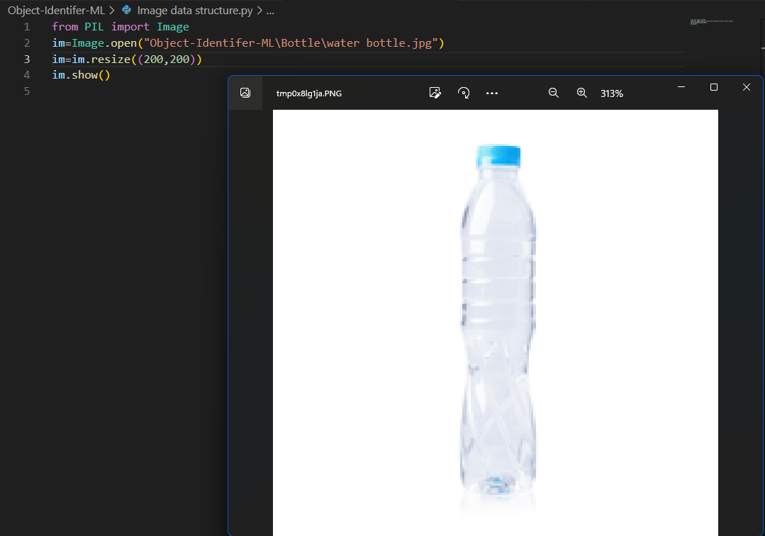Given the size of the image still being 40,000 pixels, storing each RGB colour would give 120,000 values between 0 and 255 which would cause the training time for the AI to be dramatically longer than if a greyscale image is taken instead. This is because each pixel will connect to 20 weights so this will give 2.4 million weights just in the first layer.

The pixel values of then need to be extracted and stored. There are 2 ways of going this:

* Using a NumPy array
* Using pillow and a csv file

### NumPy array

The pixel values can be extracted using NumPy and automatically stored into an array. However this has several problems. One of which is the size of the files being 20 times larger than the original image file. This is because the array stores the values in float form with an exponent increasing its size compared to just storing the integer values of each pixel.

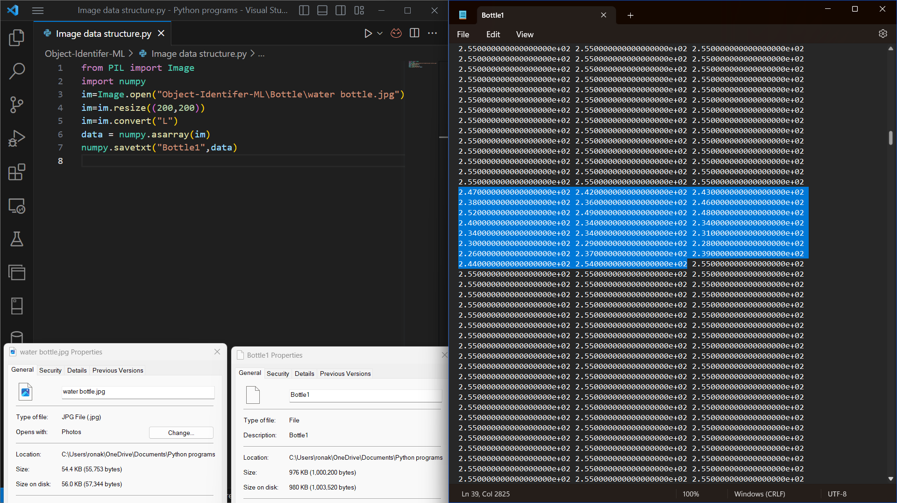

The size of this file is a problem since this will take a significant amount of time and resources to turn the images into this format to be used to train the AI for the preprocessing. A more efficient form is using a CSV file because it stores the values as integers instead of floats, decreasing the size of the numbers.

I tested this by running the program and going to the NumPy array for the image in notepad.

### CSV file

Using a CSV file would be more suitable because it does not cause the file size to increase as much with this file only being 3 times larger than the original file. In order to create the CSV file, I will need to first convert the image into grayscale. I then stored each pixel value into a list which I then wrote into a CSV file. This can then be repeated to go over all of the images creating a csv dataset instead of images.

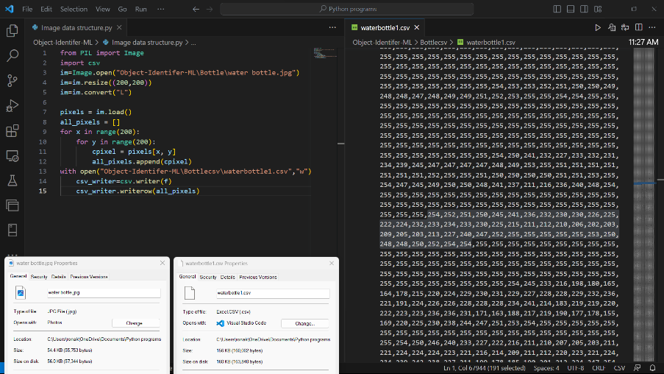Although using an NumPy array would mean a simpler import process when the data is used for the neural network, the CSV can be turned into a NumPy array.

I tested this by going to the file named water bottle 1 after running the program.

### Image dataset and formatting

In order to turn all of the images into CSV files, they must be in a correct data structure.

I first needed to find a dataset of the objects that I would like to identify. The images I chose to be able to differentiate are a bottle, bike, cat, chair and flower from Kaggle. This is because these images are sufficiently different to allow for the artificial intelligence to be able to accurately tell the difference between. The images, however did not have a sequential naming format and the images were in several different formats such as .bmp, .png, .jpeg and .jpg. I decided to turn all of the images into a jpg format because the majority of the images used this file extention. I then needed to find a way to turn all of the files to a different file extension. Internet tools require uploading all of the images and then downloading them again so a simpler and more efficient way to do this is to use a command from command prompt.

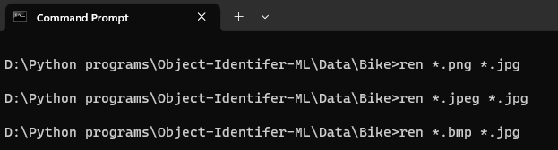

I then repeated this for each object type.

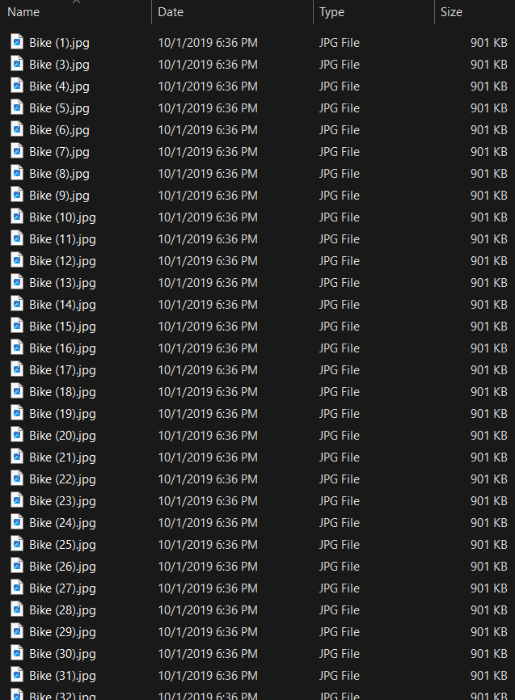I then needed to change the file names to a sequential form that can allow for all of the files to be read and then turned into the CSV files. This can be done by selecting all of the files and renaming them all to a word. This then causes all of the files to be in the form of that word followed by (x) where x is the image number.

After doing this, I have a folder containing sequentially named files of the same type.

I then needed to be able to call these files and loop through all of them and create a CSV file of the pixel values. To do this, I will need to direct the program to each of the directories of the images and know the format so it can sequentially read each image.

For the program to know how many images to process through, I stored the number of images for each dataset in a dictionary. This allowed me to turn each image dataset into CSV files by calling the directory name. I can say how long to run the loop for using the data value for each dictionary entry. Once an image is selected, the previous function to put these into a CSV file is used. To name the CSV file, I used the same structure as the name of the file being called for simplicity.

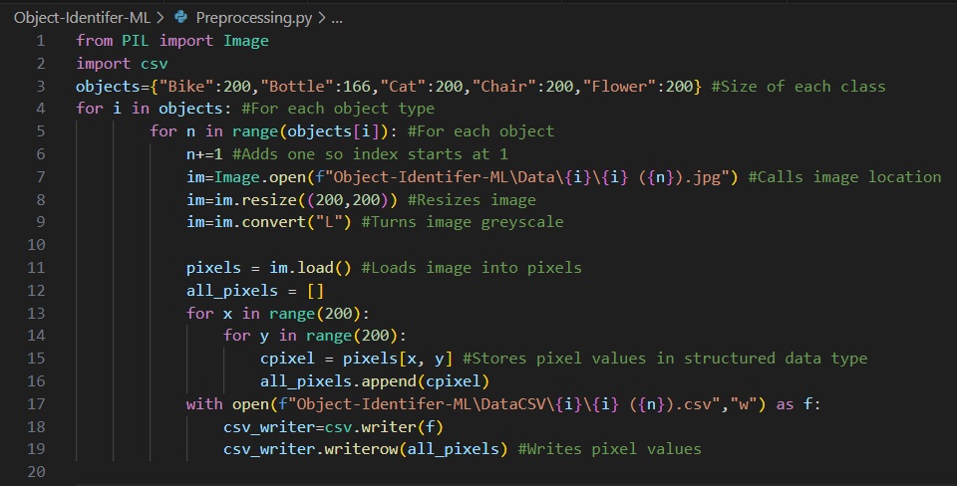

I ***tested*** this by running the program and checking the file location, comparing pixel values using an RBG tool.

This links to the success criteria of being able to capture images and get their pixel values to feed into the neural network.

The names of the CSV files will be the same as the names for the original image using the dictionary to name the files. This can then be fed into the neural network by importing the CSV as a variable in the form of a list. The original dataset is smaller than the CSV files due to decreasing the resolution dramatically and storing the greyscale pixel values.

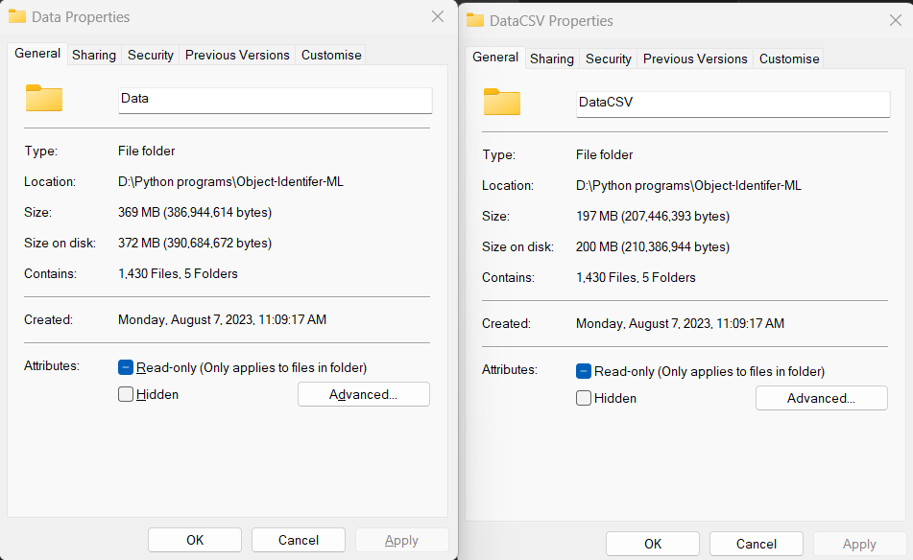

This completes the preprocessing aspect of this program. A dataset from Kaggle is used for this program completing the dataset requirement. The image format was normalised into the same file extension using a command. The file names were able to made sequential through selecting all of the files and renaming them all. I used pillow to access the pixel values which let me put it into a suitable dataset. I stored the pixels in a suitable data structure by using the same structure as how the original images were stored. This will allow for simpler training of the network.

# Neural network functions and prototypes

The neural network will be based off of several important functions that allows for images to both be processed and to allow for the artificial intelligence to be trained. I will also produce the structure of the neural network. The machine learning model is dependent on several variables that affect its output depending on how they are set. The model will find an optimal configuration of these variables to successfully detect what an image is. Between each layer of the network, a function is applied to turn each input to the node to give the output to be between 0 and 1. After all of the functions can be combined together, a Backpropagating algorithm is used to allow for the artificial intelligence to be trained.

I will create several functions and a framework for the final model and then produce a logic-based prototype which will allow me to build the final model.

## Requirements

To build this, a general structure needs to be made and all of the essential functions will be coded into a class structure followed by the Backpropagating algorithm.

* Accessing and storing weights and biases to be able to be accessed into training program.
* Coding activation functions and their derivatives
* Coding cost function
* Feeding forward through the model
* Backpropagating to train the model

## Weights and biases initialisation

To use the artificial intelligence after training, the weights and biases have to be stored within a data structure where a csv file was used. Starting weights have to be created and then refined to give useful outputs. For the original weights and biases, I arbitrarily chose a normal distribution with mean 0 and deviation 1 and created a file for each weight and bias. This is the code to produce all of the starting variables to be used within the model.

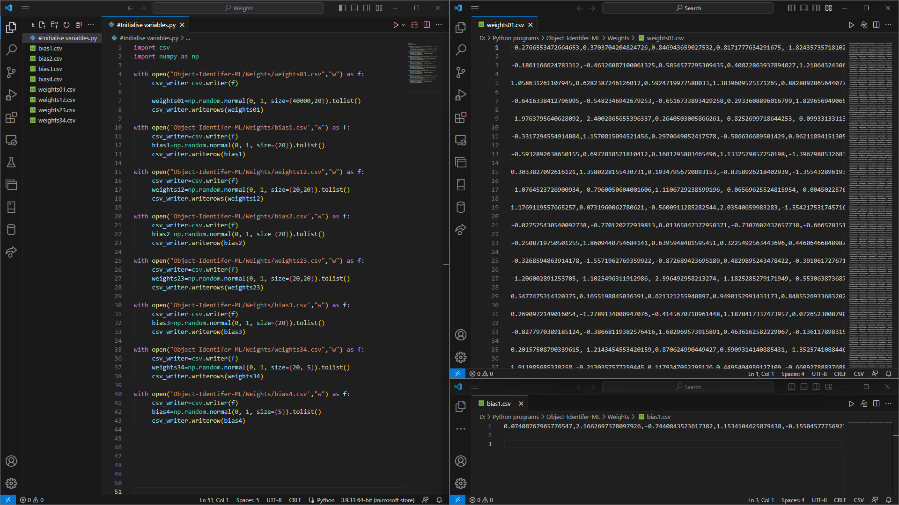

Weights 01 contains 40,000 rows of values and 20 values in each row while bias1 contains 20 values. This is because the bias is applied to the node while the weights are applied between the nodes with each number representing one connection.

Here is what each line of code does for the first open sequence. This is repeated.

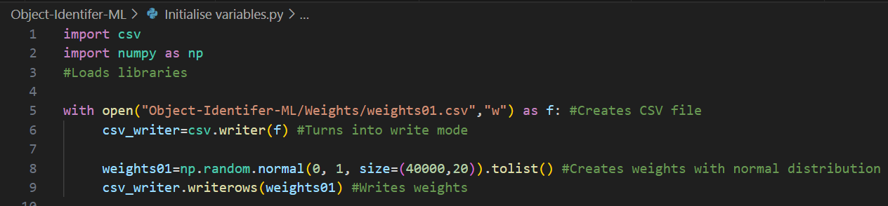

I ***tested*** this by running the program and checking whether the file weights01 contained values between -4 and 4, which seem to be randomly distributed around 0.

The first 2 lines of code represents loading the libraries required. The CSV library is used to allow for simple creation of CSV type files. The NumPy library is used to produce a list of randomised weights and is simpler and quicker than generating this myself.

The next line either opens the file at that location or produces a new one. For the purpose of this program, it does not matter since it is rewritten with the values.

The next line represents the productions of the weights to be produced. I use a normal distribution since this produces both positive and negative values close to the mean of 0 and I set the standard deviation to 1 since it keeps the randomised values close to -2 and 2. I set the size of this one to be 40000 by 20 since there are 40000 input through the grayscale images and there are 20 neurons in the next hidden layer. I then turn this into a list so it can be put into a CSV type list without requiring a NumPy float type to be stored. Since NumPy floats are much larger than traditional floats, this reduces the size of the program. The final line writes this into rows within the file. I repeat this for each weight and bias, with the sizes dependent on the architecture of the program. This can be changed by simply changing these values.

## Loading and storing weights and biases

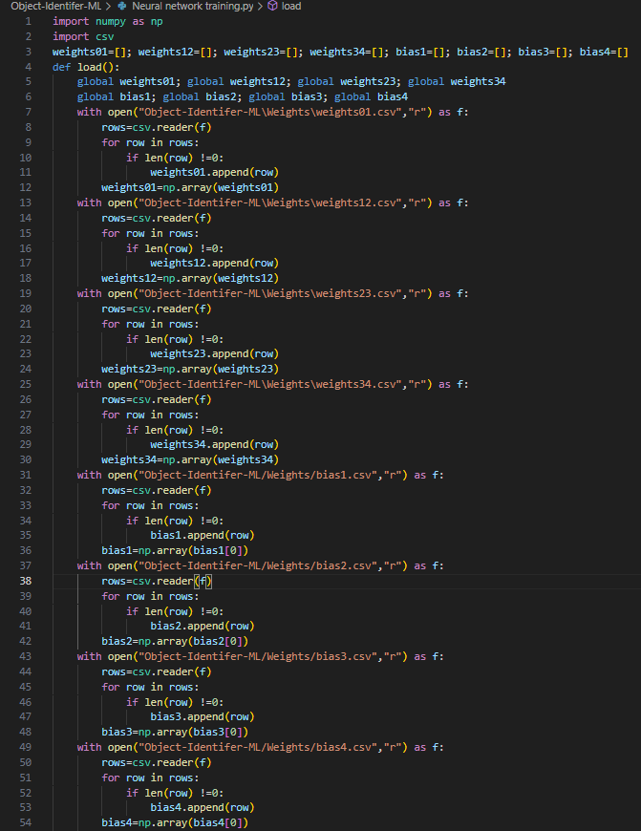

To load the weights and biases into the program, they are stored into lists. It is important to not store the empty lines between each line of the csv file, so I checked for this. This stores each weight and bias within as its own variable. This means these values can now be accessed.

I called these variables as global at the top of the function to not have to call these as inputs to the function and return the variables as outputs, making it simpler. This lets me just call load() at the top of the program to load the variables.

This is how a single part of the program works.

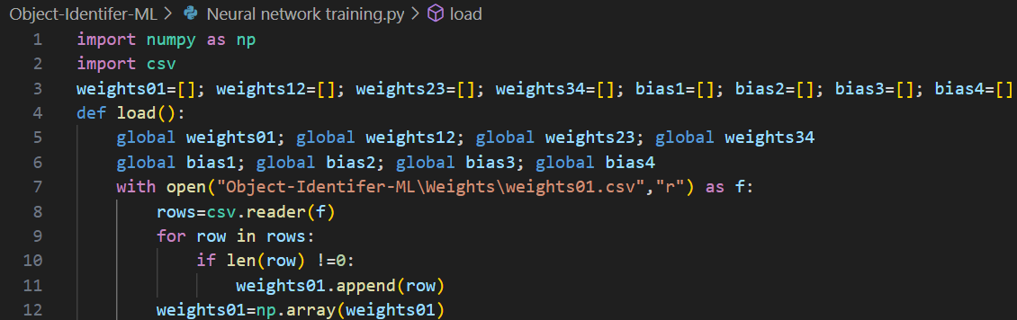

The first 2 lines of code represents loading the libraries required. The CSV library is used to allow for simple reading of CSV type files. The NumPy library is used later.

I then defined the different weights and biases with variable names representing the layer it moves between for the weights and the layer it is located on for the bias.

I then defined the function load which I can call later. This is not located in the class.

I then set the variables as global.

On line 7 I open the file at that location and places this in a read mode. This requires the file to exist. I then create a class instance of CSV that allows for reading of the files. For each line, I will check if it is empty. Due to the way CSV is turned into a NumPy form, it can cause randomised lines to be produced so it is important to remove these lines. If the row is not empty, then it represents a part of the weight matrix. I then generate this matrix by iterating through the file and I generate the weight matrix by combining the entire weight list into a NumPy array which allows to use the weights to be used as a matrix, which is important for efficient feedforward methods for the program.

To store the weights after training, I write the values back into the csv file.

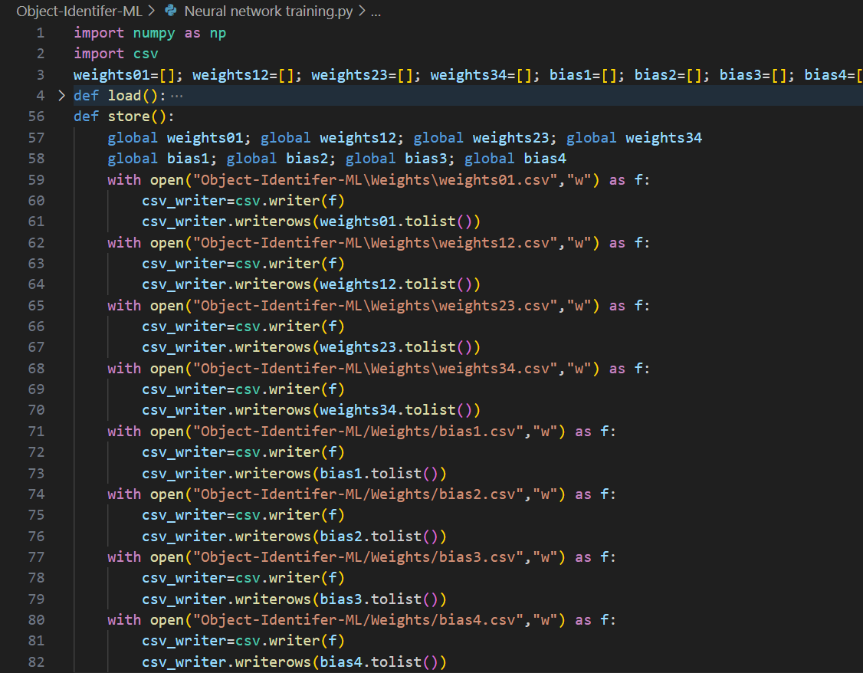

Here is how a single part of the program works.

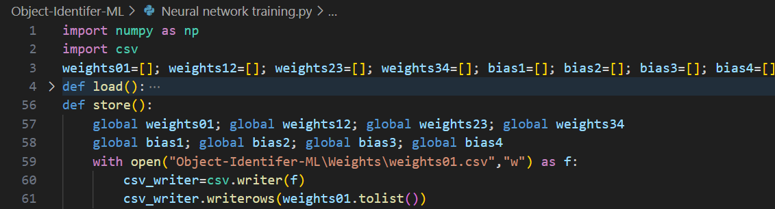

The first 2 lines of code represents loading the libraries required. The CSV library is used to allow for simple reading of CSV type files. The NumPy library is used later.

I then defined the different weights and biases with variable names representing the layer it moves between for the weights and the layer it is located on for the bias. This is made global to access these values.

I then defined the function store which I can call later. This is not located in the class.

I then opened the file in write mode. It does not matter if the file exists or not, I will rewrite the contents of the file even if it contains data. I then produce an instance of the CSV class and use this to write the weight matrix into the csv. I first turn this into a list before placing this into the CSV file to avoid using the less efficient NumPy type float and to instead use a more efficient normal float.

This lets me just call store() and all of the trained weights will be saved into the csv file. This can allow for the artificial intelligence to be trained at different times so stopping the program from running does not remove any progress from the model running and therefore does not need to start back from the beginning.

It also lets me to train the model again after the first time in case it has a lower than expected accuracy.

## Loading images

Due to using a stochastic gradient descent model, not all the images are loaded at once. I have decided to take a sample of 10 images with 2 from each category and use these to create the cost differential. The CSV values from the images now must be loaded as variables into the model. Since this is done multiple times to cover all of the training data, I have decided to use an instance of a class to complete this. The instance takes in a number which represents the epoch cycle. Since the least number of images I have for a set is 166 for bottles, I will do 80 epoch cycles. The class uses a __init__ function to store the images with that index and the image of that index +1. This is stored inside a variable in the class instance called object.

It is also important to store what activations are expected for each image. For example, if the image is of a bike, I want the most powerful output neuron activation to be the first output neuron while the other neurons are all 0. To tell the model which one should be activated for a given image, I store what the output should be within a list called ObjectPerfectOutput within the class instance. This is done from lines 98 to lines 104.

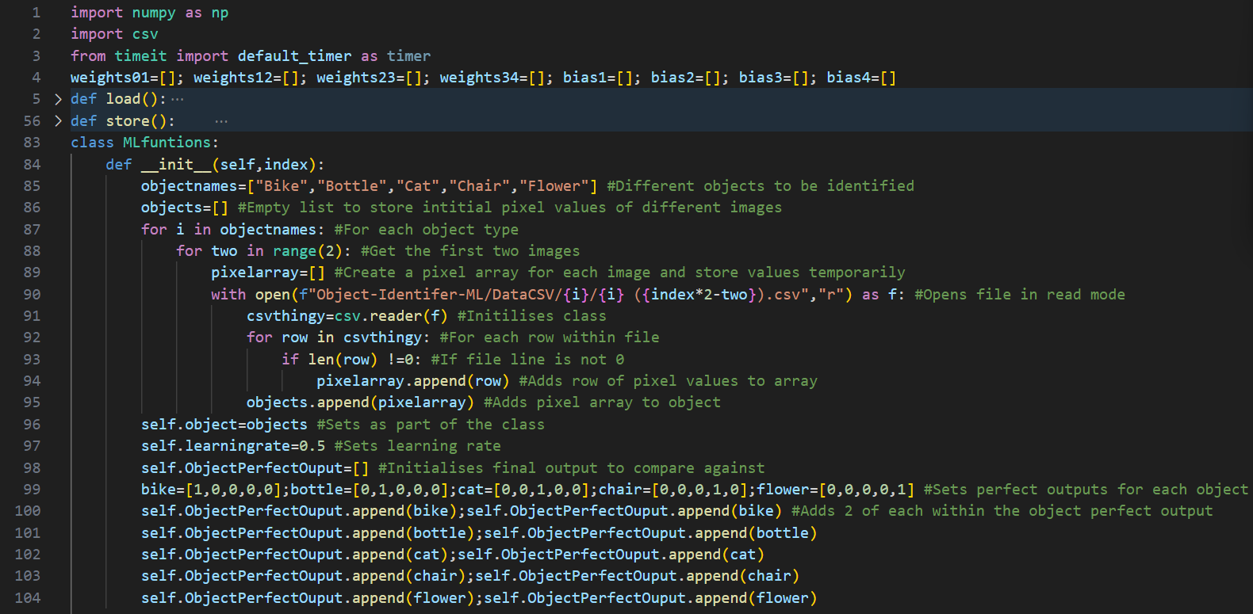

The first 2 lines define the libraries required in order for this to function.

The class is produced and when initialised, the function will be run.

First, it defines the different objects to be identified. These must be identical to the names of the folders storing the objects. It then opens the CSV files and stores the pixel values into an input form called objects. This can then have the feedforward function to be applied to this after producing this. I choose the objects to be imported by using the object types within the file names. The files must be very specifically named using the image preprocessor. I then produce a perfect set of outputs for each of these specific inputs.

I ***tested*** this by running the program and then printing out the values for “self.ObjectPerfectOutput”.

This is what the variable looks like when printed.

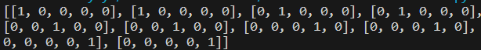

As expected, this is in the form containing 2 sets of the first image’s perfect output followed by the next image’s perfect output continuing to the final value’s perfect output.

## Feedforward

The next step is to run the model through all of the images and find their mean cost. To run through the model, firstly, you start with the input which is the image CSV in the form of a vector. However, this is in the wrong data type so I cast the image CSV into a float form as well as the weights and biases.

However, since these values are between 0 and 255, these inputs would be much larger than expected so all of the weights would have to be close to 0 to bring them down close to being between -1 and 1. A way to allow for all of the pixel values to be over a smaller range is to divide them all by 255.

This is then multiplied by the weight matrix and the bias is added to the resulting column vector. All of the values in the vector then have the activation function applied to them. For this case, it is the sigmoid function. This is the input into the next layer. This repeats for each layer until you reach the final layer which is the output.

To do this, I created 3 functions. The first function created the values for the next node by using NumPy to multiply the input vector by the weight matrix and then adding the bias vector to this. I then applied the activation function. This moves forward by 1 layer

The second function then applied this first function multiple times to different weights, taking the input of the previous values until the output is found and returned. Which represents what the model “thinks” the image is.

The second function also finds the cost for the specific example. The third function then finds this cost for all of the examples within that epoch and averages them. This number represents how well the model does in identifying an image.

I ***tested*** the program by checking the cost was between 0 and 5 and the outputs were seemingly randomised.

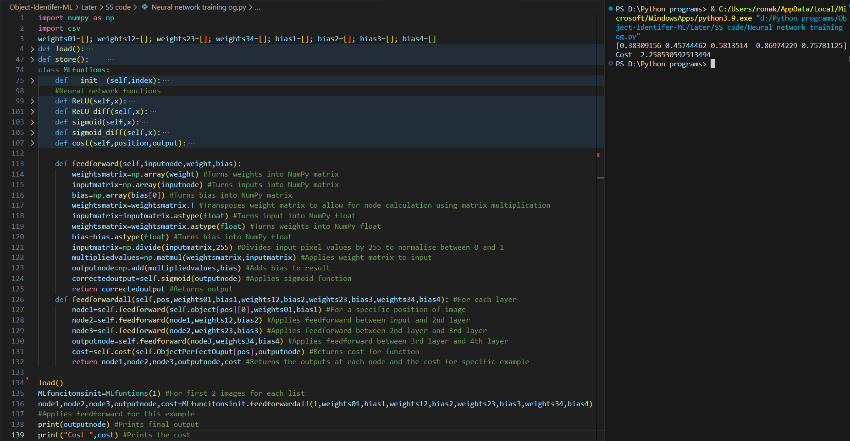

Reducing the average cost of all the examples is important so I created another function using feedforwardall and calculates the cost for each of the 10 examples. This cost is then averaged.

I ***tested*** the program by checking the cost was between 0 and 5 and I ***tested*** the program run time by using the time library.

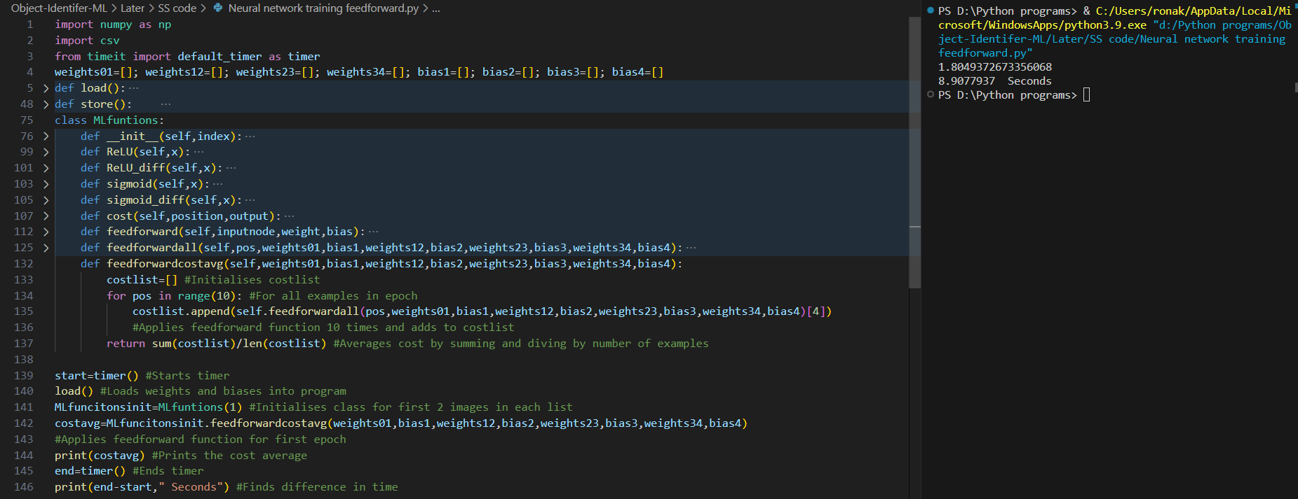

However, this is quite slow as this took 9 seconds just to run through the model without changing anything. Doing this 80 times by itself is 12 minuites and this is without changing any weights.

This code will now move through the entire network and give an output for a specific image and gives the framework to train the model. This builds the basic architecture of the neural network such as its structure and general base to build upon and will allow to build a training function on top.

## Backpropagation

This is the gradient of the cost function is found which allow for the cost function to be decreased. This is how the model will be trained.

I have used the previous XOR prototype and expanded this for this model.

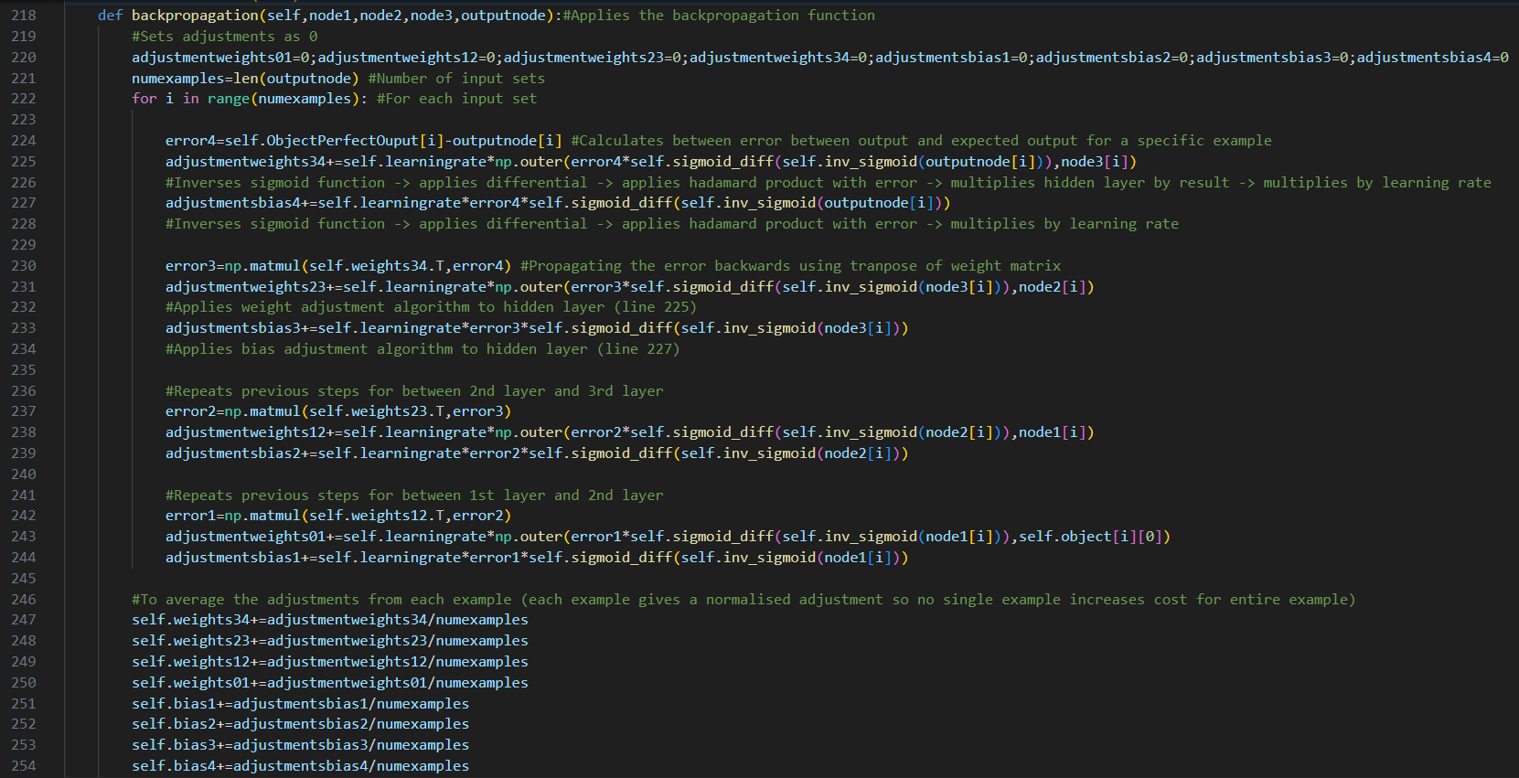

I will now explain each part.

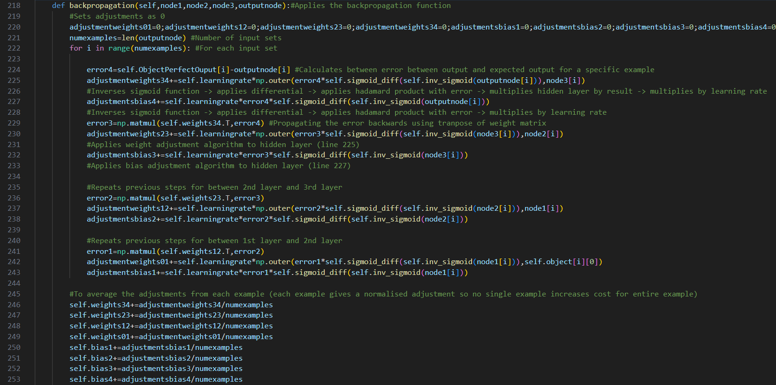

the first line defines the function and its inputs. I can call this function later to apply the backpropagation function. Self is used to call function and variables from the class itself. I then define the inputs for the function to be called. This requires the values of the first node’s output, the second node’s output, the third node's output and the final output. This is because in order to find the adjustments for the weights and biases, these are required. It does not require any of the other variables to be input into the function since they are stored within the class structure and therefore can be called using self. I then set all of the adjustments to be 0. This is because in the beginning, there are no required adjustments to be made since the program doesn’t know how to change the weights and biases until after moving through the backpropagation algorithm. This is why their original value is 0, since the program cannot guess or expect the direction that these adjustments should face. More advanced versions of this neural network, however, might be able to find an efficient way of calculating an expected adjustment list before the backpropagation algorithm is applied.

In the next line, I then calculated the number of examples by doing the length function on the output node. The output node is a 2 dimensional list where the first dimension represents the number of different examples and the second dimension represents each of the outputs given. The length function is useful since it only gives the size of the first dimension.

After calculating the number of examples, I can iterate the backpropagation process for each of these examples. This can be completed in parallel if a more complex language was used since the weights do not change during the process of finding the adjustments for this specific example, they only change after going through all the examples, this ensures that cost gradient is approximated with greater accuracy, compared to with all of the training examples.



The line 224 is calculating the error between the output layer and the expected values. This gives the neural network a general sense of the directions to move to reduce the cost value. This is done for a specific example and since each example can have a different expected output, I also indexed these different outputs, stored within ObjectPerfectOutput where each value represents the perfect output for a specific image.

The next line produces one set of weight adjustments by applying the algorithms required. The first calculation to be applied is finding the output of the output node before being corrected by the sigmoid function. After this is done, the differential of the cost function applied to the corrected output is calculated as a part of the partial derivative of the cost function with respect to the weights. This is then multiplied by the error using the Hadamard product which is used for elementwise multiplication. I then applied the np.outer() function so I could turn each of these values into the correct size. Since the size of the parts is 5 and 20, in order to multiply them to get a 5x20 matrix for the weight adjustments, the outer function is used. I then multiply by the learning rate since the partial derivative is only an approximation of the value to change and this produces the adjustment for the weight for this specific example.

The line 227 represents the adjustments to be made for the bias. This calculates the partial derivative of the bias by first finding the uncorrected output of the output node with the differential of the sigmoid function applied followed by multiplying by the error through using the Hadamard product. As described previously, to use the Hadamard product, it is very simple and only requires a multiplication sign between the vectors when using NumPy arrays. The learning rate is then applied to this value to produce an adjustment to the bias that should approximately give the change in the output.

This is how the adjustments are calculated between the output layer and the 3rd hidden layer.

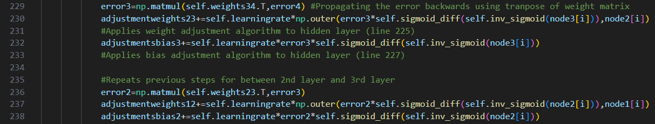

For the next part of the code, I will backpropagate this error to produce the error for the 3rd layer.

To do this, I apply a matrix multiplication between the transpose of the weight matrix and the output layer error. After this, the same weight and bias adjustment algorithm is applied.

The same concept is used on line 236, backpropagating this error and then applying the adjustment algorithms.



For the final error to be calculated between the input layer and the 1st hidden layer, I backpropagated this error and applied a similar adjustment algorithm except for the weight adjustment algorithm, I multiply by the input layer. However, this input layer will be dependent on the object used and since this is not given during the input of the function, I used self to reach the object input values. The object type is given by I which represents the position of the backpropagation algorithm such as if I was 0, then the program would be on the 1st image. The final [0] is simply used since the input layer has 2 lines instead of one due to using a CSV type file to store the input instead of locally storing this within the program initially and calculating the CSV values from the images.

After the adjustments have been found for all examples, I then average this.

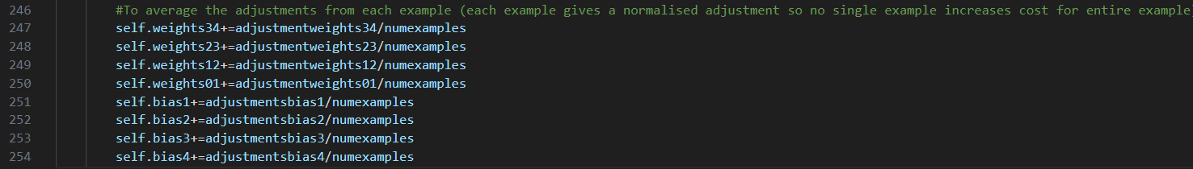

I create the sum during the production of the adjustments and I divide by the number of examples to produce this average.

After producing the function, I can now run the program. To do this, I will code the use of these functions to train the network.

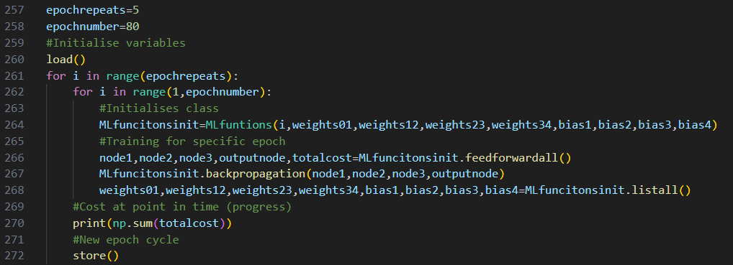

The first value, epoch repeats, represents the number of cycles that the program will cycle through the image set to be used. This will cycle through the image set 5 times.

The second variable represents the size of the smallest image set that is used. Since my smallest image set has a size of 166 and each epoch, it cycles through 2 from each image type, I set this as 80 to reduce any error from getting close to this value.

I then initialize the class with the 10 images chosen. I will first choose the first 2 images from each image type and then choose the next 2 images from each of the 5 image types. I will also initialise the class with the weights and biases to be included in the class so can be called and changed during the production of the class. I then apply the backpropagation algorithm for these 10 images and this will change the local values of the weights and biases. However, in order to be able to use these again, I will need to store them back to the main program. I do this by listing all of these variables, storing them in the global part of the program. These can then be used when initialising the class again.

After each epoch cycle, I will print the sum of the total cost for the 10 examples to see if the cost is reducing over time. I will now run this program to check for errors.

I then attempted to ***test*** the program by running this for the first time, however an error is produced.

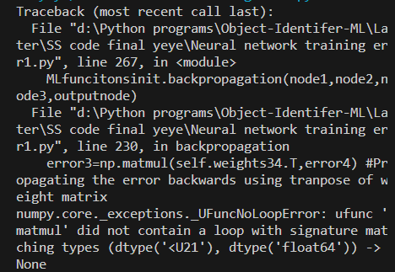

This is due to the NumPy library and a similar error was produced when coding the feedforward part of the program. This is because when turning the CSV values into a NumPy library, it is set with a different data type. This was turned into a float within the feedforward part of the program locally as can be seen below.

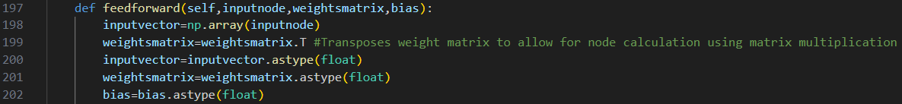

However, a simpler and more efficient approach would be to simply define all the different values as a float when initialising the class to avoid this error from occurring. I have changed the initialise class to now include these values.



After running the program to ***test*** after changing this, a new error appears.



To follow this trace, I start with line 265 where the backpropagation function no longer works. This is because it tries to multiply the transpose of the weight matrix with the error. There is a dimensional error since the inner dimension of the arrays do not match so the matrix multiplication is not possible. I will now attempt to debug the program by listing the dimensions of the input matrices to this function and see where the error is from this point.

The line that is causing this error is the line where I multiply the transpose the weight matrix and the error value together. The dimensions of the weight matrix and the error are given below.



Interestingly, this suggests that I do not need to apply the transpose function to do this. I will trace back to the feedforward function to see why this is the case.

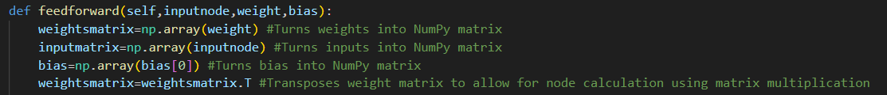

I locally apply the transpose during the feedforward function, not since this is what should be done, but because it is easier to store the transpose of the weight matrix (40000 lines with 20 values each is simpler to store than 20 lines with 40000 values in each one). Since the weight matrices have already been transposed, I do not need to use .T within the backpropagation process. I only needed to use the transpose when applying the feedforward function since it reverses the already transposed matricies.

I will now correct the code by removing the transpose function during the backpropagation function. This should produce a functional training algorithm for backpropagation.

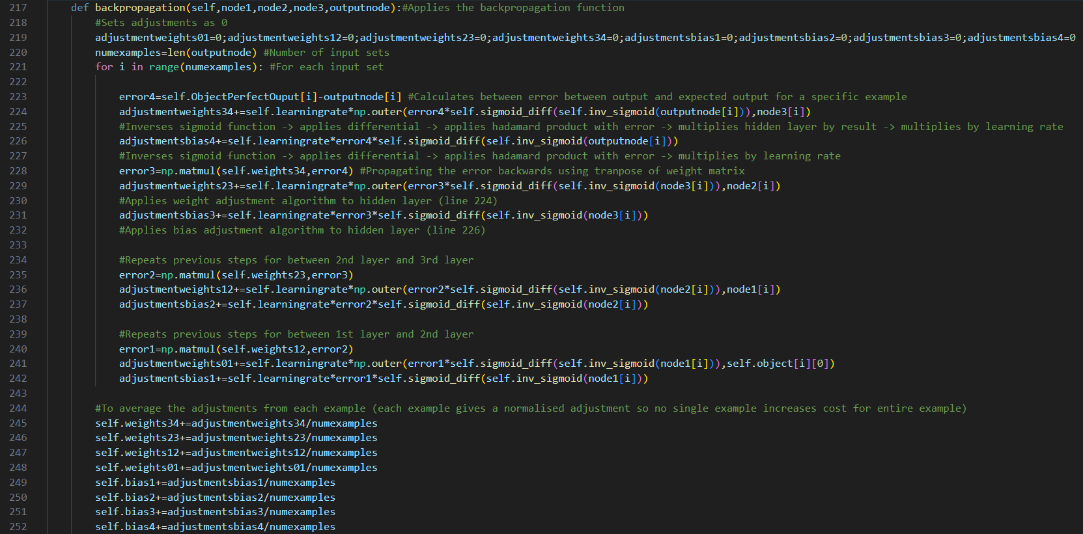

This is used to train the neural network. After this, I will need to be able to take an image input using a Raspberry Pi camera and store the image in a folder location.

## Feedforward network for image

However, before attempting to try to run this program, I will need to have another program that will allow for me to use this neural network for object detection. To do this, I will need to program something that can use these weights and biases and give an accurate value for which object the network thinks it is.

The beneficial aspect of modular programming is that the majority of the previous code can be reused in the use of the neural network and the output for a specific image can be found. The first part of the program to be changed is to the beginning of the program. It is not possible to preprocess the images since they are generated and then immediately run through the program. During the training phase, the pre-processing program is run once and then all of the CSV values are generated for the images however when running this program, the image is captured and is then run through the network however the CSV intermediate step is required. Due to the modular nature of the code, it is very similar to the preprocessing program except the file locations and file name is different.

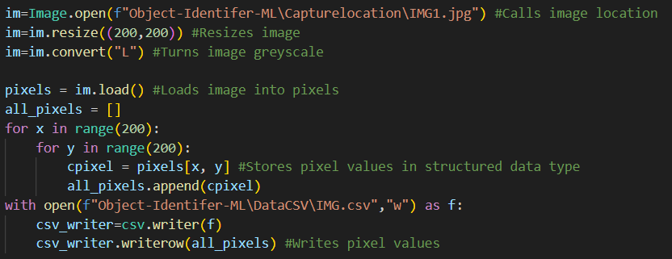

The main changes between this and the original preprocessing program is that it does not require the complexity of file naming and reading to be iteratively completed for each image. This makes the program much simpler. I also only need to load one picture and since the file name is fixed, I do not need to manipulate the file name at all when running this intermediate preprocessing stage.

The main parts to change is the image location and the iterative aspects of the program since it only takes one image at a time instead of 10, turning several values from being a list into a variable.

One change is within the initialise part of the program where I no longer need to define which image set I am using and I no longer need to load the pixel values of all 10 images during the initialisation process, just the pixel values of the singular image.

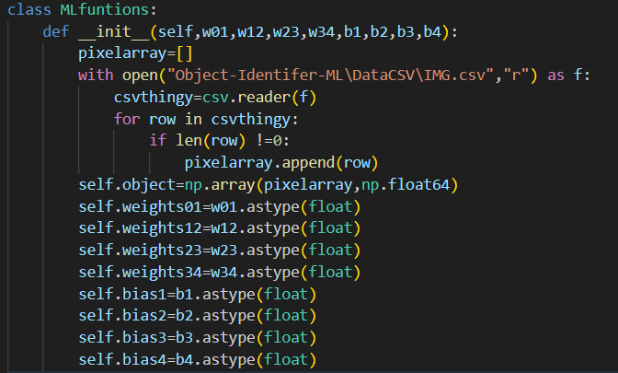

The neural network functions stay the same since they are still required for the feedforward process.

I also removed the cost function from the final feedforward all function as well as only doing feedforward for one image instead of all of the 10 images, so the node can become a value. This meant that I could remove the index in front of each node and for the object and I could make the output from the feedforward equal to that node since I do not need to store these values.

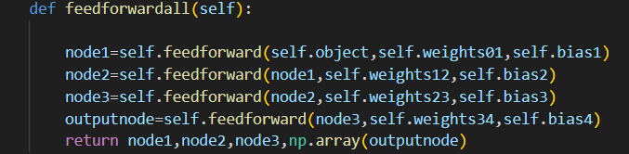

The final change is within main where I no longer need to use the backpropagation functions or store the weights and biases after training. This significantly simplifies the code. I first initialise the class, which no longer requires an index of which image set is used since there is only one image location and I then run the feedforward all function. There is no longer an output of total cost since this is a waste of computational power. The output node is then used to represent which image is most likely to be chosen and the largest value is then taken as an index and then this index is then set to each of the images.

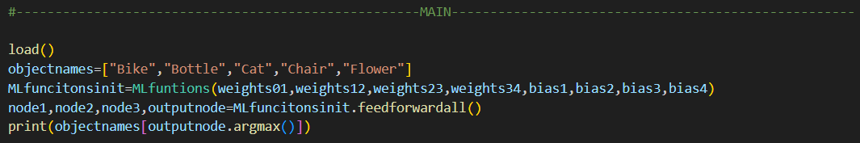

This is the feedforward part of the program. I now need to code the ability to take images and turn this into an auditory output.

## Raspberry Pi image store

To code this, I will use the Raspberry Pi image taking device. unfortunately, this can only be used on a Raspberry Pi.

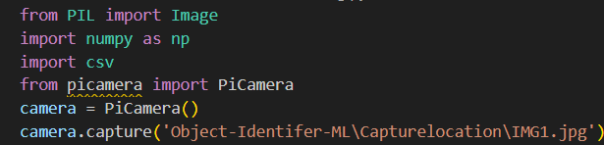

This is the main way an image is taken and then stored to this file location. I use the pi camera library in order to take this image and I store this to the capture location. At the end of the program, it is important to delete the image since this will not allow for the same file name to be used during the program’s run time. In order to store the images as part of the success criteria of producing a log, I will also store these images in the log folder.

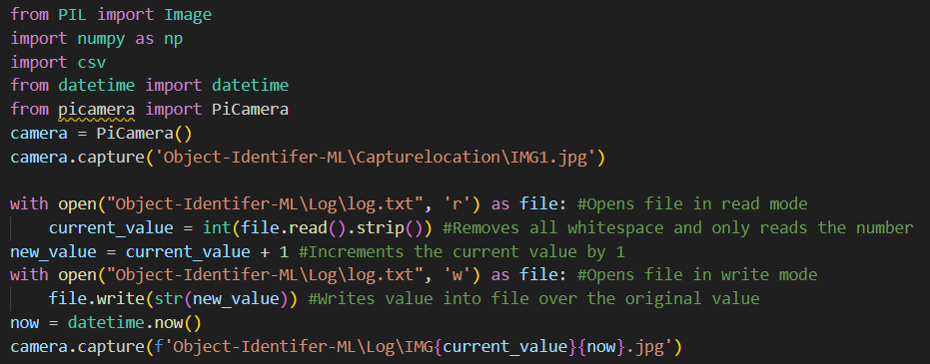

This uses a text file called log.txt which contains a single number, representing the logged image file. This can be used in the future to look back at images. I also used a datetime library which allows for the images to be time stamped so the user can see when the image was logged simply by looking at the file name.

The final step to be made is to remove the image after the detection is completed from the capture location. I do this by using the operating system library called os. I use os.remove to remove the image and csv file after running the feedforward operation and I call the library at the top of the program.



This completes taking the image from the Raspberry Pi and then storing it within the correct location. It also removes the image from the capture location to avoid the new image to be taken renaming itself. I also have successfully completed the log functionality.

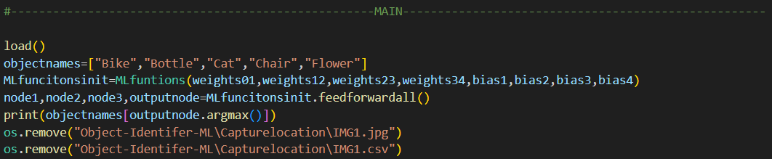

This completes the image classification part of the program. The final steps include iterating this process and giving an auditory output.

## Auditory output

This is one of the simplest parts of the program so far, since it only requires using a library function to work. I import pyttsx3 and I use the text to speech function.

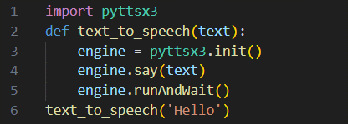

I then implement this into the code relatively simply. I copy the first 5 lines into the top of the program and I then call the name of the object within the function. I ***tested*** the program by running this on a Raspberry Pi and it successfully said the word hello after connecting to a speaker.

However, according to my success criteria, I will need to implement a way of uniquely identifying each object depending on a part of the voice. In my success criteria, I suggested using a pitch modulation however, this library does not support this so I will instead change the rate of speech. Since this is designed for people who have difficult understanding this voice, I will ensure I only slow down the voice instead of speeding this up.

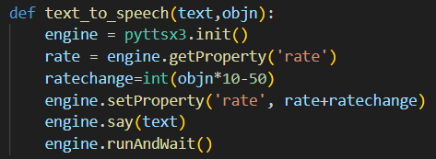

This will change the speed of the word said depending on the object index which is an input through the object number input, “objn”. I then call this function.



This successfully completes the success criteria from being able to identify each object from another feature of voice. This completes the object detection as well as the voice output.

## Activating change in voice speed feature

In order to activate the change in voice speed, I will check within a text file for a letter. If the letter is Y, then it will change the pitch. If the letter is N then it will not use this feature. In order to allow for the user to change this feature to yes or no, I will implement a form where the user will either input yes or no, using validation to ensure that no mistakes are made.

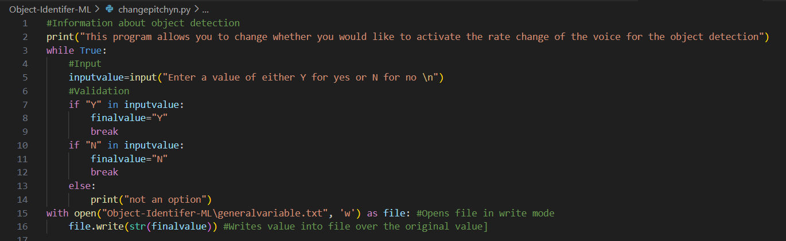

This provides validation to the input and ensure that the general variable file only contains “Y” or “N”. This ensure that the user’s input is successfully entered into this file and ensure proper validation.

However, if the user accidentally changes the value within the general variable file, then this would otherwise cause the main program to crash. To avoid this, the program requires a validation check before using the variable to ensure this is in the correct format, as well as being able to properly deal with such a mistake without the user needing to know.

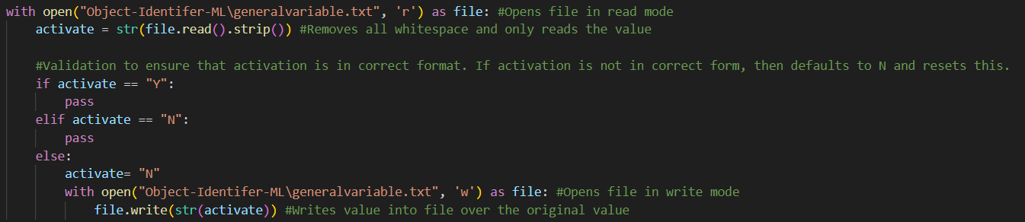

This opens the file and assign its contents to activate. If the variable activate has been tampered since the last assignment, it is reset to no and the file is rewritten to only contain “N”. This protects the program against any input tampering, allowing the user to correctly enter the value when trying to activate the feature and preventing any tampering to cause any errors while being stored.

I also slightly changed the text to speech such that the activation variable will affect whether the pitch change is used or not.

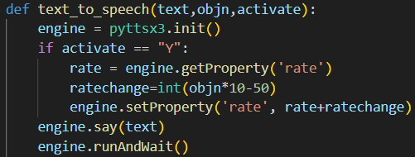

This checks if activation is “Y” and if so, then it uses the feature. Otherwise, the rate change part is ignored within the function.

Another file containing a variable is log.txt which contains a value used to assign the image number within the log. To avoid any tampering of this variable to cause the program to produce an error, I added a level of validation to this.

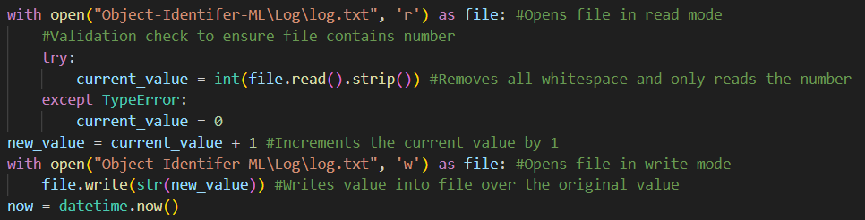

If there is a type error which would happen if the value within the file is not just an integer, then the program will not crash and will instead reset the counter to 0 within the file. This validation further protects the program from any errors.

## Testing changing voice speed

I will test the input to change the feature of the rate modulator by running the program and editing the file when it does not expect to do so.

Test case 1: Was previously Y and changed to Y

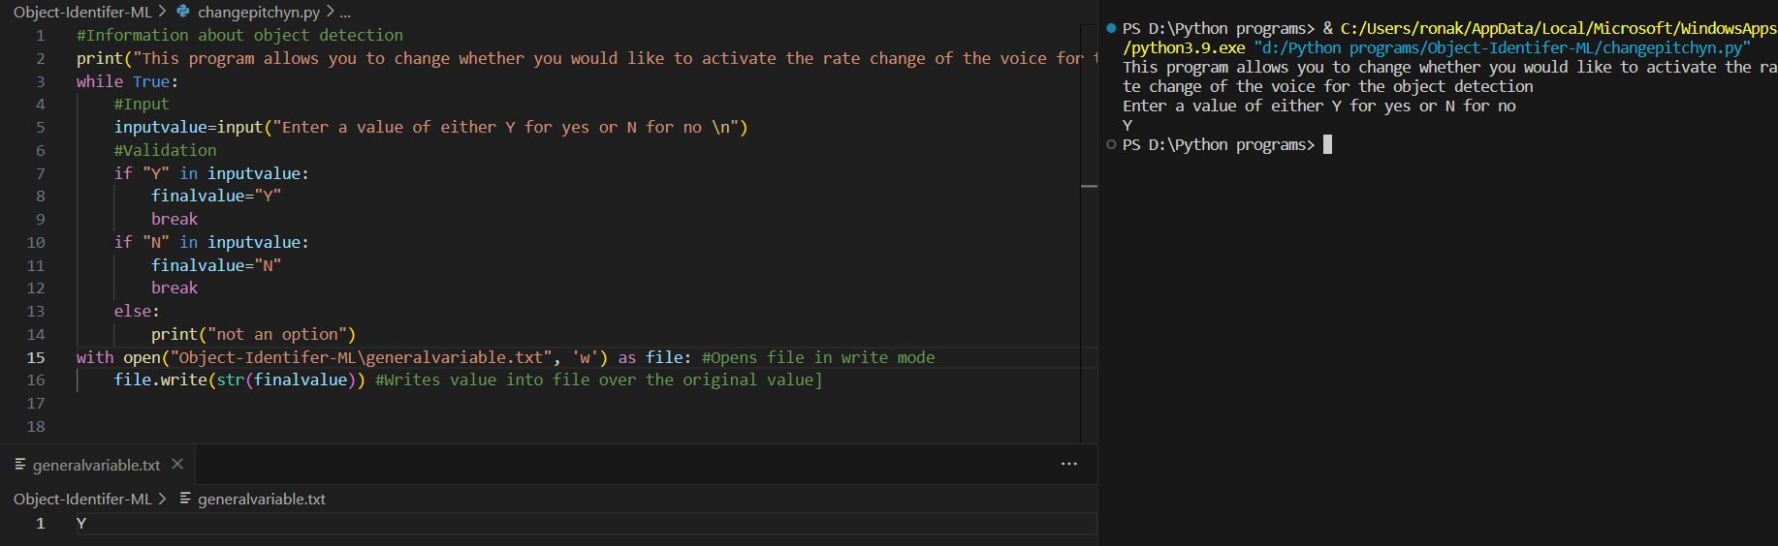

As can be seen, it still has a value of Y after running the program.

Test case 2: Was previously Y and changed to N.

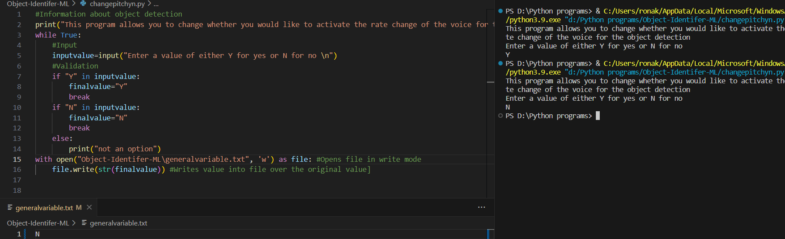

As can be seen, after giving an input of “N”, the file has changed to “N”, successfully going from “Y” to “N”.

Test case 3: Was previously N and changed to Y

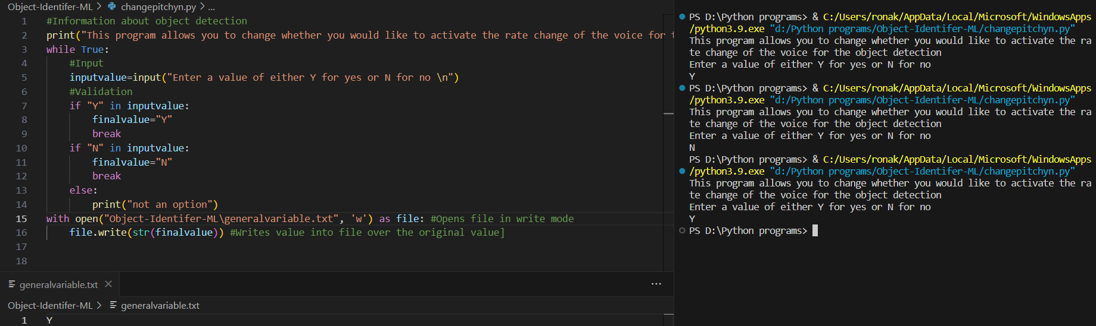As can be seen, the value has now turned back to Y from N

Test case 4: Was previously N and changed to N

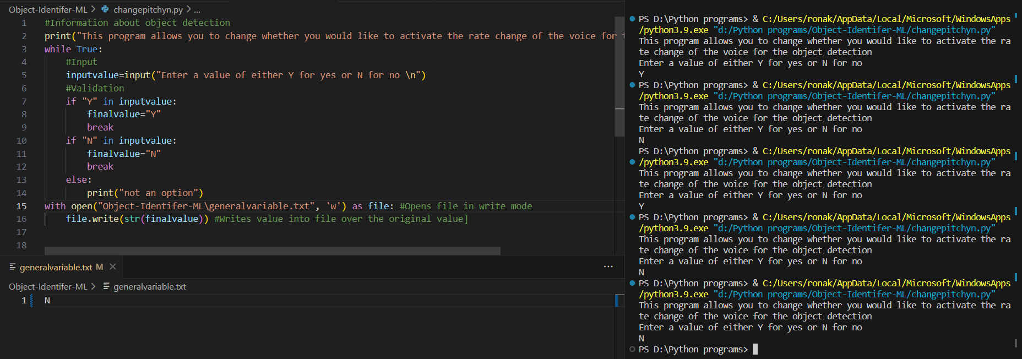

I set the value to N from test case 2 and I then input N again to test for this test case and as can be seen, the value stays as N.

Invalid test case 1: value does not contain “Y” or “N”

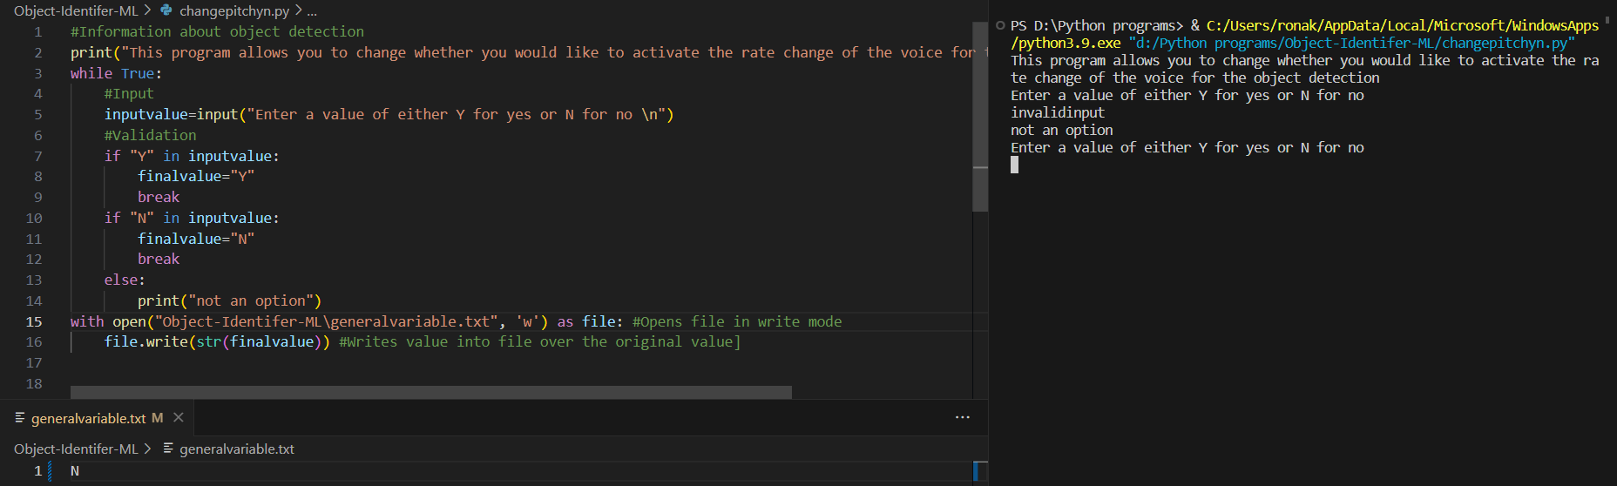

As can be seen, the value of the general variables is not updated with the use of an invalid input and is kept as the previous value (from test case 4). The program then informs the user of the mistake and then allows the user to input the value again.

Invalid test case 2: “yes”

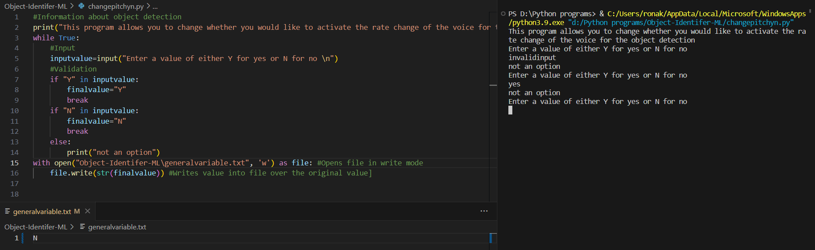

As can be seen, “yes” is also an invalid answer since it does not contain a capital “Y” within the option and the program therefore rejects this. This is the program working as expected however, changing this would be most optimal so I will change the program to allow for an answer of yes.

To do this, I change the check for both a capital “Y” and a lower case “y”

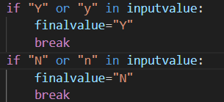

I will then test invalid test case 2

Previously invalid test case 2: “yes”

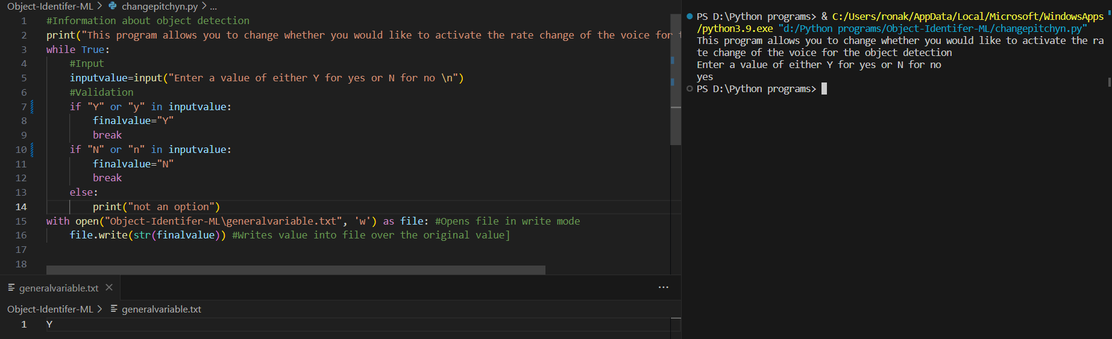

This time, the input yes is successfully parsed and sets the general variable file to be “Y”. I will now test the, now valid test case of “no”

Previously invalid test case 3: “no”

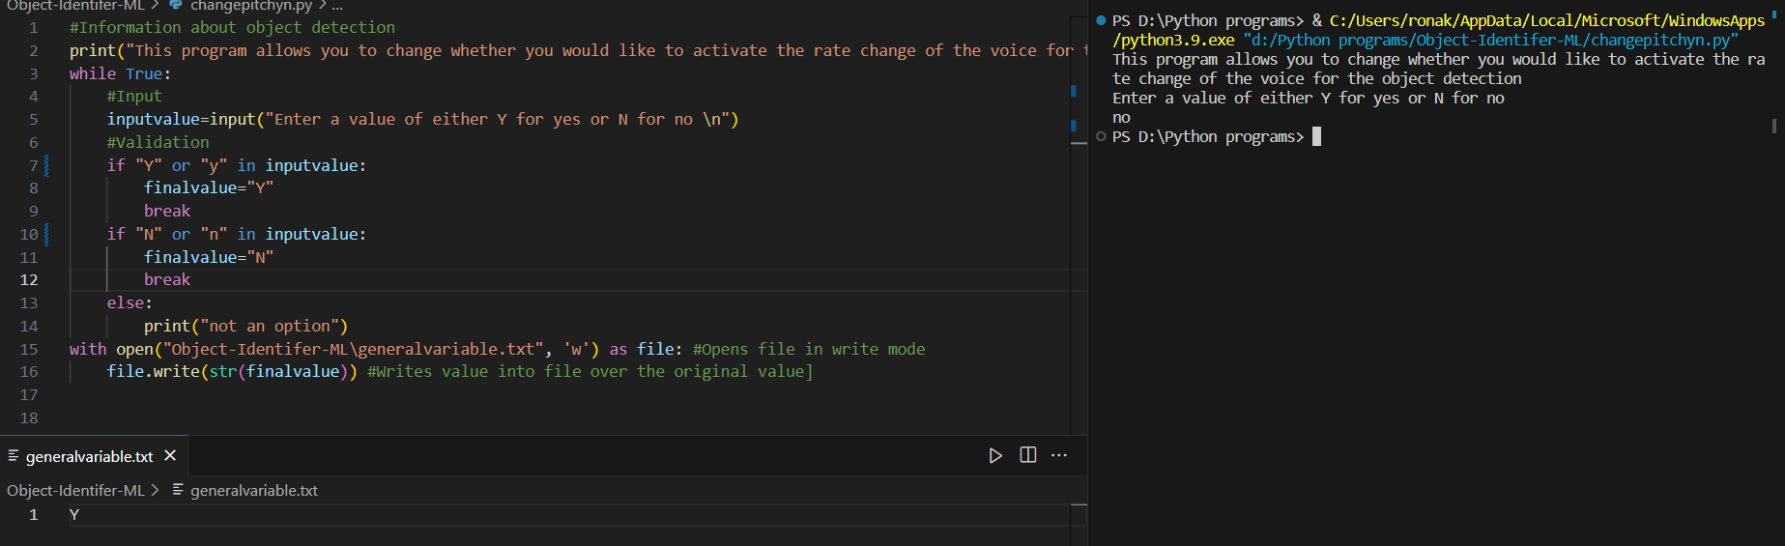

The program does not turn an input of “no” into turning the general variable file into “N”. I will now test “N”

Previously valid test case 2: Y to N

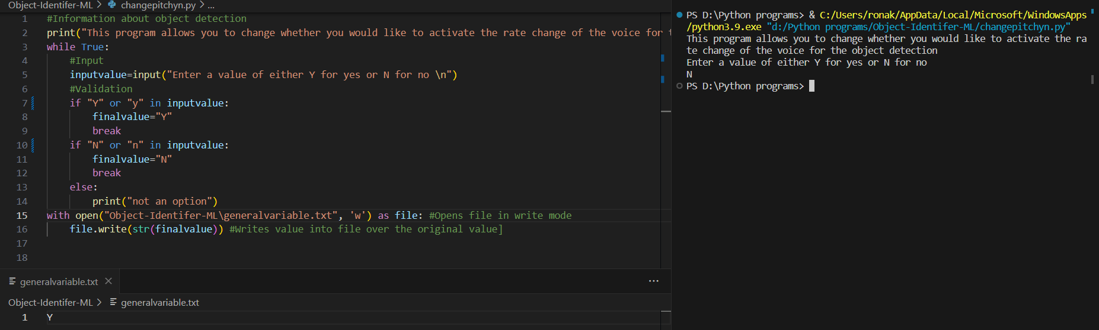

This does not work either. This is because adding the or command caused the program to no longer be able to identify the letters correctly since it was not done in a correct way. I will now reimplement the code to allow for both “Y” and “y” as well as “y” and “Y”.

Previously invalid test case 3:

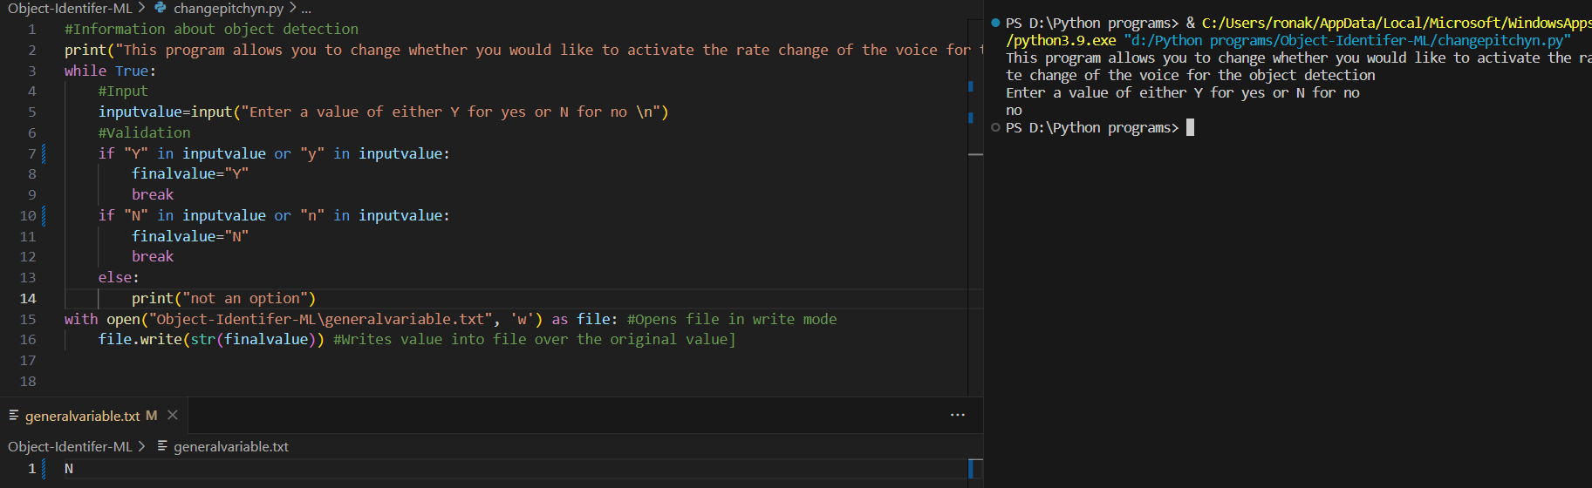

As can be seen, this now functions as expected with “no” turning the general variable to “N” in the file as expected.

I will now go through all of the test cases to ensure that this change in code has not affected these previous tests, in accordance with the spiral iterative testing development model.

New test case 1: Was previously Y and changed to Y using “Y” and “yes” as inputs

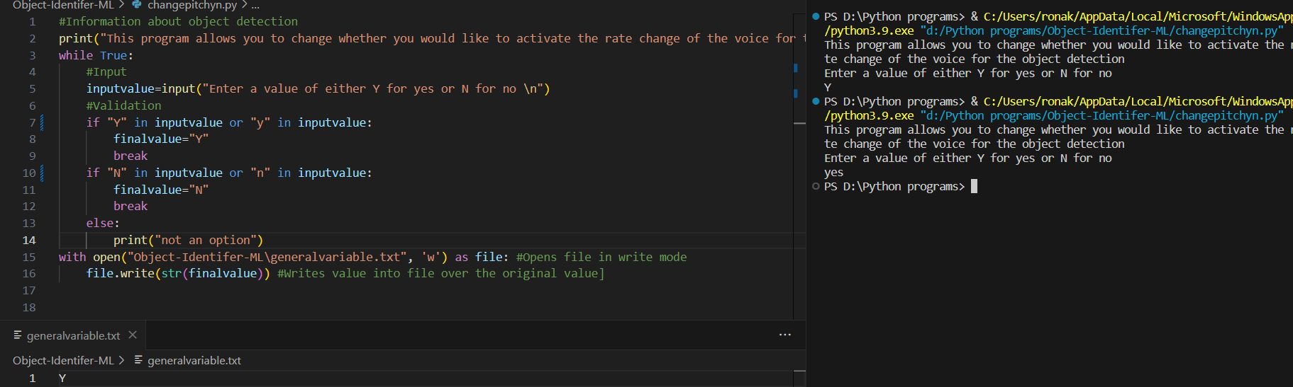

Both the input “Y” and “yes” keep the general variable file as “Y”

Test case 2: Was previously Y and changed to N using “N” and “no” as inputs

To do this, I will have to turn the general variables file into Y between tests by physically changing the value in the file which is something that should not be done.

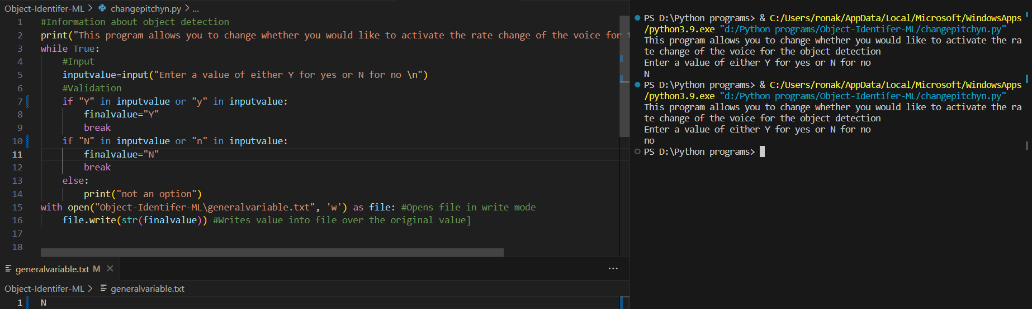

Both successfully turned the Y into N with these test cases functioning as expected.

Test case 3: Was previously N and changed to Y

To do this, I also change the general variable file as I did for test case 2.

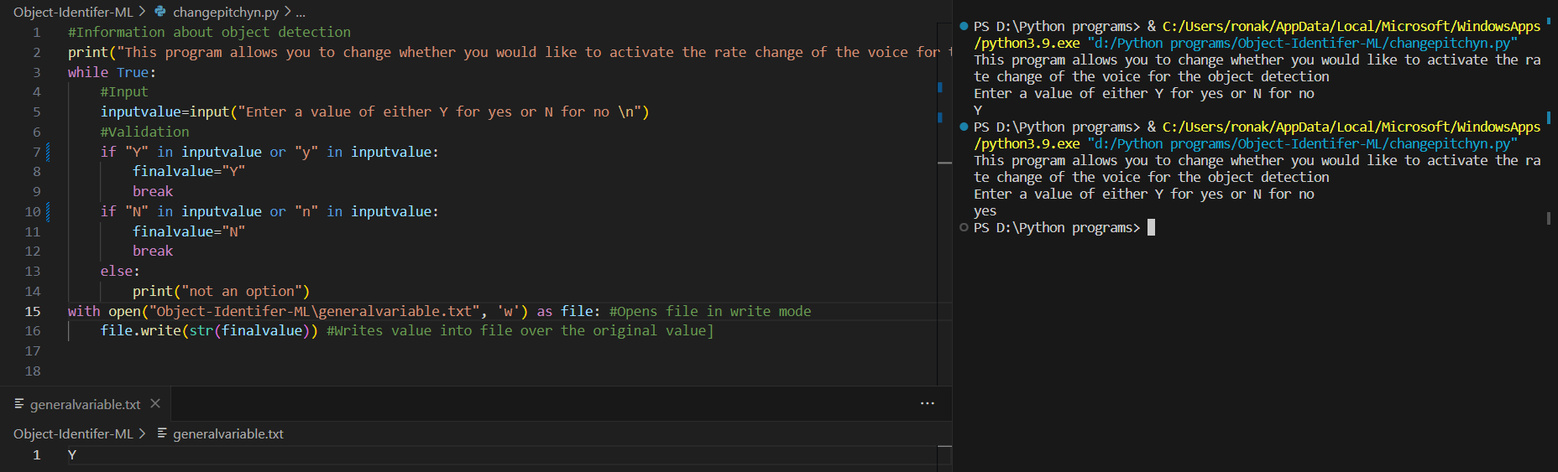

This functions as expected.

Test case 4: Was previously N and changed to N using “N” and “no” inputs

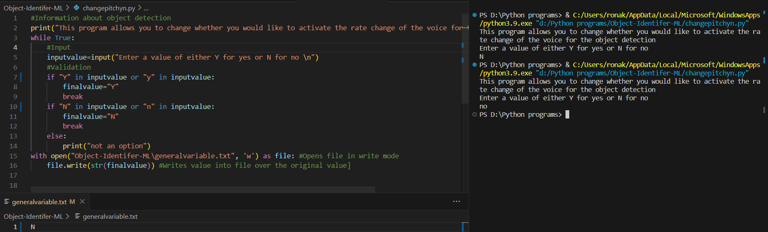

This too functions as expected.

Invalid test case 1: value does not contain “Y”, “yes”, “N” or “no”

This is an important test case since it is when the user does not enter either “Y”, “yes”, “N” or “no” and is important since if the user does not enter any of these, the program assumes that the user did not enter the data in the correct format so gives the instructions again and allows the user an attempt to retry.

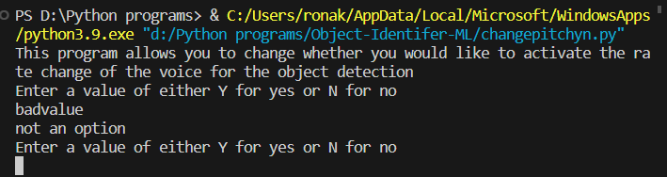

This informs the user that their value in this case, “badvalue” is not an option and gives the user an opportunity to revise their answer, giving the instructions of entering the value for “Y” for yes and “N” for no.

This completes the testing for the input to activate this feature.

Another test case is if the general variable file itself is altered and this could cause the problem to crash. I will test the validation on the image identification file.

I first set the general variable file to have a file called invalid file.

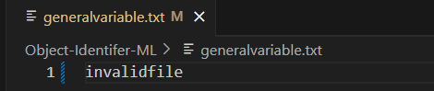

I then run the image identification file, testing the code below.

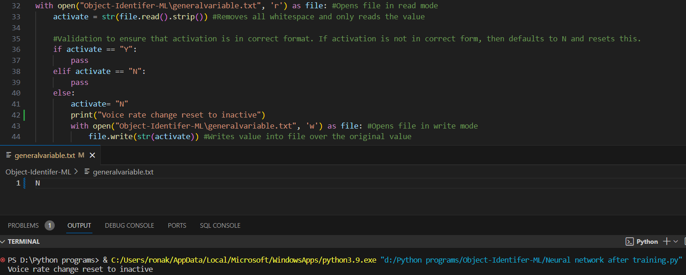

This successfully reset the voice rate change file to have a value of “N” after being run on a Raspberry Pi.

This completes testing on the general variable file.

## Activating time delay feature

Using the modular code design from the previous feature, I can use the modular testing to ensure that this code will also work as expected. This is another benefit of working with modular code, where code only needs to be tested one and then can be implemented many times since its behaviour has been previously tested and therefore I can ensure that it works as expected.

I will start with the framework of the previous code and change it to go to a different file location.

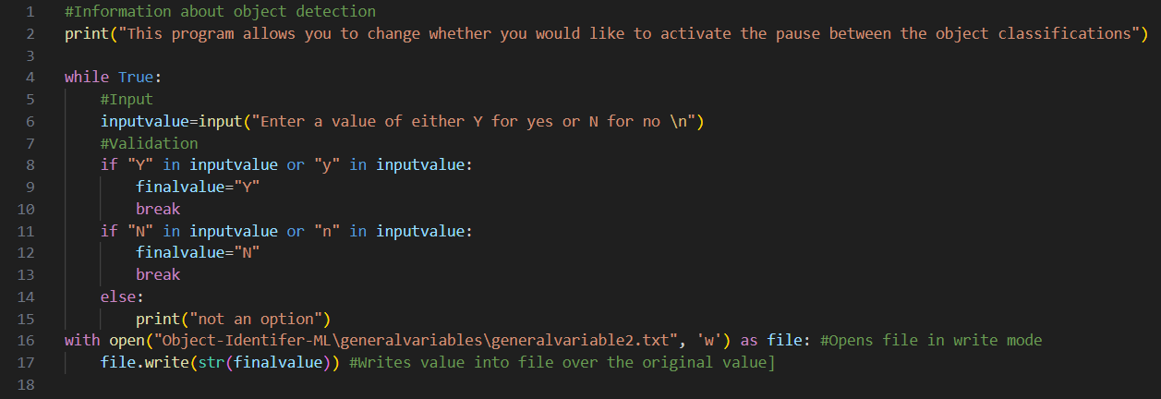

I also changed the file location of the previous general variable file to a folder. This simplifies the file structure.

I also implemented the checks as for the previous feature. I also changed the file location for both.

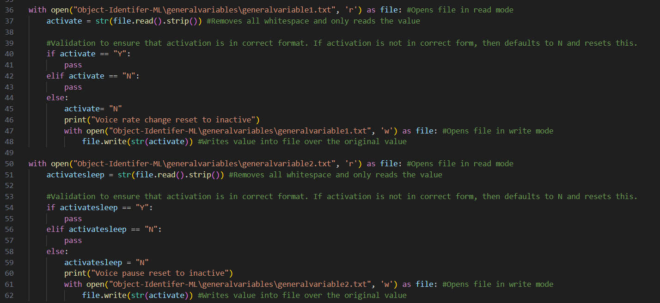

As can be seen, I now store these variables in \generalvariables\generalvariable1 and \generalvariables\generalvariable2 which simplifies the file structure.

I also produced the function that gives this time delay within the program

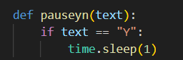

I then called these functions at the end of the program



I will now iterate through the main function using a while loop at the top of the program and I then indented the rest of the code.

## Distance sensor

The final modular part of the program is to program a distance sensor. In order to do this, I will need to attach the distance sensor to the Raspberry Pi through circuitry and then code the distance sensor function that outputs a number that represents the number of centimetres it is from an object. The code below will send a trigger signal to pin 4 and a trigger signal to pin 17. This is the code.

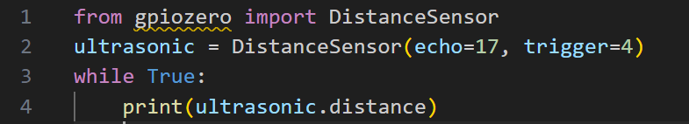As can be seen, this will output the distance using the library.

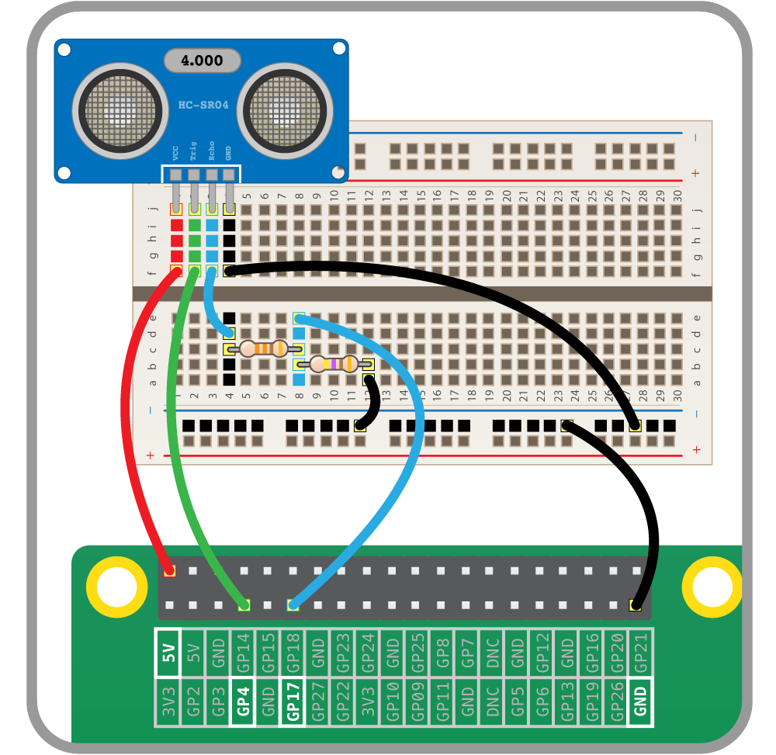

Here is an overview of the entire system as well as a close picture of the simple physical circuitry used for the distance sensor.

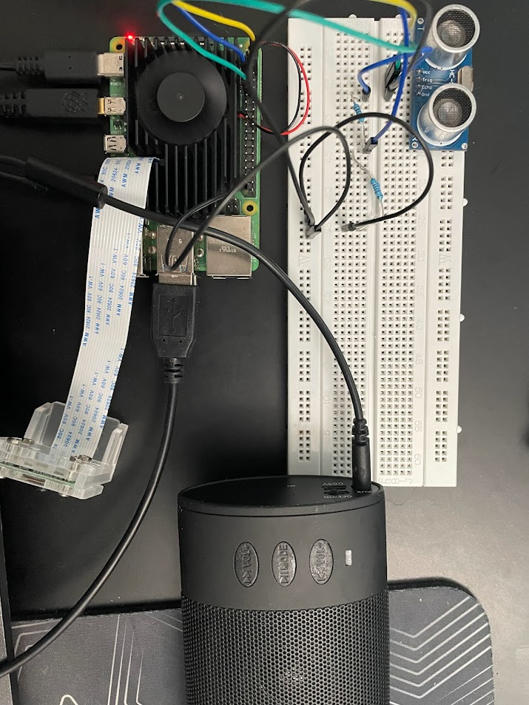

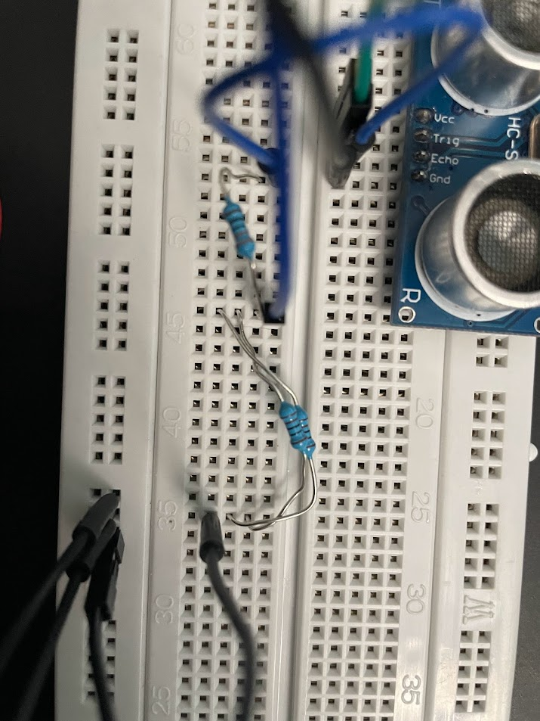

I used 2 1 kilo-ohm resistor instead of a 470 ohm resistor since I did not have a 470 ohm resistor which can be seen by the 2 resistors with their wires crossing above.

Due to the modularised nature of this design, I can add this to the main program and this value can be output as an auditory signal.

This is this code combined with the main program that outputs the final sound value.

I turned this into a function, and I then called this function at the end of the program.

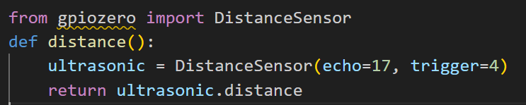

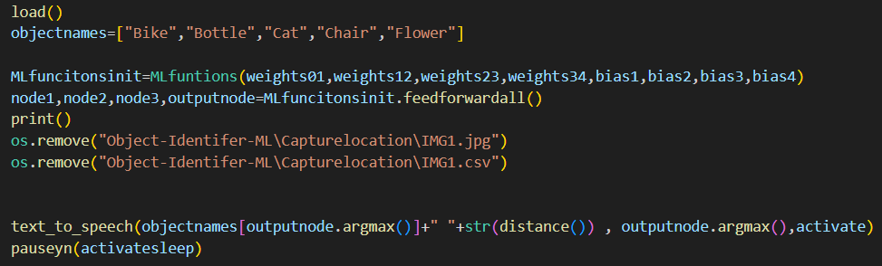

The input of the text to speech function has been modified to include the string distance value and a space to give a word break between the distance and its sensor.

## Testing of final product

### Testing modular functions

In order to test the functionality of the final product, I will test the functionality of each function and ensure that the outputs are as expected.

The first function to test is the sigmoid function. I will run specific values for the function and if they are the same as the values calculated with a calculator, then the function is working as expected.

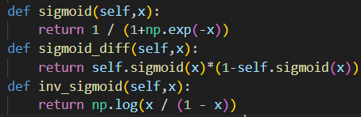

These are the 3 functions. I will then output the values for 0, 0.5 and 0.8 for each and then compare to what I expect the values to be.

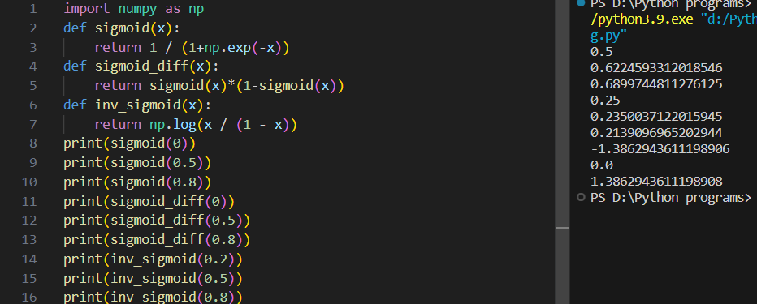

After comparing these to the values that I calculated using a calculator and a verified sigmoid function calculator, these are all correct and function as expected.

### Testing user experience

I will now test the functionality from a user standpoint. Here is a video of the product being fully functional.

[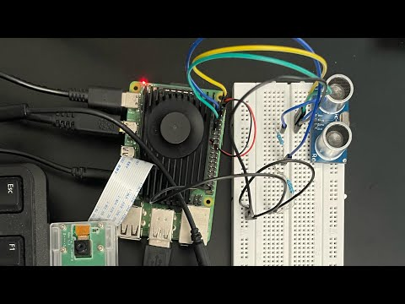](https://www.youtube.com/embed/ZE3M99bzP2c?feature=oembed)

[Link to video](https://youtu.be/ZE3M99bzP2c?si=ivxU1YyMSY3Wbxza)

As can be seen, the product works as expected for detecting the water bottle and the chair.

# Evaluation

I will now evaluate the final solution. To do this, I will compare to the success criteria produced during the design stage and ensuring that all parts of the program work as expected. It is important to use the success criteria since this will check the suitability of the final solution. I have copied you.

## Testing checklist

|  |  |
| --- | --- |
| Actions to test | Functionality/10 |
| Main network class | 8 |
| Training Class | 9 |
| Auditory output class | 10 |
| Change frequency output | 6 |
| Change object set output | 4 |
| Change colour information | 0 |
| Change input training files | 6 |
| Change the time between identification | 10 |

I will now discuss my reasoning to give the scores that I have given for each score.

|  |  |
| --- | --- |
| Main network class | 8 |

During the main network class, it has a high level of functionality since it successfully implements the gradient descent algorithm. However, since the NumPy array uses a simpler parallel form of matrix multiplication instead of a fast matrix multiplication algorithm. This means that the algorithm is held back by the speed of the matrix multiplication algorithm. In the future, I would like to move to using a different library. This would require changing the data types of the entire program and produce my own matrix transposition algorithm. This could slow down the program. This causes the program to be slower than intended.

|  |  |
| --- | --- |
| Training Class | 9 |

I believe that the training class has a relatively high functionality since it is able to train the neural network for a set input and expected output to give reasonable output. This is because I successfully implemented the gradient descent algorithm and therefore the network can be trained. It does not have full functionality however, since it has some of the slower properties as I described above.

|  |  |
| --- | --- |
| Auditory output class | 10 |

The auditory class output has full functionality since it is implementing a pre-defined library which functions as expected.

|  |  |
| --- | --- |
| Change frequency output | 6 |

The change frequency output functionality is not present due to the limitations of the library “pyttsx3” used. In the future, I could potentially use different libraries without this limitation, however these libraries would not provide an auditory sound output within Python, it would only give a sound output through a media file such as producing an mp3 file. Using the “OS” library, this can be executed but requires the device to have an mp3 program that functions in a way that is expected. The full file path name would also be required to run this so this would reduce the modularity of the program. This would also require the mp3 file player to be able to be turned off by the Python program, which requires administrator access to the program. This would increase the difficulty of running such a program. This could also be unstable since if the program crashes at any point, then an mp3 file may not close as expected, requiring human intervention by opening up the Raspberry Pi and checking the status, therefore requiring a guide on how to solve such a problem. Since Pyttsx3 is one of the only Python libraries that can implement an auditory output directly within Python, this is the only current option, therefore making pitch changing quite difficult to implement. However, Pyttsx3 has several different voices that could be used so potentially different voices can be used instead of changing the pitch. The current functionality stands as using a rate of speech changer. This less ideal since each word is less distinctive than if the words are said at different pitches. This partially achieves the functionality of the program to improve the accessibility of not requiring to be able to directly understand the words, but other features of the voice. The user could potentially identify the different time lengths taken for each word however has a lower level of functionality than I originally desired.

|  |  |
| --- | --- |
| Change object set output | 4 |

The functionality to change the image set is quite low due to the lower level of modularity as I had originally hoped during the initialisation of the main class. This is because the 5 different sets are coded in with several parts of the programming only functioning assuming that there are 5 different image sets. In order to increase the number of images set, several distinct programs must be changed. One would be within the primary initialisation of the weights and biases from the program, “initialise variables”. This reduces the functionality of being able to identify other objects since this requires fully understanding the code structure and knowing where to specifically add images as well as how to label such images, requiring a command which would change depending on if a Linux based kernel or a windows-based kernel is used. This complexity would not be suitable for most users of such a device and therefore would require the image sets to be set before the user starts to use such a device. This gives a relatively low functionality of this option since it requires changing many different variables and lines of code in order to accommodate the addition of another item. However, this is still possible using the current framework of the network and if a user is capable to change several specific parts of the network, then it is quite simple to change the program to allow for 6 different image sets. Also, changing the image set is relatively easy. For example, if I wanted to personalise the image dataset for water bottles, I can simply upload a set of at least 160 images of water bottles and delete the previous set and then ensure correct naming schemes by running the command “ren *png *jpg” for each image type and changing the naming to the ones used during the program using power toys or any integrated tools that the user chooses. This does not require a high level of expertise however could be difficult to those who have never used command prompt before since it requires reaching the file location of the different images. Due to the difficulty of changing the object set, this has a functionality of 6 instead of being closer to 10.

|  |  |
| --- | --- |
| Change colour information | 0 |

This was given a functionality of 0 since it cannot be implemented in a way that a user would expect such a feature to work as the program uses an image classification model instead of an image detector. I will explain the main differences between these aspects since this prevents the model from achieving an expected form of this program to work.

Image classification attempts to give a label to the entire image. This is what I did by running the image pixel values through a network that compresses the output into 5 values, representing the image that it thinks the object is. I chose to do image classification since it is compatible with multi-layer perceptron neural networks. The goal is to train the model to give the entire image a category and whether it contains a water bottle or a chair etc. However, the network does not understand what a water bottle or a chair truly looks like, it simply can identify patterns that all chairs and water bottles have. For example, this type of network can be tricked into having a very high confidence that seemingly random noise is a specific object. This is one of the limitations of this type of network. This is one of the reasons why it cannot identify where an object is.

Image detection goes beyond what image classification can do by gaining information about the specific location of the object. This is done by drawing many boxes within the images and applying a smaller version of the network to each box producing a multi-dimensional box containing its confidence of each sub part of the image to be each image. For example, one part of the image may have a confidence of 20% of being a cat , 70% chance of being a water bottle and 2% chance of being a plane. This would provide information for that box to most likely be a water bottle. If the surrounding boxes also have a high confidence to be a water bottle, these boxes combine to produce a bounding box of where the image detection algorithm thinks the water bottle is. This requires a different type of neural network such as a convolutional neural network and is much more complex than my type of neural network. This allows for information about the specific location of the specific location of the image. Unfortunately my program does not use this type of neural network and therefore cannot gain information about the specific location of the object. This means if colour information is found, this would not be representative of the colour of the object, it would instead represent the colour of the entire image. This is not very useful since most images are not of a similar colour. This is a major problem since it does not provide an accurate representation of the colour of the object. This reduces the effectiveness of such a feature to a level such that it chooses a random colour to a point which is not that useful. This is why I decided to not include such a feature since gaining information about the average colour of an environment is not very informative and useful. A more useful piece of information that to be gained at regular intervals is the distance between the object. The user will most likely not use the colour information about the entire location in any way which was one of the reasons why I decided against using such a feature. This is also much less information since the value depends on many factors that mean the value the user expects is different to what the value is given as. It will also depend on the brightness. For example, a very bright blue is more likely to be identified as yellow since the bounding values for the hex colours of yellow are quite large and the values for a very light blue are also quite large. This would mean even block colours could be incorrectly identified due to the different brightness levels.

|  |  |
| --- | --- |
| Change input training files | 6 |

As described previously, this has a relatively low value since this requires a level of user intervention that most users that this is designed for will not be able to reach. To improve this value, the program should have several different files where one contains the different names of the objects. The program will then be able to change the architecture the entire network to reach this value and then using the names given, the file names will follow the same structure so in the future, I could potentially improve the program to allow for such different values. This is why I gave this a rating of 6 instead of a rating closer to 10. This requires a relatively high level of competency to change currently but is possible which is why I chose to give a rating of 6.

|  |  |
| --- | --- |
| Change the time between identification | 10 |

I successfully completed this using the in built time module within Python. Using the modular design from attempting to change the frequency output, I was able to use most of the code in a similar way and it completes this part of the success criteria since it gives a time delay. However, in the future, I could potentially give the user the option to change the time delay. For example, if the user requests a time delay of 1 second, then I can use the time.sleep for a specific set time for this to be used. However, the code does successfully complete this objective.

I will now evaluate the final solution compared to the test tables I designed during the design aspect of the program. I have used a spiral methodology so I will evaluate whether the final prototype meets the testing criteria.

## Checking test tables

I will now test the program compared to the test tables I made during the design aspect of this in accordance with the spiral methodology.

This is the first test table I produced. I will compare to all of the test tables I have produced to ensure that it was properly done. This first table tests the default object detection. The 5 objects I have chosen to identify against are: Bike, Bottle, Cat, Chair and Flower. I will replace the object 1, object 2, etc. with these values. The table below is the original test table I produced.

|  |  |  |  |  |  |
| --- | --- | --- | --- | --- | --- |
| Object type | Attempt 1 | Attempt 2 | Attempt 3 | Attempt 4 | Accuracy |
| Object 1 |  |  |  |  |  |
| Object 2 |  |  |  |  |  |
| Object 3 |  |  |  |  |  |
| Object 4 |  |  |  |  |  |
| Object 5 |  |  |  |  |  |

In the table below, I have replaced the object 1, object 2 parts with the names of the objects.

|  |  |  |  |  |  |
| --- | --- | --- | --- | --- | --- |
| Object type | Attempt 1 | Attempt 2 | Attempt 3 | Attempt 4 | Accuracy |
| Bike | Yes | No | No | No | 25% |
| Bottle | Yes | Yes | Yes | Yes | 100% |
| Cat | Yes | Yes | Yes | Yes | 100% |
| Chair | Yes | No | Yes | No | 50% |
| Flower | No | Yes | No | No | 25% |

As can be seen, the object detection is very good at identifying bottles. For the cat test, I fed the training images into the program and it successfully identified all of them however, this could potentially not affect real world performance since I did not have access to any cats. For the bike accuracy test, only the first test was successful since it was a direct image of a bike. The others were from other angles so it was less accurate. The chair was surprisingly inaccurate however only 2 chairs were used and the first chair worked both times while the second chair was not identified correctly. The flower was not identified correctly most of the time. This is most likely due to the background being similar to that of the bottle since for all fails, the flower was identified as a bottle.

When designing this test table, I intended for a confidence rating to be used instead of a yes, no answer, however after considering the fact that when the product is used, only a yes no answer is given so testing confidence is not as accurate when testing for real world performance. This is also why in the program, I took the maximum value and used that instead of giving a confidence rating for what it thinks for each image. Unfortunately, this means no matter what the image is, the network will always give an output even if the image does not contain any of the options. This could be improved in the future by testing if any of the outputs are above a specific threshold and if so, then it says it is that object. Otherwise, it does not give any output.

I also tested the input types such as the different ways to interact with the options to choose for the network for both valid and invalid inputs. Blow is my original table for each action.

|  |  |  |
| --- | --- | --- |
| Action | Expected output | Output |
| Object description | During object detection, object description is given |  |
| Different pitch mode | During object detection, each object has a different pitch |  |
| Colour information | During running the program, colour information about the surroundings is given |  |
| Log | The log either runs or does not run |  |
| Time between identification | Changes the time between object identifications |  |

However, after producing the model, many of these are not as important or make much sense due to how the final code has changed since design. This is mainly due to choosing a spiral methodology. If a simpler methodology such as waterfall was used, the same test tables could be used however due to the added complexity of producing this through the spiral methodology, producing many different prototypes, it is not as valid as it was in the beginning of the production process. I will now update the table to be more current and properly explains the new features provided by the program.

|  |  |  |
| --- | --- | --- |
| Action | Expected output | Output |
| Different rate of speech mode | During object detection, each object has a different rate of speech | Successfully changes the rate if feature is activated from running the change feature program. |
| Log | The log either runs or does not run | Can be turned on and off from the change feature program. When turned on, the log is used and the images seen are stored within the log file. |
| Time between identification | Changes the time between object identifications | Can also be turned on and off from the same program. If turned on, then there is a delay between activations. |

As can be seen, all input test cases running through the changing program functions as expected. They all change the parts of the program that can now be done. The object description is no longer given since this is unnecessary in my opinion since if an object is identified, by pointing the device towards the object, a description will either already be known if the person is an adult with vision loss, or if the person is a young person who does not know what the object is, the name will correlate to the shape of the object, with the young person learning in a similar way to the neural network, making connections with the patterns within the object and the output given. Except for the young person, the output is auditory instead of being an array of what the expected output should be.

I will now test the outputs for the program for the inputs. I will do this by testing if the inputs given are successful or not. I will first test this for turning on and off the rate change of the voice detection.

|  |  |  |
| --- | --- | --- |
| Action | Input | Output |
| Different rate of speech mode | “yes” | Changed successfully |
| Different rate of speech mode | “invalid” | Not an option |
| Different rate of speech mode | “no” | Changed successfully |

This is functional therefore the input is properly validated within the program.

## Input testing

There are 2 main forms of input for the user. The first input is to change the rate of speech. The second input is to change the time delay.

I will now evaluate whether the variables take inputs as expected.

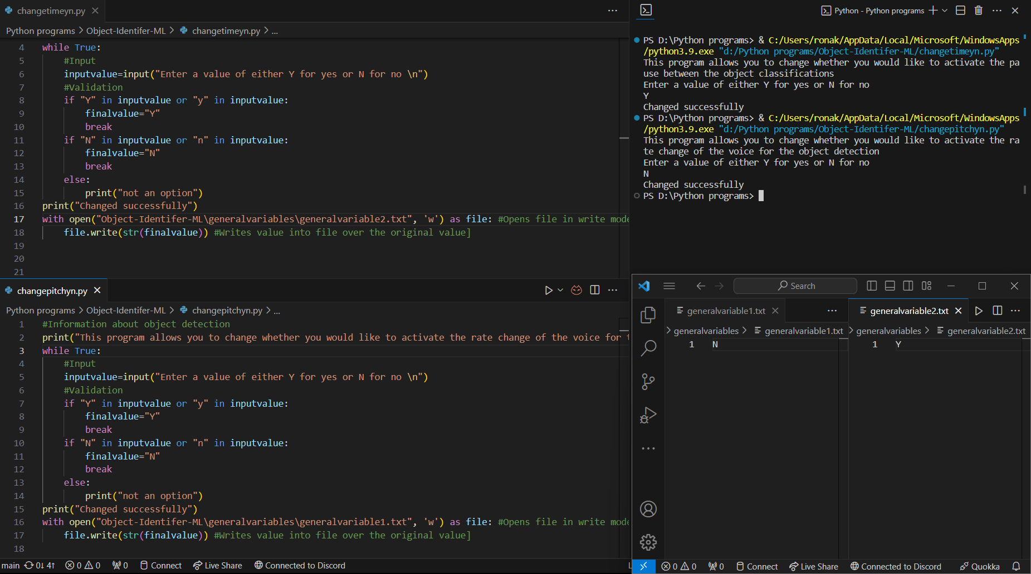

As can be seen, both programs successfully change their respective general variable files correctly, therefore activating their features as expected. These are all the inputs directly attributed to the user and since they work as expected, the inputs have been successfully tested and proven to work.

This completes input testing since the tests have been completed in a greater detail above and the results continue to this program.

## Stakeholder testing and evaluation

I asked my stakeholders several questions to evaluate their response and opining on the validity of the program. This is an essential part of the evaluation since it gives information on their opinion on the final product which has been designed for them. If the user believes that the product successfully completes the success criteria as they require, the program is successful. Using the information given by the stakeholders, it can provide valuable insight into the success of the program.

One of the stakeholders who I will interview is Sarah Brown who has a form of blindness. I believe this will provide information about how well the product works for someone who has a form of blindness where it is difficult to see the surroundings.

I will evaluate their response after producing a set of questions after giving Sarah Brown access to the device. The questions will be used to evaluate the product.

1. Was the use of the feature that changes the rate of speech for each object useful?
2. Was the use of the feature that adds a time delay between each object detection useful?
3. Was the object detection effective?
4. What the distance sensor effective?

After careful evaluation, I believe these questions will cover most aspects of the program that the user will deal with on a day-to-day basis. These are the responses given by Sarah Brown.

1. Was the use of the feature that changes the rate of speech for each object useful?

I believe that although the use of the feature of being able to change the rate of speech could potentially be useful, it added no direct benefit to me since I can understand the words and the changing of the rate of speech provided no direct assistance. This feature is not as effective as changing the pitch since it still requires the user to be able to understand the word of the object. Also, the change in rate of speech was not significant enough to be easily identifiable and the object with the slowest rate of speech, flower, was too slow so turning the program where the first objects are faster would be better.

1. Was the use of the feature that adds a time delay between each object detection useful?

I can see how this feature can be potentially useful however since having constant object detection every 2 seconds became unnecessary, so I preferred having a time delay over not having a time delay. I would, however, prefer the option to have a different, longer time delay as an option since even with the time delay, it happens too often.

1. Was the object detection effective?

I believe that it could identify certain object effectively however it has a very limited set of items it can detect, and it sometimes gets these objects wrong. It also gives an output even when I am not looking towards any object. It also requires a certain angle to take the image at for this to be effective which is slightly inconvenient and most of the time, I can identify the object before it gives an accurate reading.

1. What the distance sensor effective?

Yes. It worked as I expected it would, giving accurate distance measurements and helped me navigate around. This was the most useful part of the device in my opinion. However, I don’t need to know how far something is to the nearest centimetre, I think nearest 10 centimetres would be a more human centred design choice.

This gives an invaluable overview of the final product and its design.

The first question gives feedback on the feature of changing the rate of speech. The feedback gives information about how it can provide some level of effectiveness however does not provide direct support to Sarah Brown. After reviewing the reasoning, I believe this feature does not provide the same level of accessibility as changing the pitch since in order to be able to tell the difference between the rates of speech, you will also most likely be able to tell the difference between the words, therefore making the range of people where this feature is useful very small. Therefore, this feature has limited utility so in the future, I will change the library to a different library that uses pitch changing features and ensure stability using thorough testing.

The second question allows for me to change this feature to be more suitable for the user. I realised that the time delay was not as long as the user would’ve wanted. To allow for a variability in the time delay, I will let the user to entre a value to enter the time delay value. I then set this value as the time delay. This would give my stakeholder this option which would improve the effectiveness of this product, fully completing the success criteria. I was not aware that the constant information would not be the best of ideas however, after reviewing, I realised that I will have an inbuilt 2 second time delay.

The third question unfortunately represents the difficulty of producing a functional neural network. My architecture has very limited effectiveness since it does not look for patterns in the same way as a convolutional neural network, it can easily identify objects as wrong. This can be improved by using a pre-defined library but that would remove the performance benefits of coding such a network from scratch without the unnecessary functions. I could potentially use a different type of architecture in the future. Currently, this is affected by the level of training and the size of the network. A larger network could potentially be more accurate but would take much longer to train.

The final question gave a useful insight into making the product have more human centred design. I was informed that having such an accurate distance measurement is not necessary however is sufficient for the success criteria. Changing the program to give a distance to the nearest 10 centimetres when the object is over 20 centimetres away would give a more valuable insight into the distance from an object. I think in future iterations of this program, using a 10-centimetre design would be more effective.

I will also interview another of my Stakeholders. My second stakeholder who I will interview is Shashank Vinoo. I asked the same set of questions to reduce the bias.

1. Was the use of the feature that changes the rate of speech for each object useful?

I feel like the variable speech rate could be quite useful. It did not help me because I can understand the object names easily. It was slightly annoying since the difference between the fastest word and slowest word was quite significant and it did not help me in any way.

1. Was the use of the feature that adds a time delay between each object detection useful?

I preferred it with the time delay on but I wanted it to be longer since I was told about the object type every few seconds which was still to often. I never felt like it was too slow. I don’t know about others but a longer time between detections would be better.

1. Was the object detection effective?

I think that it could work better for other people but it got basically most of the things I showed it like a computer. It was able to say water bottle sometimes when I showed it my water bottle upright and it sometimes got my chair correct but a lot of the time, it said the background was a flower which was unusual.

1. What the distance sensor effective?

It worked quite well and did what I thought it would do. It doesn’t have a good range but I think its good enough most of the time.

The first question answer tells me that this feature was not useful or designed for this stakeholder category since this feature was designed for those who have difficulty hearing words. This is why I have the ability to turn on and off this feature since it was not designed for all user categories.

The second question gives a similar insight, similar to my previous stakeholder’s feedback however, I believe having the time delay to be set as 1 and then having the option to increase this would be better than having no time delay since otherwise, it would happen too often.

The third answer suggests that a larger object range would be more suitable for identifying other objects however, due to the limitations I will discuss later, this is not currently possible due to the added complexity of doing such a task.

The feedback for the fourth answer tells me that the distance sensor was an effective part of the device. I think improving its range could be a way of improving the product in the future. This could potentially be done through using 2 camera which are a set displacement again and compare the angles and pixel distortions. However, this would require another library to find these changes in pixel values which would be very difficult.

In conclusion, the product meets all success criteria, however, can be optimised towards some specific styles and the features could be maintained with additional code to increase the user customisation abilities however I think this could potentially be even more complex to set up so it is important for future iterations, a clear level of documentation is produced. This will be produced, however since I use a spiral model.

## Limitations

When evaluating the final product, I will also check for any limitations within the code. Due to the complexity of producing even a simple version of a neural network, this product has many limitations that I will talk about below.

### Requires pip installer to run

Unfortunately, this program requires pyttsx3 for the voice output. This means that setting up the program requires the user to install this library as well as any other libraries that are not present during their initial installation. This will change depending on the version of Python installed therefore the user must be able to identify which libraries are present or not.

### Only runs as expected on a Raspberry Pi camera.

The program is only designed to run on a Raspberry Pi due to using a Raspberry Pi library to run the code. I coded this part on a Raspberry Pi and then synced the code through GitHub to show code however cannot be used for this. The program cannot also be run on general images since the Raspberry Pi camera can take images with a BGR sub pixel layout and this is required in order for the grey scale conversion to be done accurately and will let the network to identify the images correctly. A Raspberry Pi cooler is also necessary due to the computational intensity of running many matrix multiplications to train the network.

### Complex to set up.

To set this up from scratch, there are many steps required in order to do this. I have detailed them in the document that can be seen below.

How to set up neural network.

Hardware required for setup.

* Raspberry Pi with cooler
* SD card 32Gb
* Computer with SD card slot
* Monitor
* Keyboard and mouse
* Internet connection dx

First, install the Raspberry Pi Imager from this website: <https://www.raspberrypi.com/software/>

Then, run program and install the correct Raspberry Pi operating system. It is important to install 64 bit if the Raspberry Pi uses this and 32 bit otherwise. A 64-bit operating system is not compatible with a 32 bit Raspberry Pi and could potentially cause problems.

Then select SD card from the choose storage option. Ensure the correct drive is chosen because it will be wiped when run.

Then select write. Ater this has been completed, place micro-SD card within Raspberry Pi. After this point, there are 2 ways to continue. This is one of the ways. The other way includes opening a SSH session on the main computer using WSL and connecting to the Raspberry Pi from this. Programs can then be opened using the commands to open the executable locations. Since this is a headless installation methodology, the user must be competent using commands to use this method, so it is not recommended.

Then attach monitor, keyboard and mouse to Raspberry Pi using the USB ports and the mini-HDMI connection.

Then connect to power. Raspberry Pi should boot. If not, repeat the first steps and use a different SD card. There are many reasons on why the Raspberry Pi does not boot. Check the error message on the Raspberry Pi and compare to documentation.

Once Raspberry Pi is booted, enter username and password to program. Then connect device to internet.

After this, install Python if not done already and install Git on the Raspberry Pi. Visual studio code is also required to be installed. You must also sign into visual studio code on the computer. This can be done by opening a git terminal and running the following commands with your email and name.

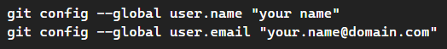

You can check the git configuration files using the command below

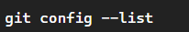

After this, go to visual studio code and type ctrl shift p. Then select clone and enter URL of git repository. If the program asks you to store the program in a specific location, ensure that the folder name is “Object-Identifier-ML”. This is not the same as the repository so this must be changed. If this is not possible, this can be changed within the programs.

After this, set up a virtual environment and locally install the libraries. You will know which libraries to install depending on if the libraries are underlined. To install a specific library within the virtual environment, do the command “pip install <library-name>”. If this doesn't work, then a global installation of the library may be done, if not optimal by opening a terminal and typing “python3 pip install <library-name>”.

After this, run the programs in the following order. If not done, in this order, this could potentially cause the program to give an error.

1. Run preprocessing file. This will produce the CSV files from the images.
2. Run initialise variables. This will generate the random weights and biases.
3. Run Neural Network training. This will train the network for that set of images. This will take approximately 5 hours of running on a powerful computer. This cannot be run on a Raspberry Pi in a reasonable time frame, with each of the 400 mini-epoch cycles taking around 15 minutes and therefore requires the program to be run on an EC2 instance. This can be done from the Raspberry Pi relatively easily however will cost around £30 to fully train using the EC2 instance.
4. Run change pitch program.
5. Run neural network after training.

The program should now running as expected. If the program as a low accuracy, it can easily be retrained by running the “initialise variables” file again and running the Neural Network training program.

If you do not want to retrain the program, its important not to run initialise variables. The change pitch program can be run at any time if the user would like to change this.

### Potential accuracy training

Due to the type of neural network used being a feedforward multi-layer perception neural network, it is limited to have a relatively low accuracy due to the simple type of neural network used. This can be improved by using a convolutional type of neural network. The problem with using a feedforward neural network is that each pixel will have the same effect as each other. This is not the case as for a convolutional neural network. With a convolutional neural network, it is dependent on the change of pixel values. This is a much better heuristic than the discrete pixel values, allowing for a much higher accuracy.

Also, during my testing for my personal branch of the trained network, it struggled even with some very similar images to the data set. Of the four examples given, around twenty different images were fed in, and I chose the four that were close to the value that was accurate. This means that the one hundred percent accuracy of the bottle was in fact, twenty percent accurate since of the other sixteen values taken, they were all incorrect. The flower only had one of the twenty values to correctly identify this as a flower. This could suggest that the program does not work as expected however, for some of the examples given, it accurately identified the images.

However, after retraining again, some of the results are better when I reran this on my PC and synced to the Raspberry Pi. This has an accuracy closer to what I expected.

### Slower than expected due to NumPy limitations.

As described previously, NumPy uses a different form of matrix multiplication where arrays are used and values are multiplied in parallel however uses a relatively simple way of multiplying matrices. A better form is fast matrix multiplication using a library that completes this. However, due to the way that fast matrix multiplication works, this normally requires floats as an input. This would require changing all data types into floats from NumPy arrays. I would also need another library. This could cause compatibility issues and the programs intent is to reduce the need of many libraries so including another one in order to run the program is not beneficial. Although this would reduce the computational intensity required to run the program and improve its speed of training and detection, I believe the added complexity is not a worthy trade off.

## Avoiding these limitations

One of the ways to simplify the downloading process is to include a local instance of the libraries. This would also ensure stability since the same library would be used to code the program and to run the program, avoiding many incompatibility checks required when upgrading a library. Another way to avoid the limitation would be being able to run the network through an EC2 instance instead of using the hardware of the Raspberry Pi. This would speed up the process of image classification dramatically however would require a constant access to the internet and therefore would not be able to be run outside unless a hotspot is used by a mobile device.

## User input evaluation

Due to the way the program functions and given that during the set-up process, several other programs must be run, I believe that the simplest way for the user to give inputs to the program is through a program interface. I have discussed this with my stakeholders and after consolidating the throughs of all of my stakeholders through lengthy conversations, we came to the unanimous decision that after setting up the program, most users will not choose to change the settings of the program. This is because during the setup process, the user gets to decide which features the user wants as a personal choice however as I discussed within the limitations section, this is a relatively complex program to set up for the target audience of those who cannot see very well. This means that someone else will be required for the initial setup process and since the user will not be directly interacting with the user interface, this is unnecessary since the only output the user will be interacting with is the auditory output during normal usage. This is why I think producing a user interface is unnecessary since the user will never interact with this except during the setup process of the device and since the user will require a high level of technical expertise to set up the program, it is unnecessary to produce a user interface since the person who sets up the program will also have to set up the user interface program and this produces an added layer of complexity instead of simplifying the process of installing the program.

After evaluating the limitations of adding a user interface, I have decided that this part of the program was not required. I discovered this due to the use of a spiral methodology, where the many prototypes with my stakeholders allowed for me to better understand the desires of the user, where I learnt that most of my stakeholders agreed that they would not change a feature after activating it during setup. The users also agreed that reaching a point where the user interface could be accessed would require another person to help since the user would have to sign in onto the Raspberry Pi due to the security concerns of keeping a log. This would require an expert in the field to help with and therefore the need of a user interface for such as person would simply limit their accessibility to important powerful features. This can be thought of as comparing a Linux install compared to iOS. iOS focuses on the user interface however, it is locked down and prevents a power user from being able to do many useful features while Linux focuses on freedom at the cost of added complexity. Since the Raspberry Pi runs on a flavour of Linux, the program will lean towards having a lower level of control and therefore a user will not be able to understand how to change the features.

The biggest and most important reason why a graphical user interface would not be suitable is because this would cause performance issues for the object detection. Running a graphical user interface is computationally intensive and the little computational power on a Raspberry Pi should be focused on completing the matrix calculations for the object detection. Also, since the main form of output is sound instead of a visual output, this would be completely unnecessary.

Combining all of these reasons, this is why I believe a user interface would not be beneficial for my program.

## Maintenance

This code will require maintenance in regular checks to ensure that it is working as intended. If the code is not checked, then it could potentially not identify objects correctly so ensuring that all libraries are up to date and the code is functional with regular checks would ensure that the program works as expected.

The code can also be changed by changing the image sets as new objects are replaced over old image data sets after becoming out of date for not being a modernised version of such as an object. It can then be retrained. It is also important to run the program on the most modern hardware such as the Raspberry Pi 5 which should be ideally used over the Raspberry Pi 4. It will run on the Raspberry Pi 4 but will be much slower. I think largest limitation of the current implementation is speed so upgrading to better hardware will make the device more useful. Another way to improve the device through maintenance is to use a better camera. The basic Raspberry Pi camera has a low resolution and produces a relatively noisy picture.

Another form of maintenance is to add more features if the stakeholders choose to ask for more features. Due to the modular nature of the code, this would be relatively simple and possible. The class structure can allow for sub classes to be produced containing all of the methods from the main class with new methods from the stakeholders to be added onto this sub class. This would not affect the main program unless the user chooses to. I think that this structure would be better since it would be simpler to maintain the code and ensure that everything keeps on working as expected.

Due to the modular nature of the code, any one part can be upgraded without affecting the rest of the program due to the multiple levels of validation on each function used. The code is also open source and commented with documentation for installation so the user can choose to upgrade parts if desired. Future versions will use a different architecture of neural network for a higher level of accuracy for object detection.

# Final code

## Neural network after training

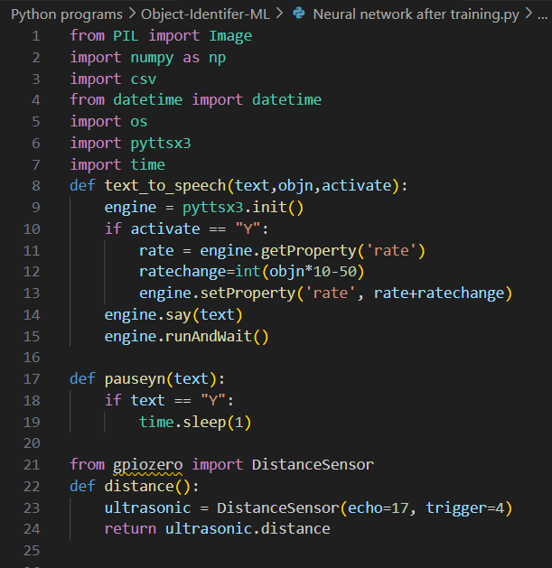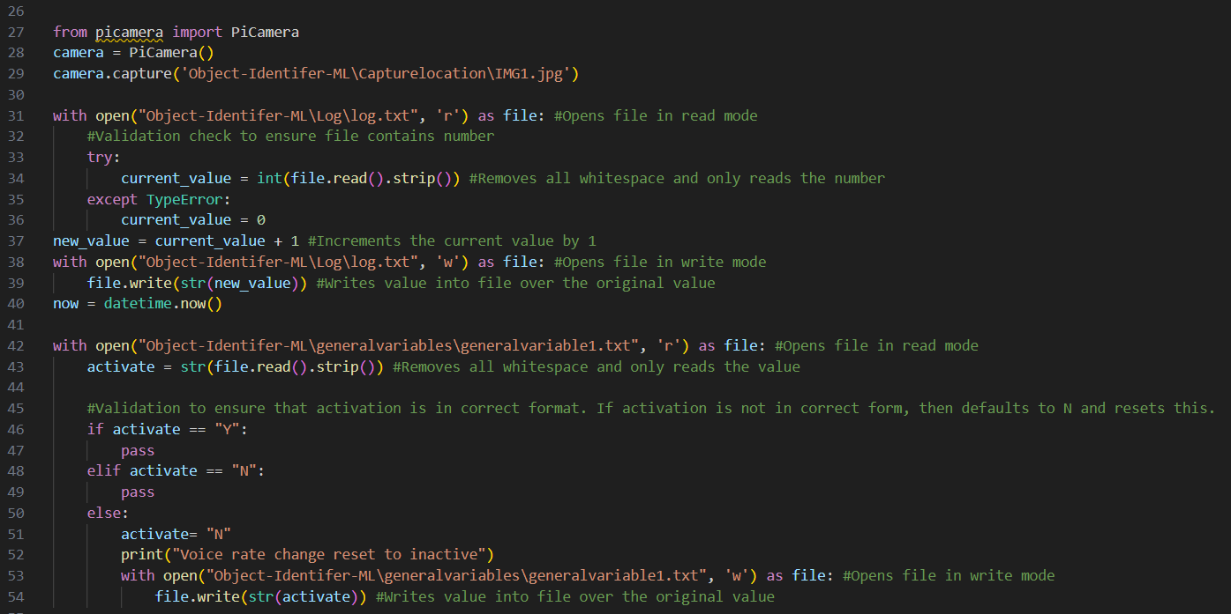

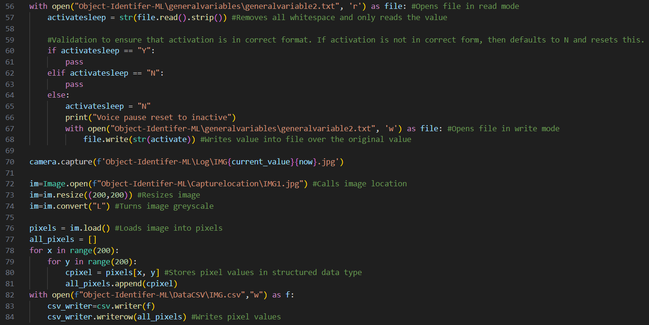

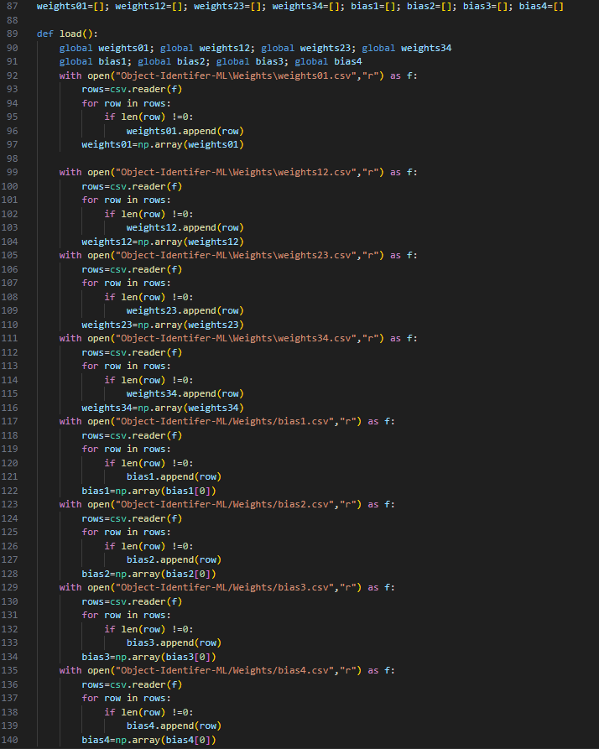

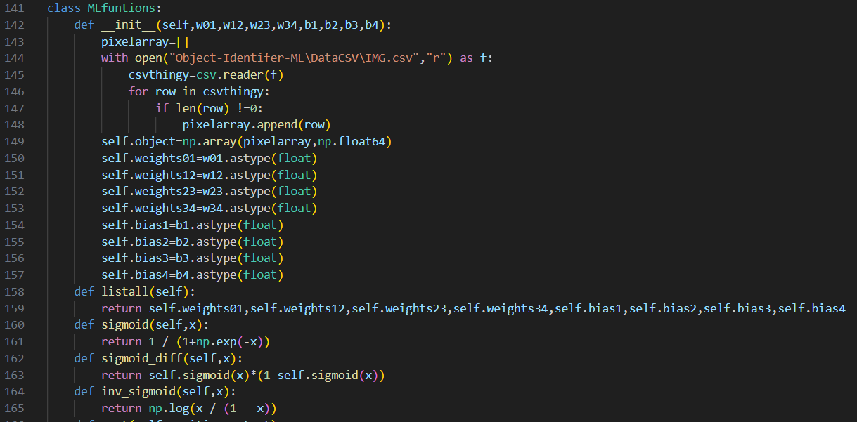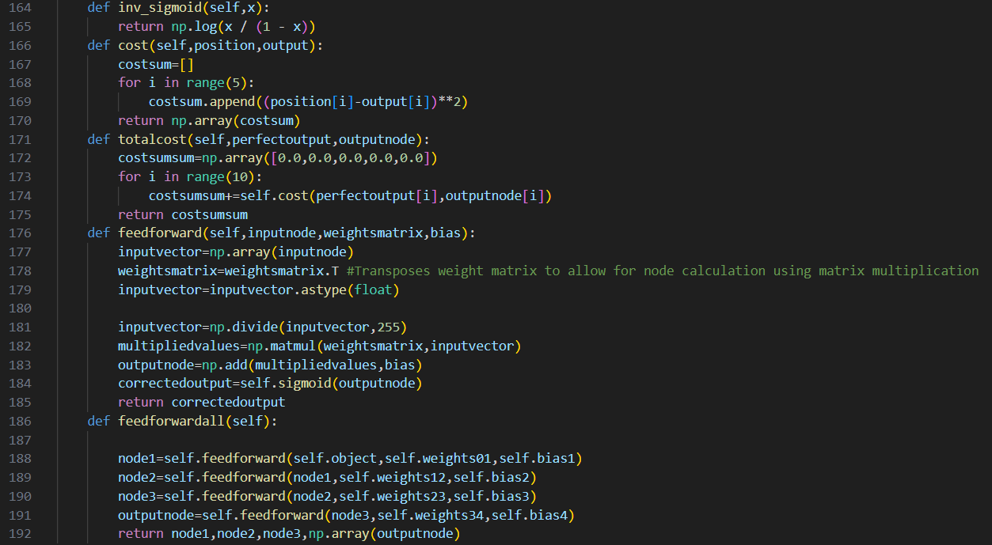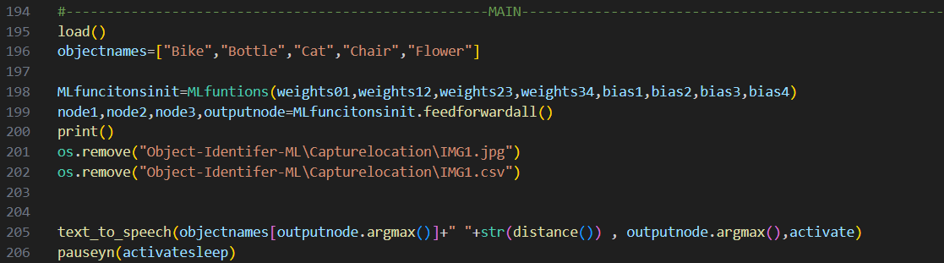

## Neural network training

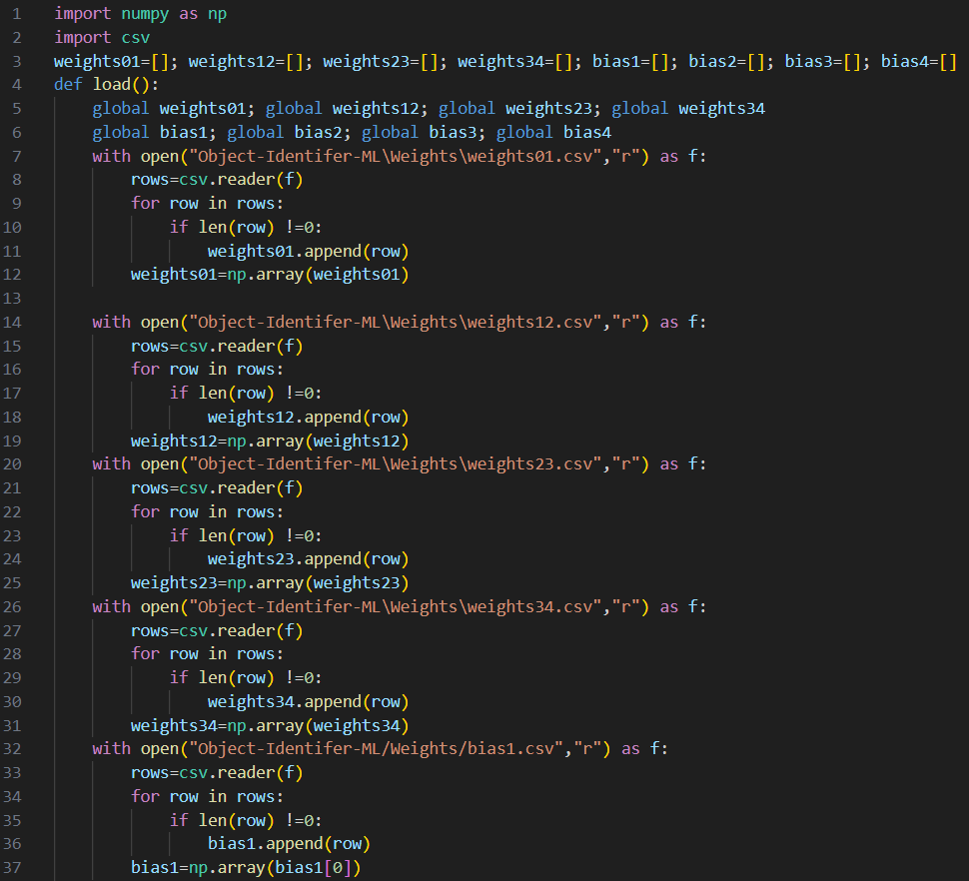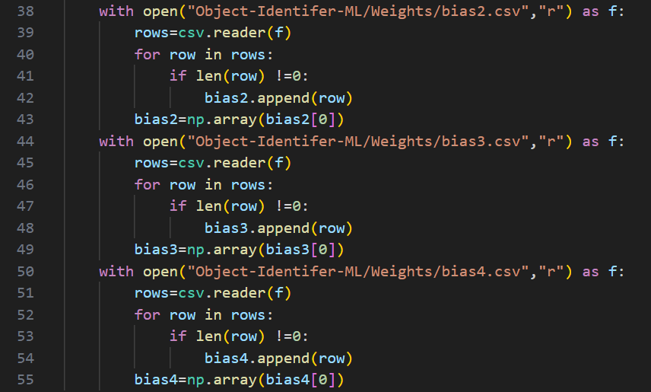

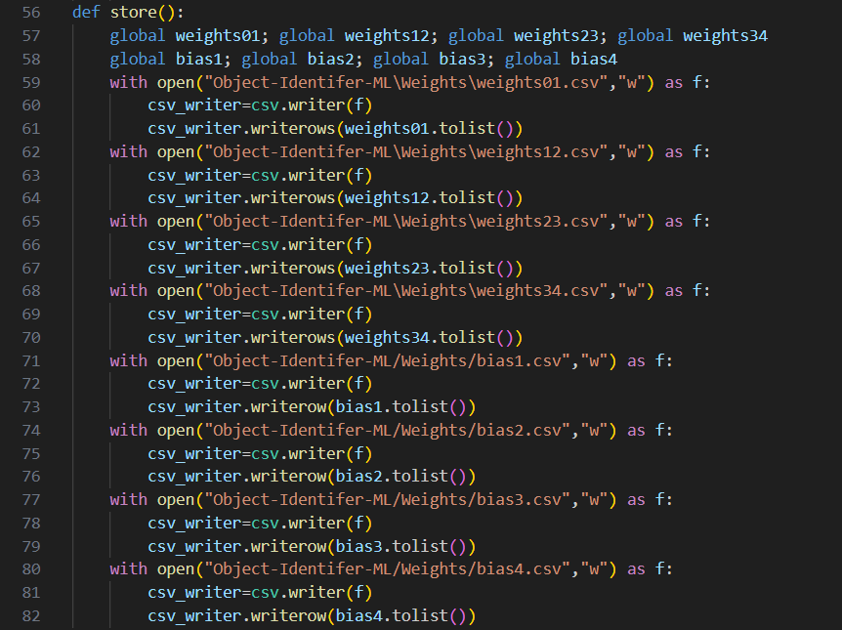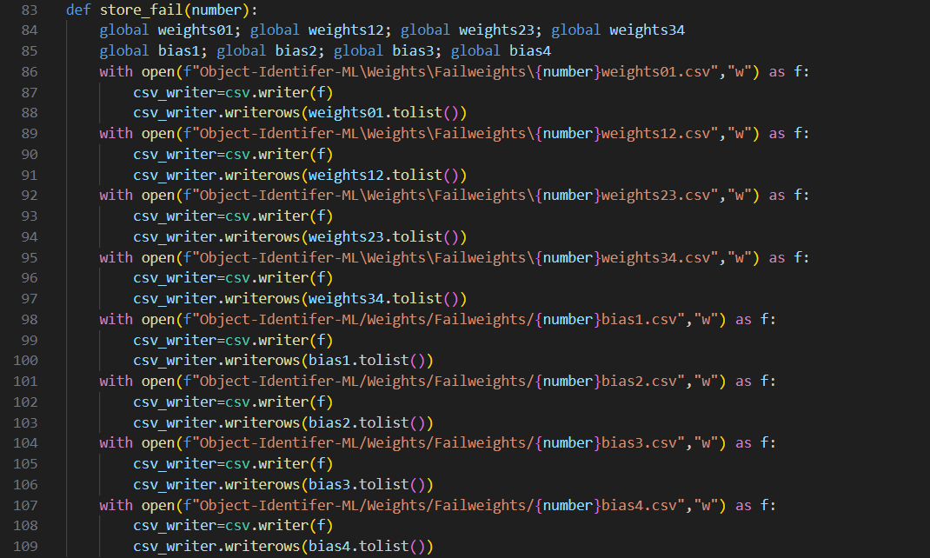

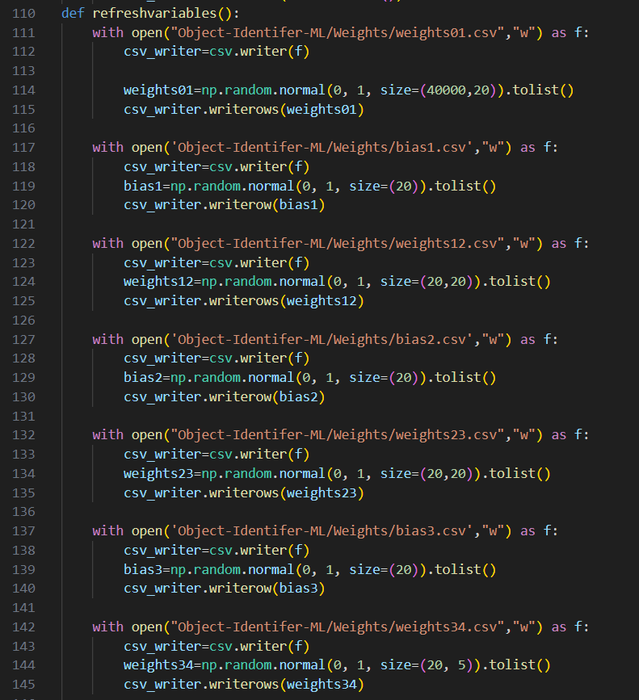

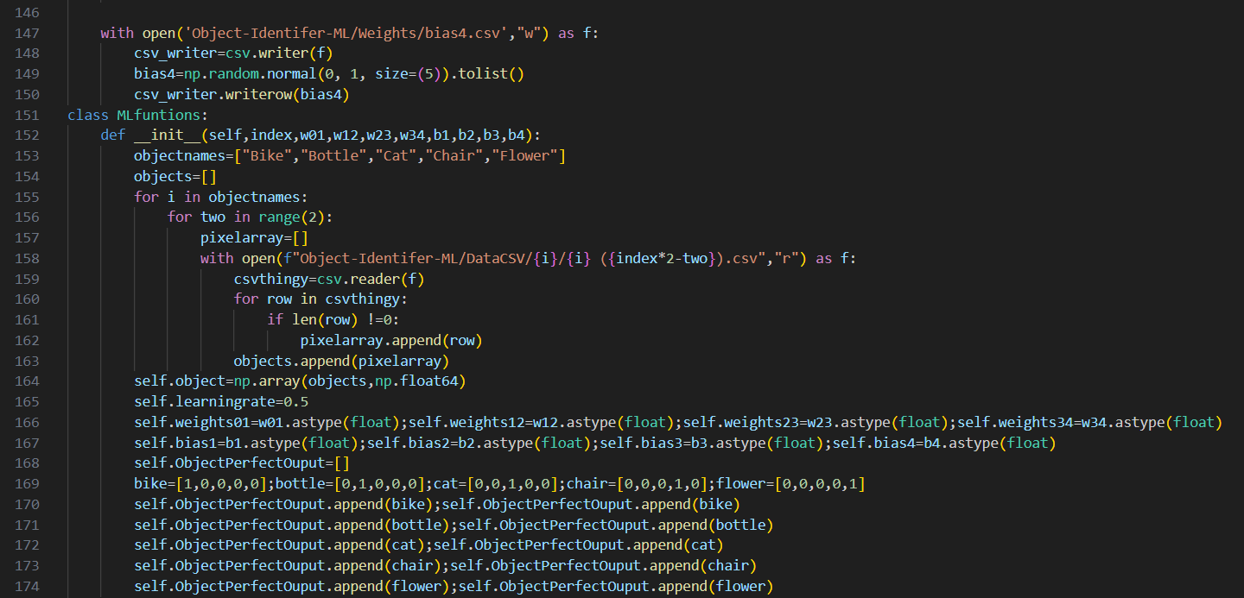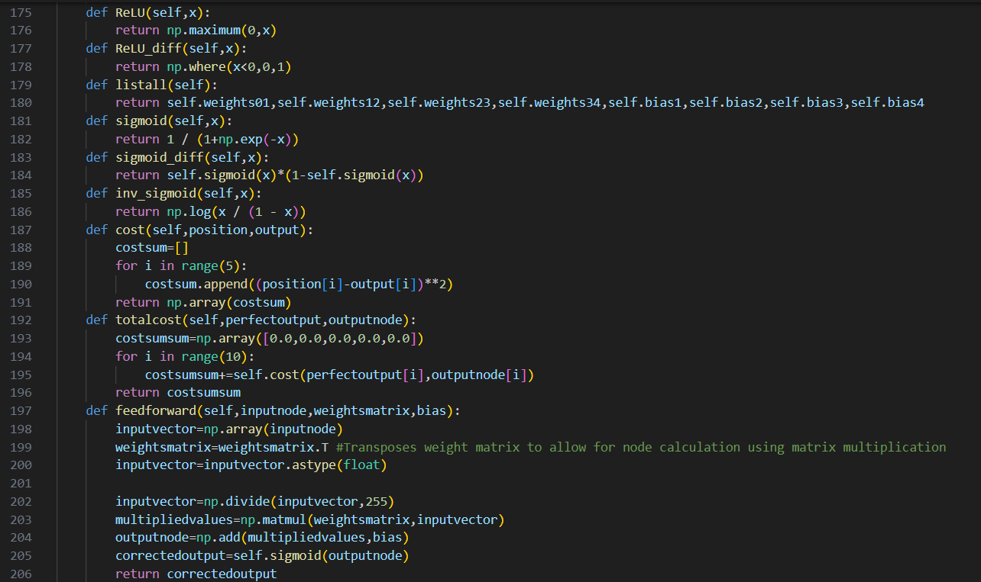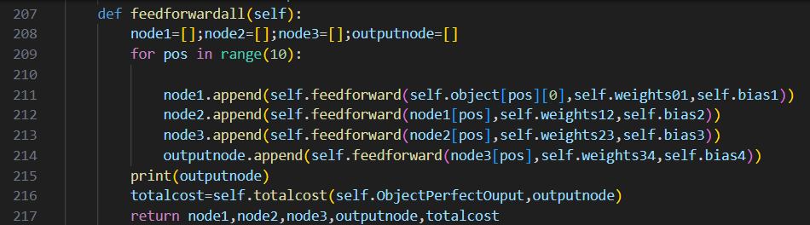

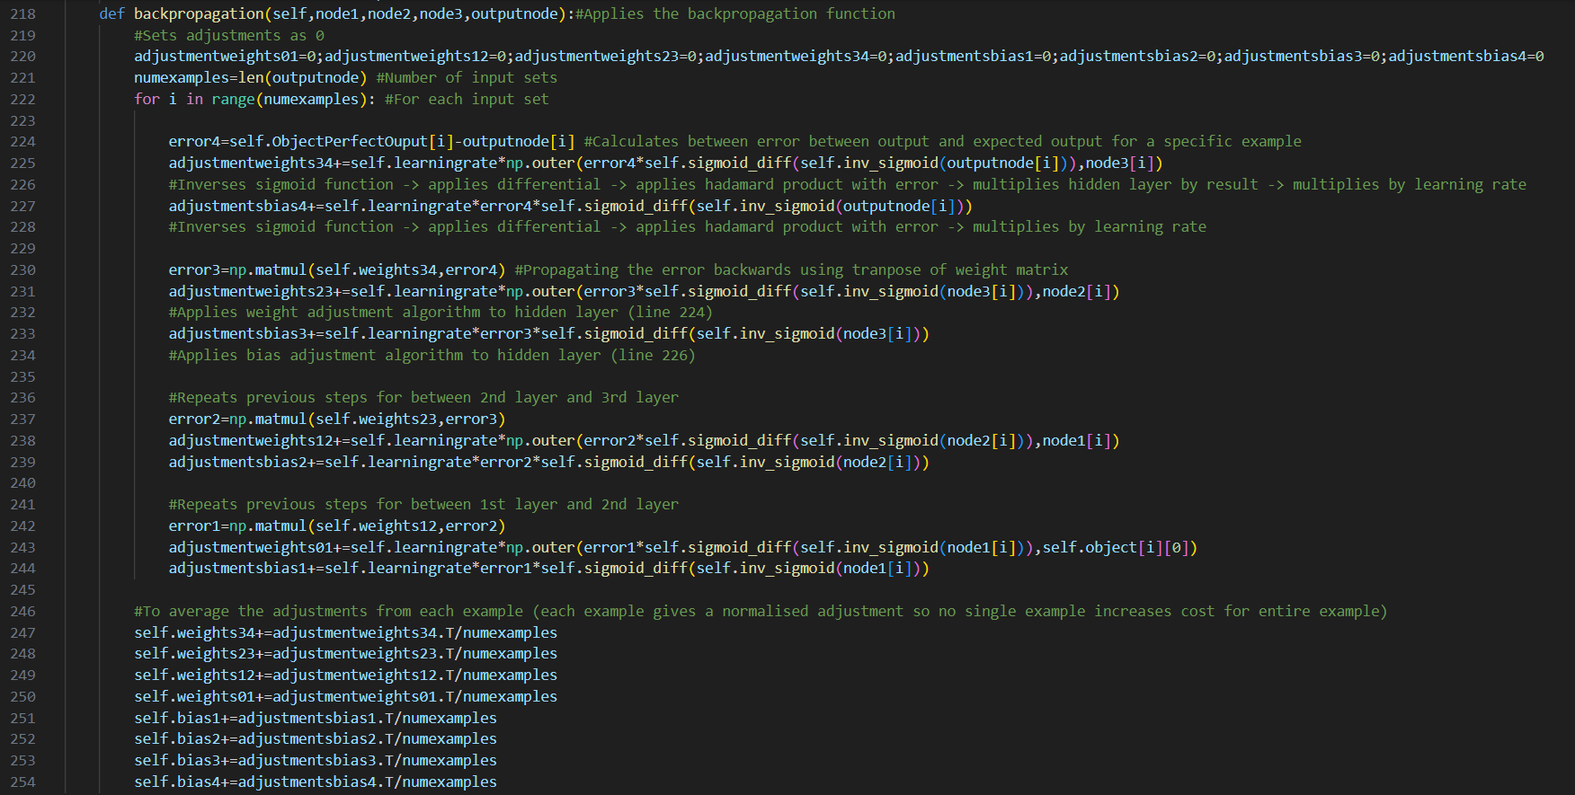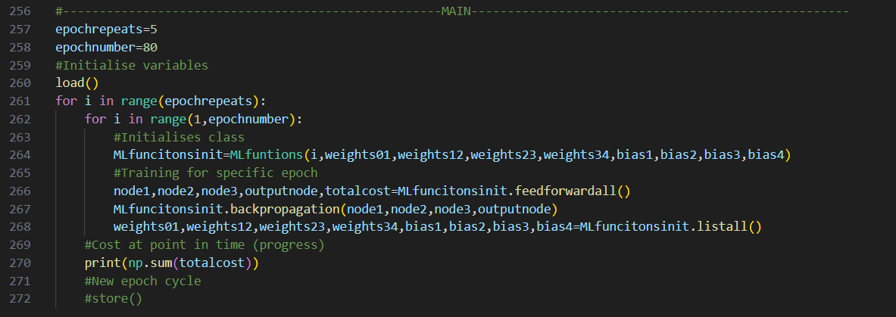

## Preprocessing

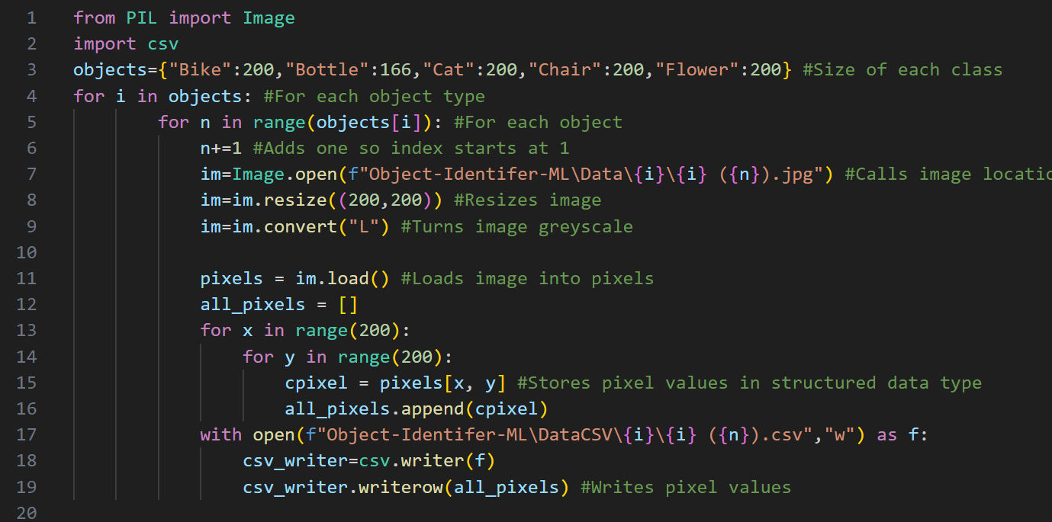

## 

## Change rate of speech input program

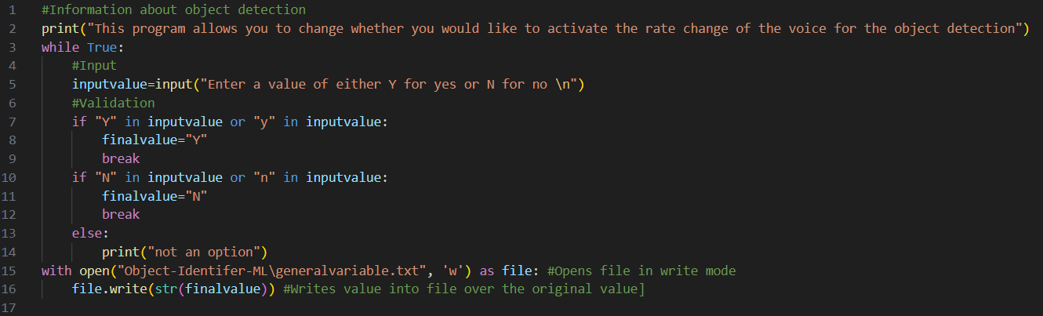

## Initialise variables.

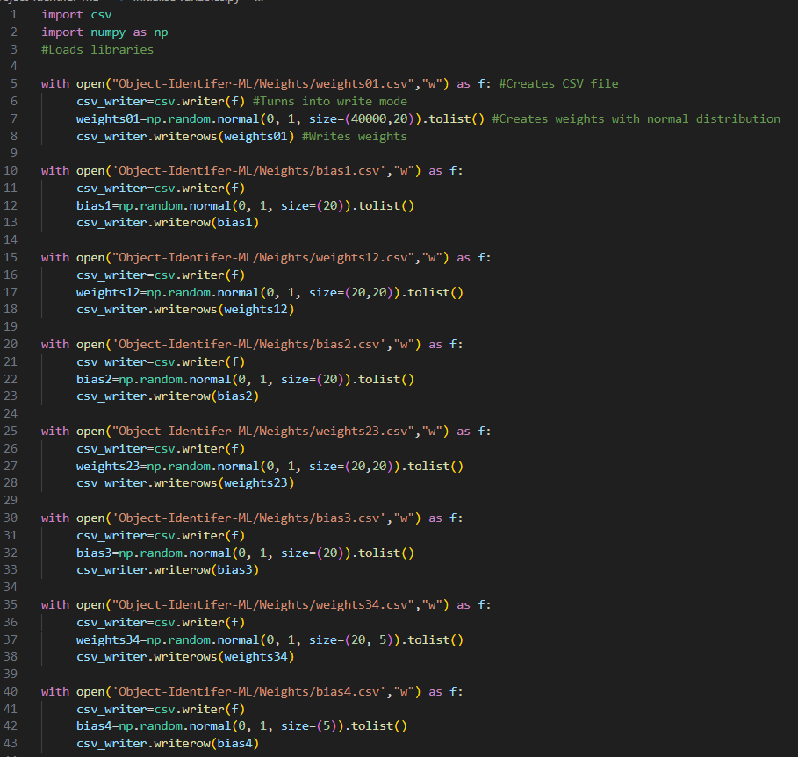

# Prototype code

## Simple network

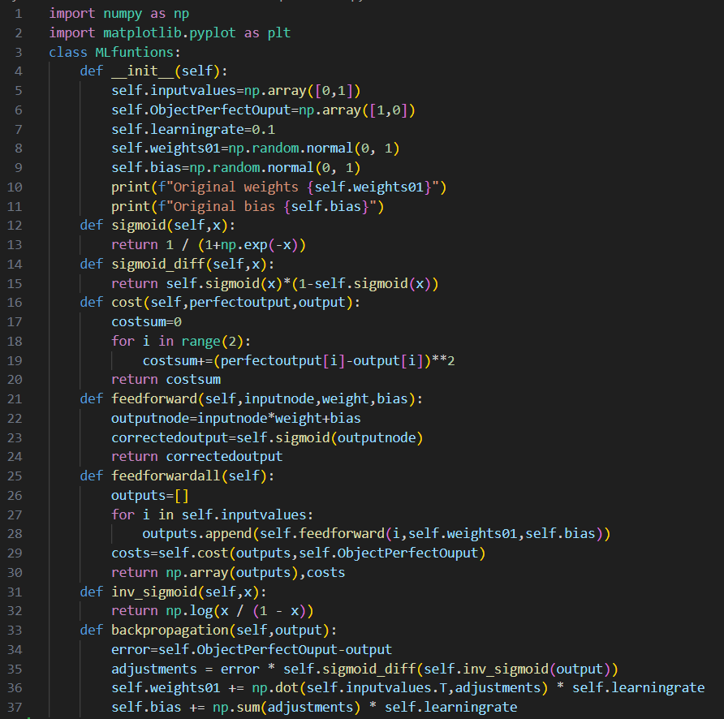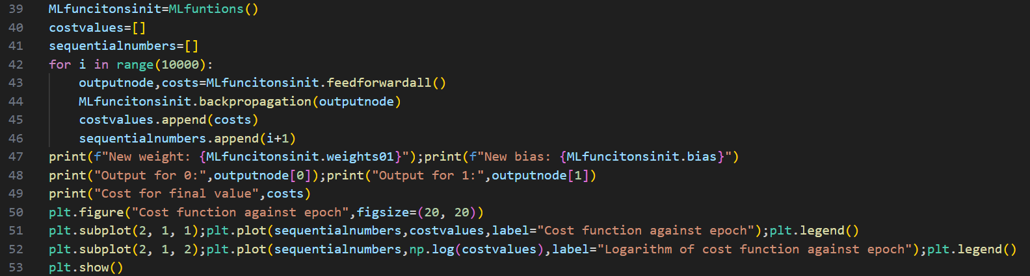

## XOR network feedforward

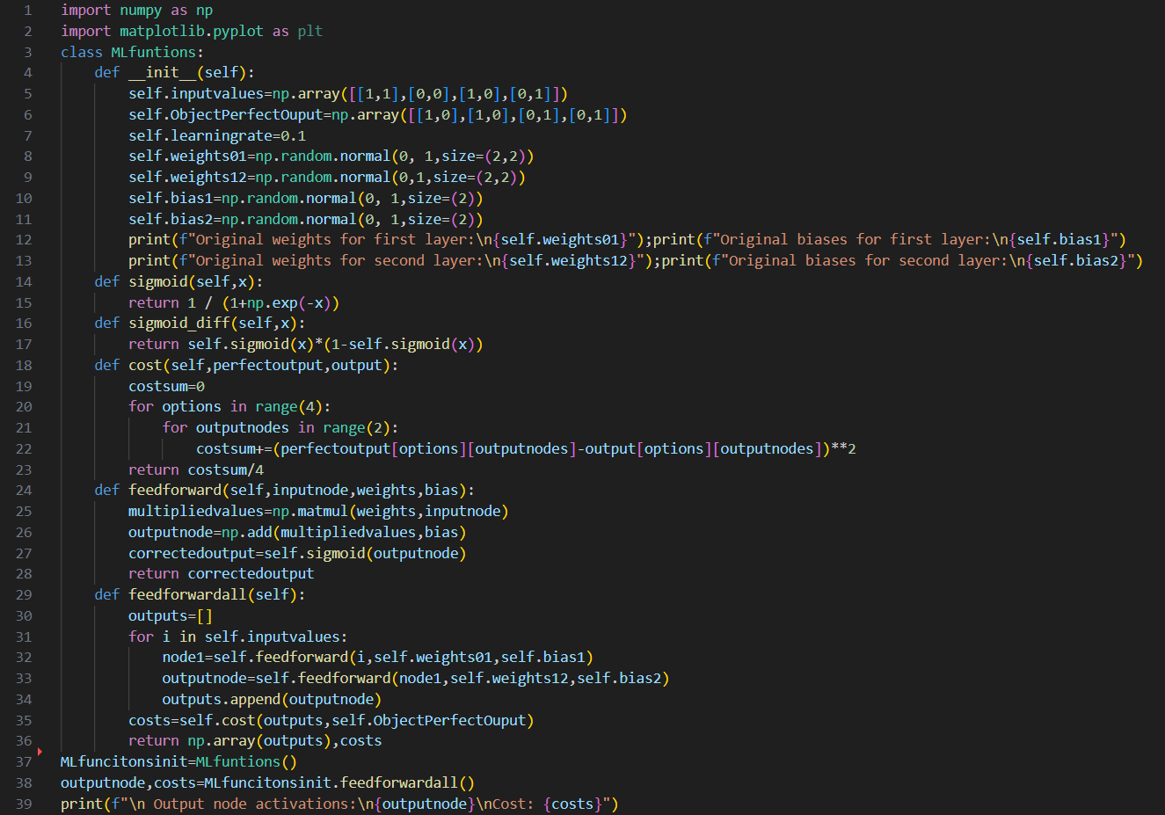

## XOR network backpropagation

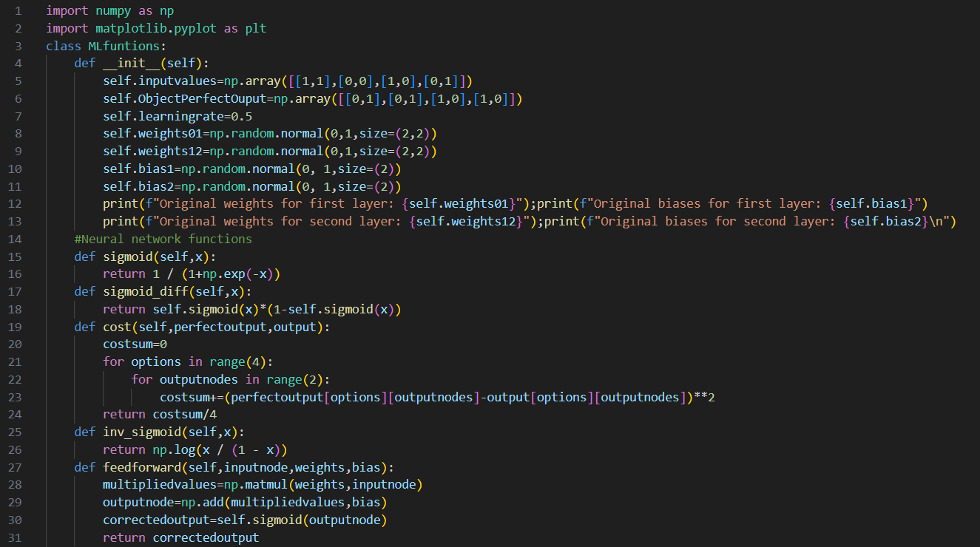 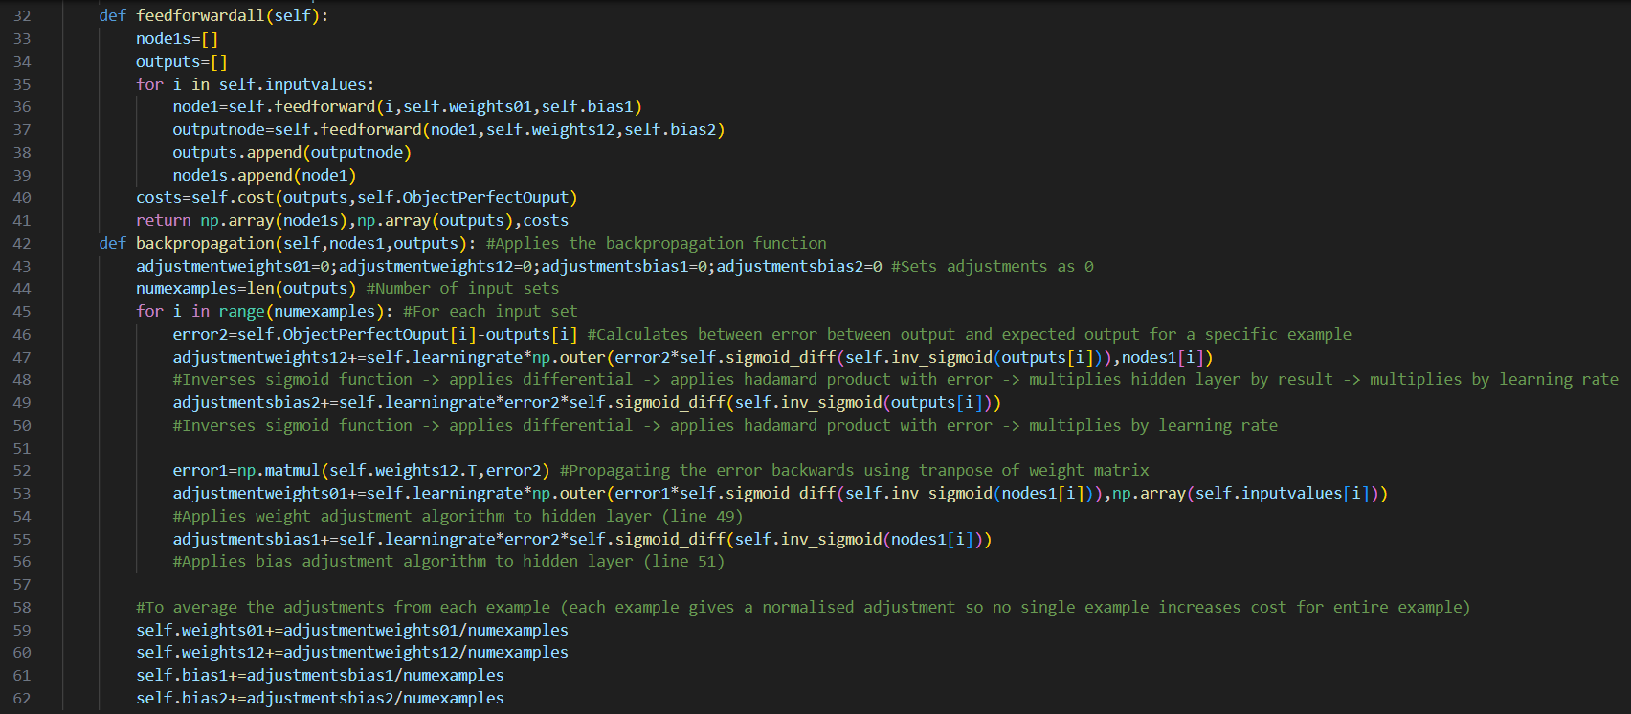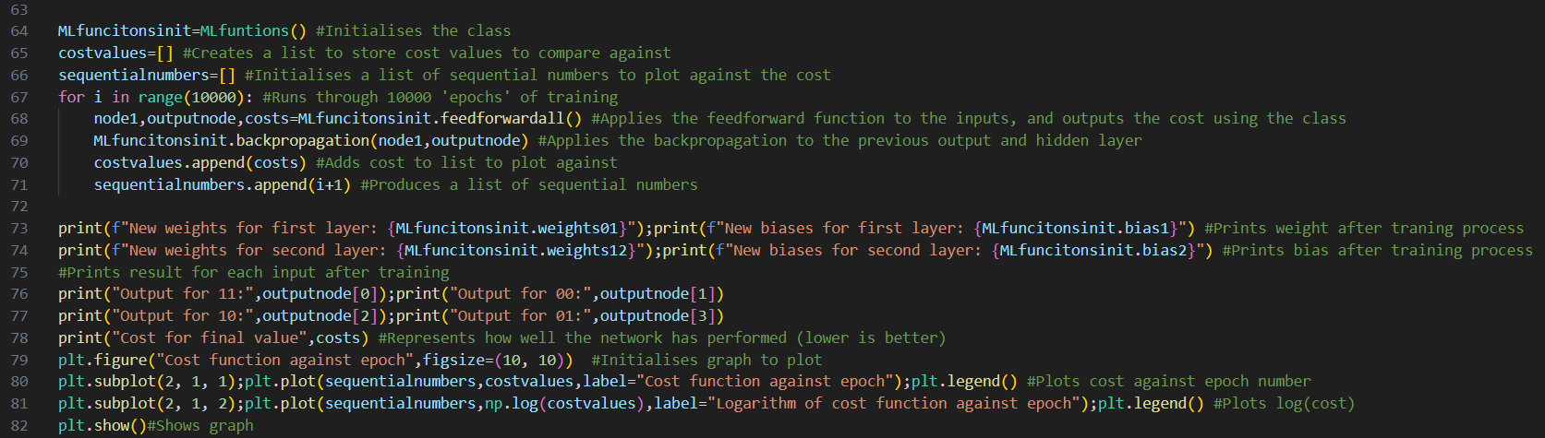

## XOR network fail check

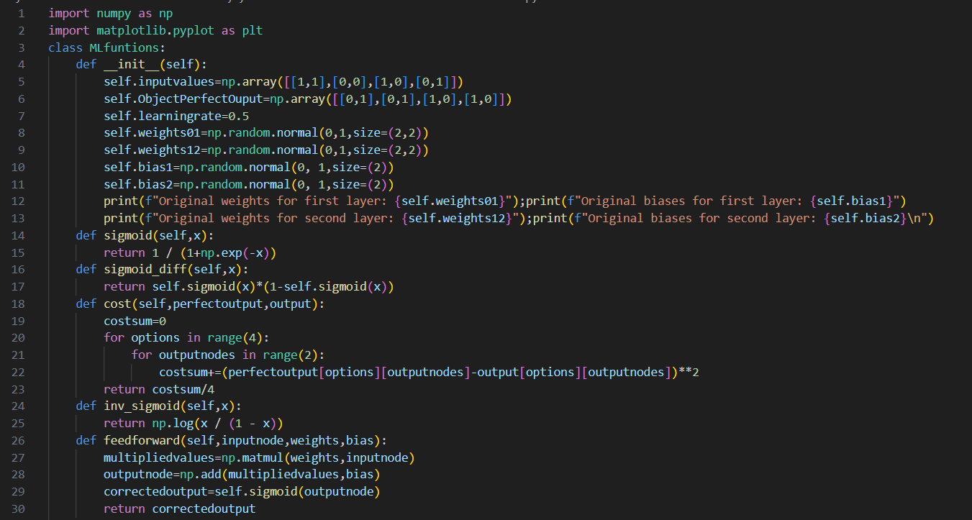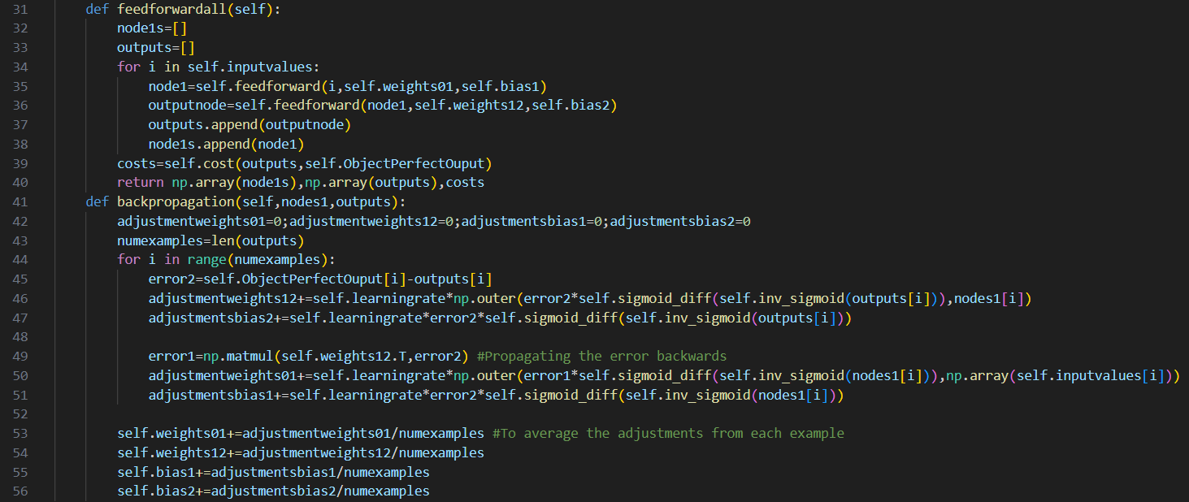 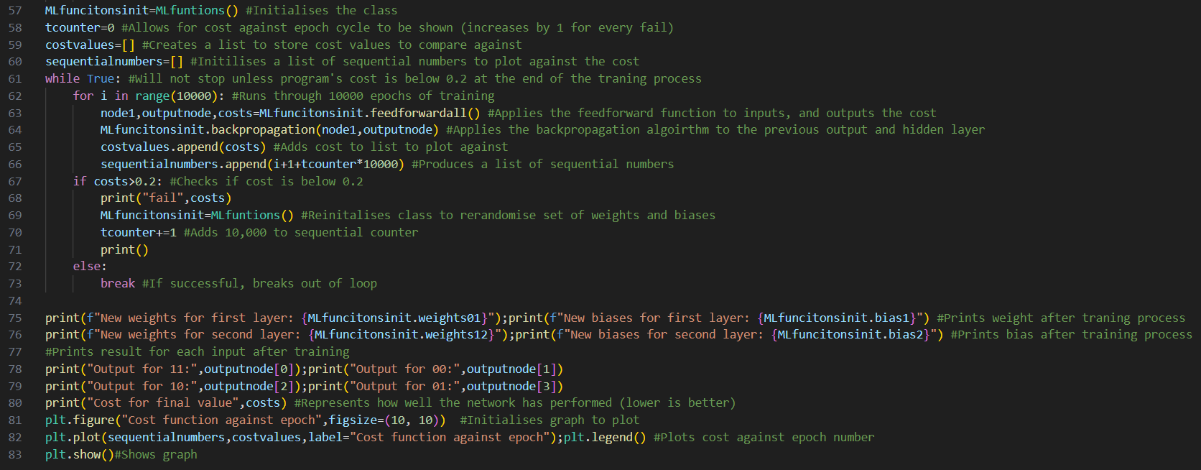

# Bibliography

Distance sensor: <https://www.raspberrypi.com/software/>

Time sensor: <https://docs.python.org/3/library/time.html>

Python text to speech: <https://pyttsx3.readthedocs.io/en/latest/>

OS: <https://docs.python.org/3/library/os.html>

CSV: <https://docs.python.org/3/library/csv.html>

Pillow: <https://pillow.readthedocs.io/en/stable/>

NumPy: <https://numpy.org/doc/>

Raspberry Pi camera: <https://picamera.readthedocs.io/en/release-1.13/>

AI knowledge: <https://youtube.com/playlist?list=PLZHQObOWTQDNU6R1_67000Dx_ZCJB-3pi&si=f-KfHSv5YWWOze3s>

Research for existing solutions links

<https://www.orcam.com/en-us/myeye-store>

<https://shop.letsenvision.com/en-gb/products/glasses-professional?variant=43528052506880>

<https://blog.google/products/google-lens/google-lens-real-time-answers-questions-about-world-around-you/>

<https://opencv.org>

<https://towardsdatascience.com/yolo-object-detection-with-opencv-and-python-21e50ac599e9?gi=275481831727>

<https://www.amazon.com/b?ie=UTF8&node=21576558011>